**db2**

| **db2** | **SNRdB_Lung**  **_Sound** | **RMSE_Lung**  **_Sound** | **PRD_Lung_Sound** | **CC_Lung**  **_Sound** |
| --- | --- | --- | --- | --- |
| Level 2 | 24.0102 dB | 0.00010256 | 6.3022% | 0.95217 |
| Level 3 | 24.6547 dB | 9.5269e-05 | 5.8515% | 0.95892 |
| Level 4 | 24.8055 dB | 9.3638e-05 | 5.7507% | 0.96033 |
| Level 5 | 24.9441 dB | 9.2134e-05 | 5.6597% | 0.96173 |
| Level 6 | 26.25 dB | 7.9288e-05 | 4.8697% | 0.97171 |
| Level 7 | 26.3345 dB | 7.8494e-05 | 4.8225% | 0.97223 |

**(1) db2 LEVEL 2**

(a) db2 LEVEL 2 ARCHITECTURE

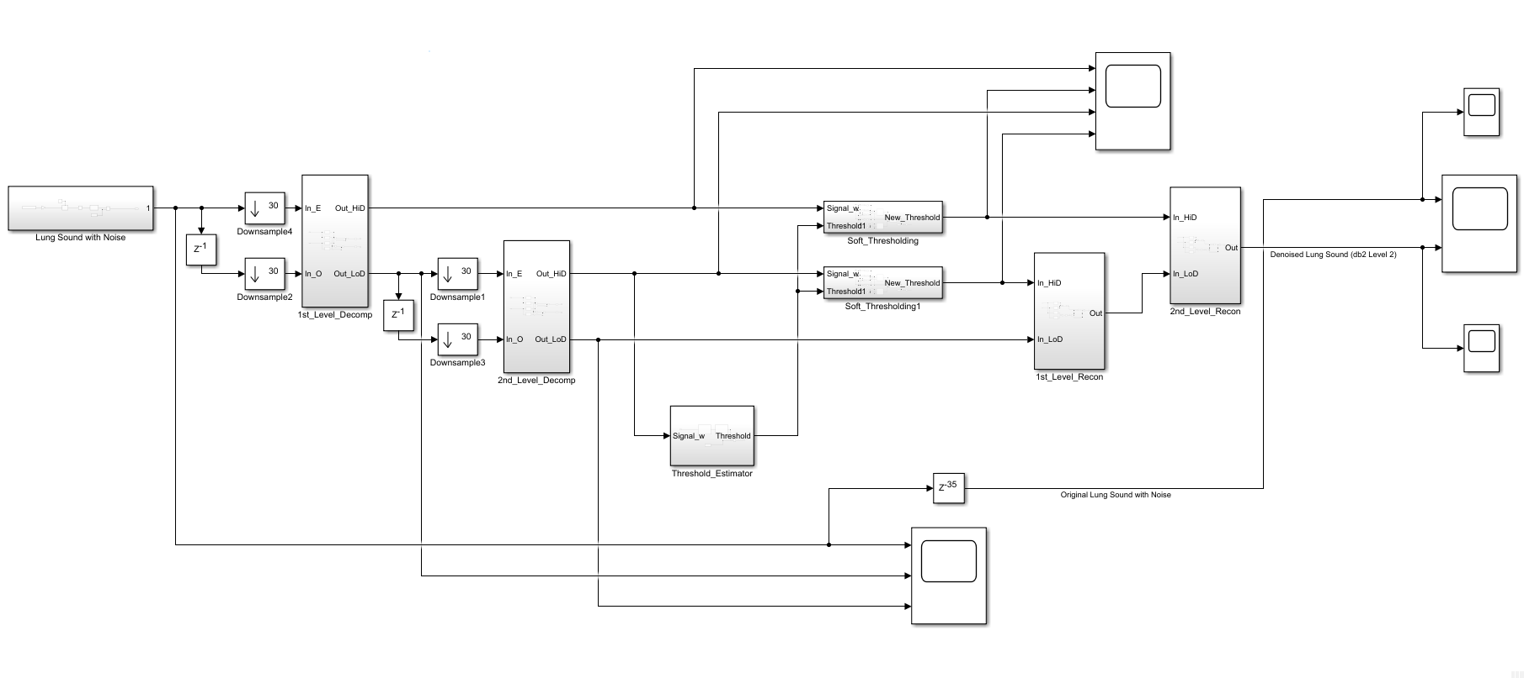

(b) db2 LEVEL 2 SIMULATION RESULT

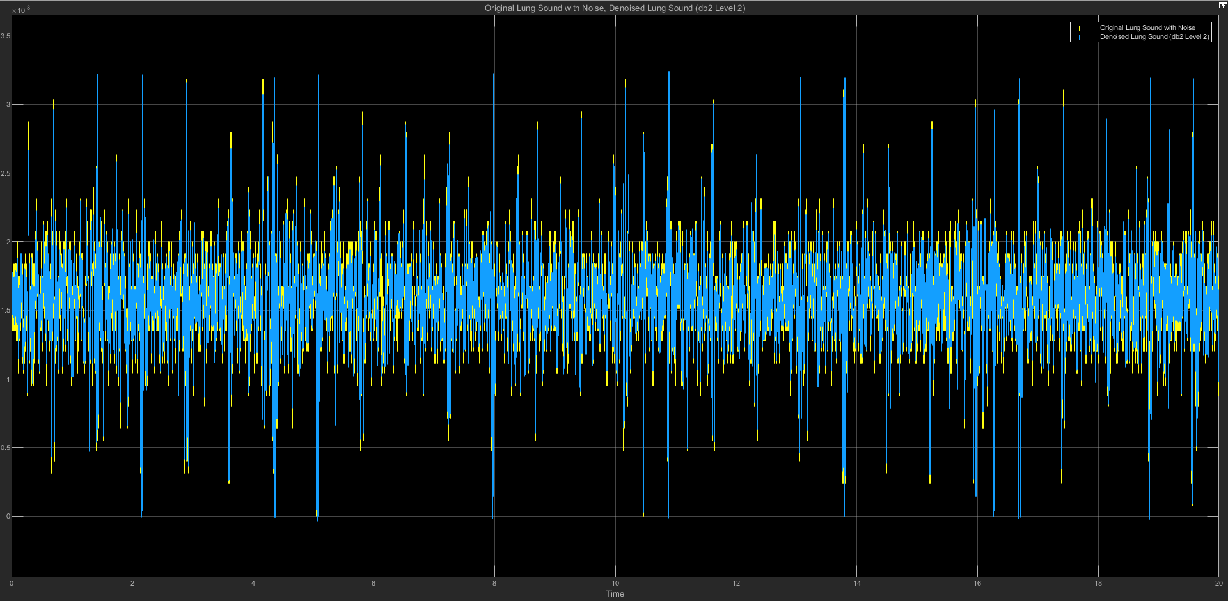

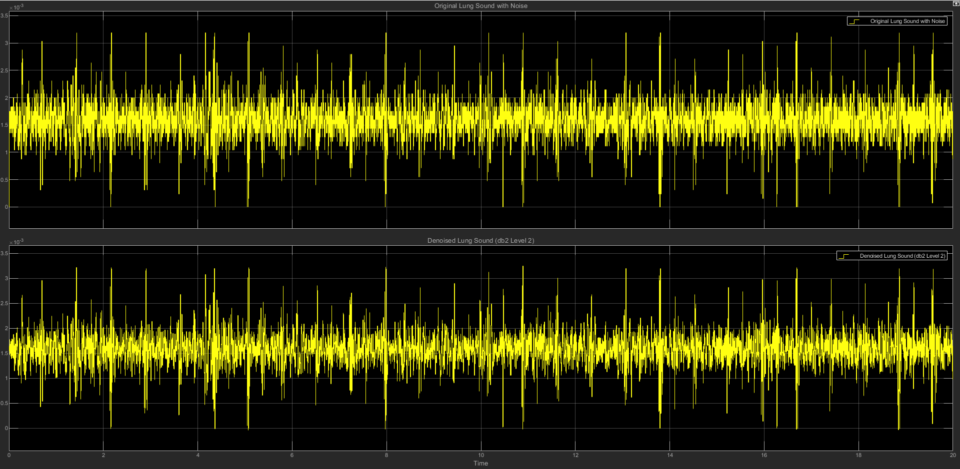

(c) db2 LEVEL 2 STATISTICS RESULT

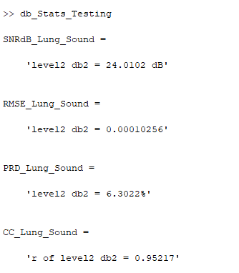

(d) db2 LEVEL 2 SCATTER PLOT RESULT

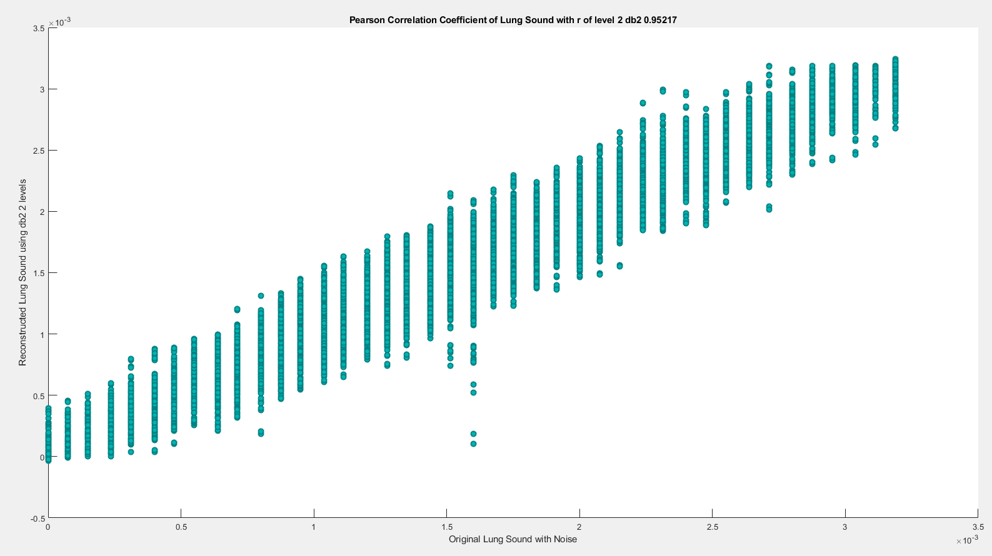

**(2) db2 LEVEL 3**

(a) db2 LEVEL 3 ARCHITECTURE

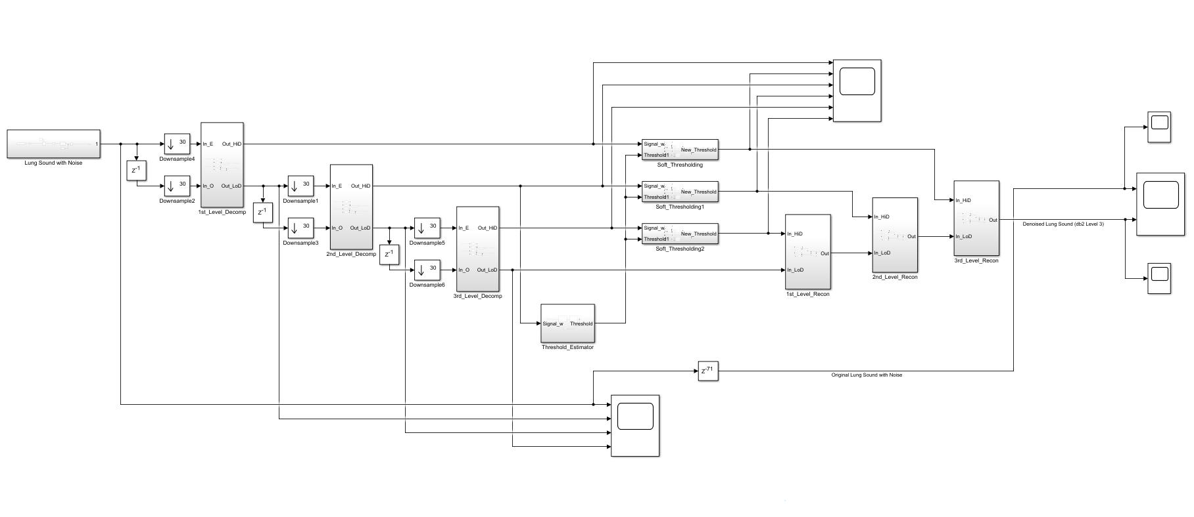

(b) db2 LEVEL 3 SIMULATION RESULT

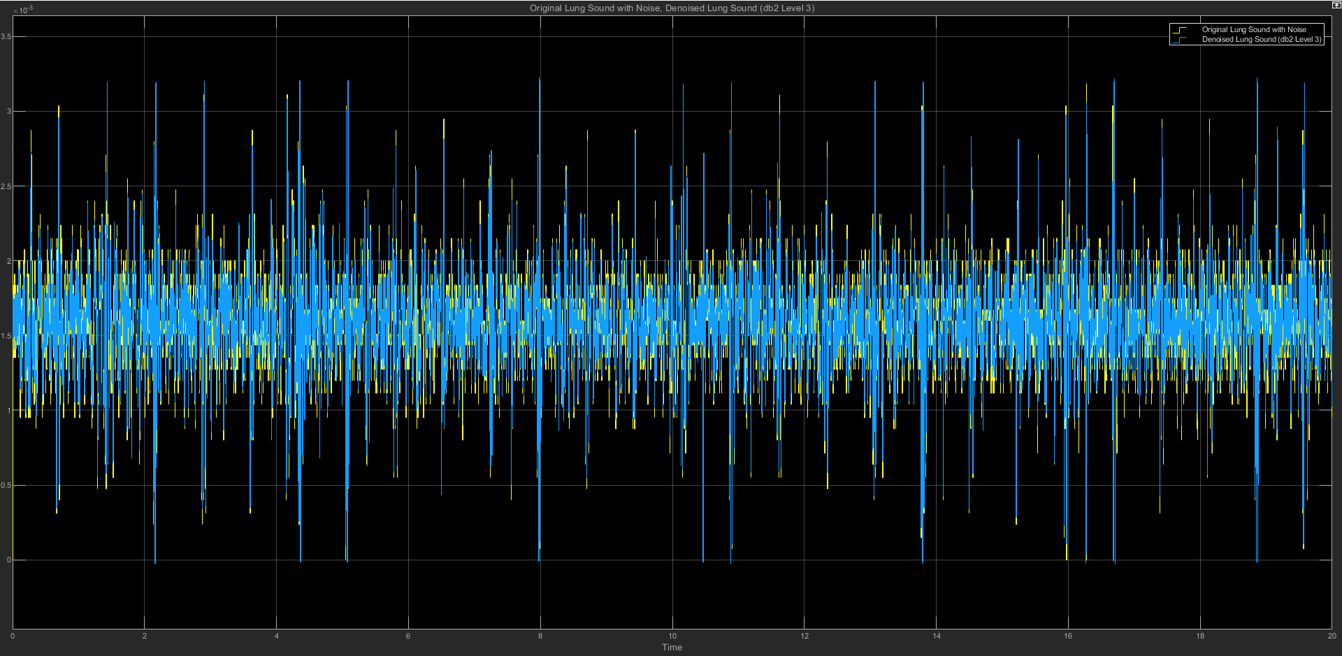

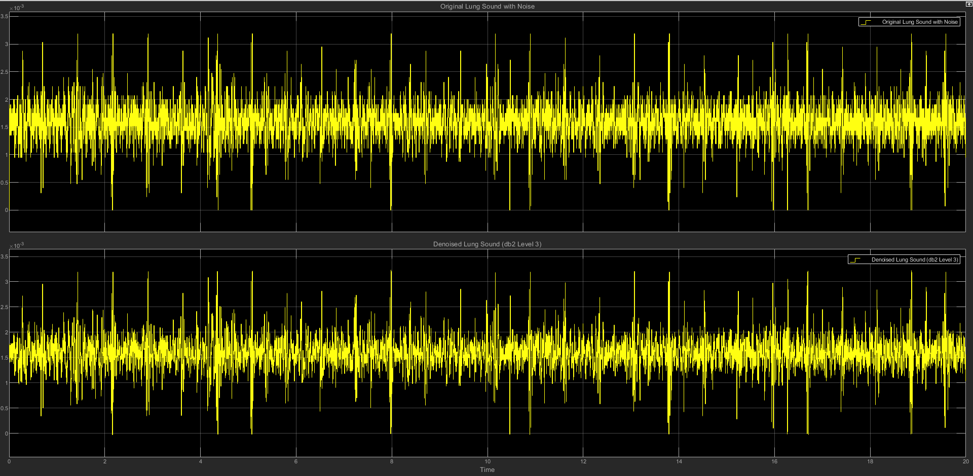

(c) db2 LEVEL 3 STATISTICS RESULT

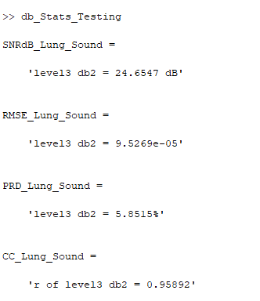

(d) db2 LEVEL 3 SCATTER PLOT RESULT

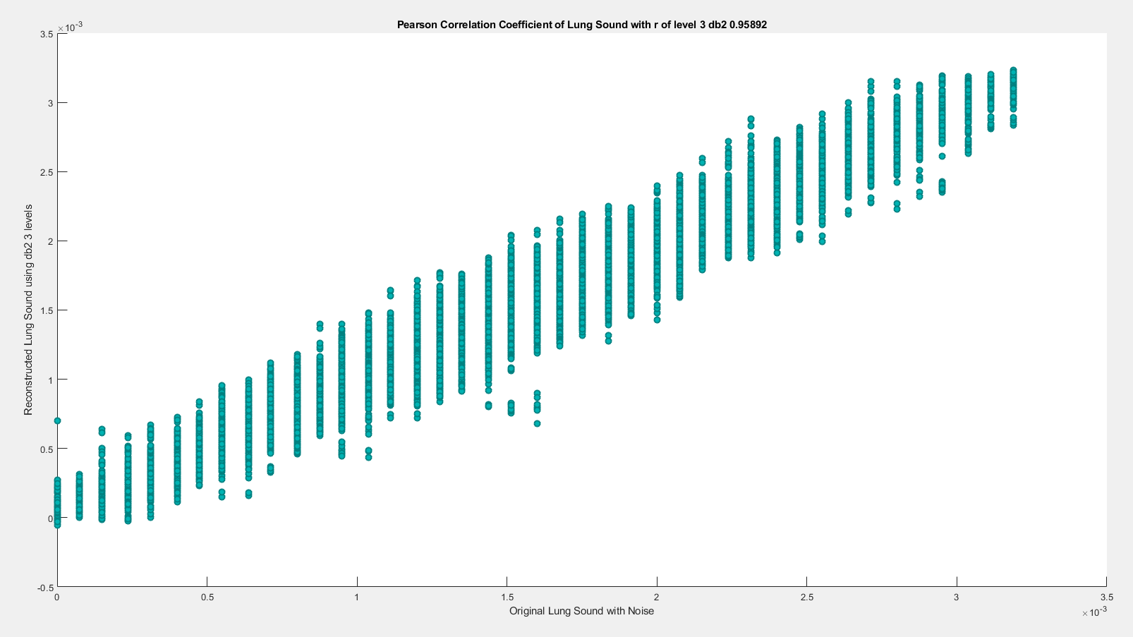

**(3) db2 LEVEL 4**

(a) db2 LEVEL 4 ARCHITECTURE

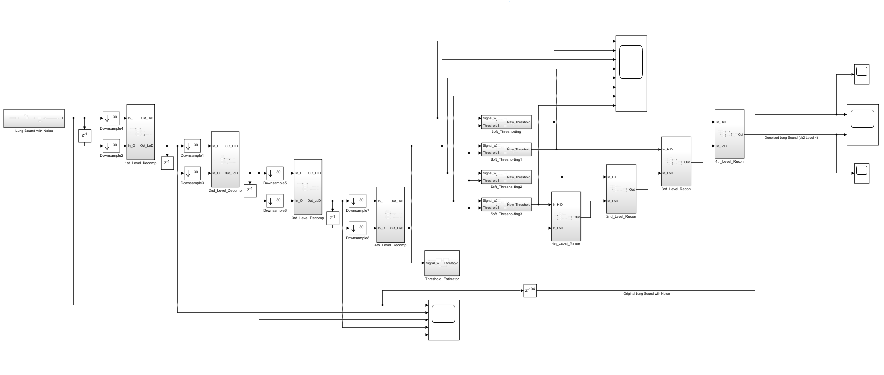

(b) db2 LEVEL 4 SIMULATION RESULT

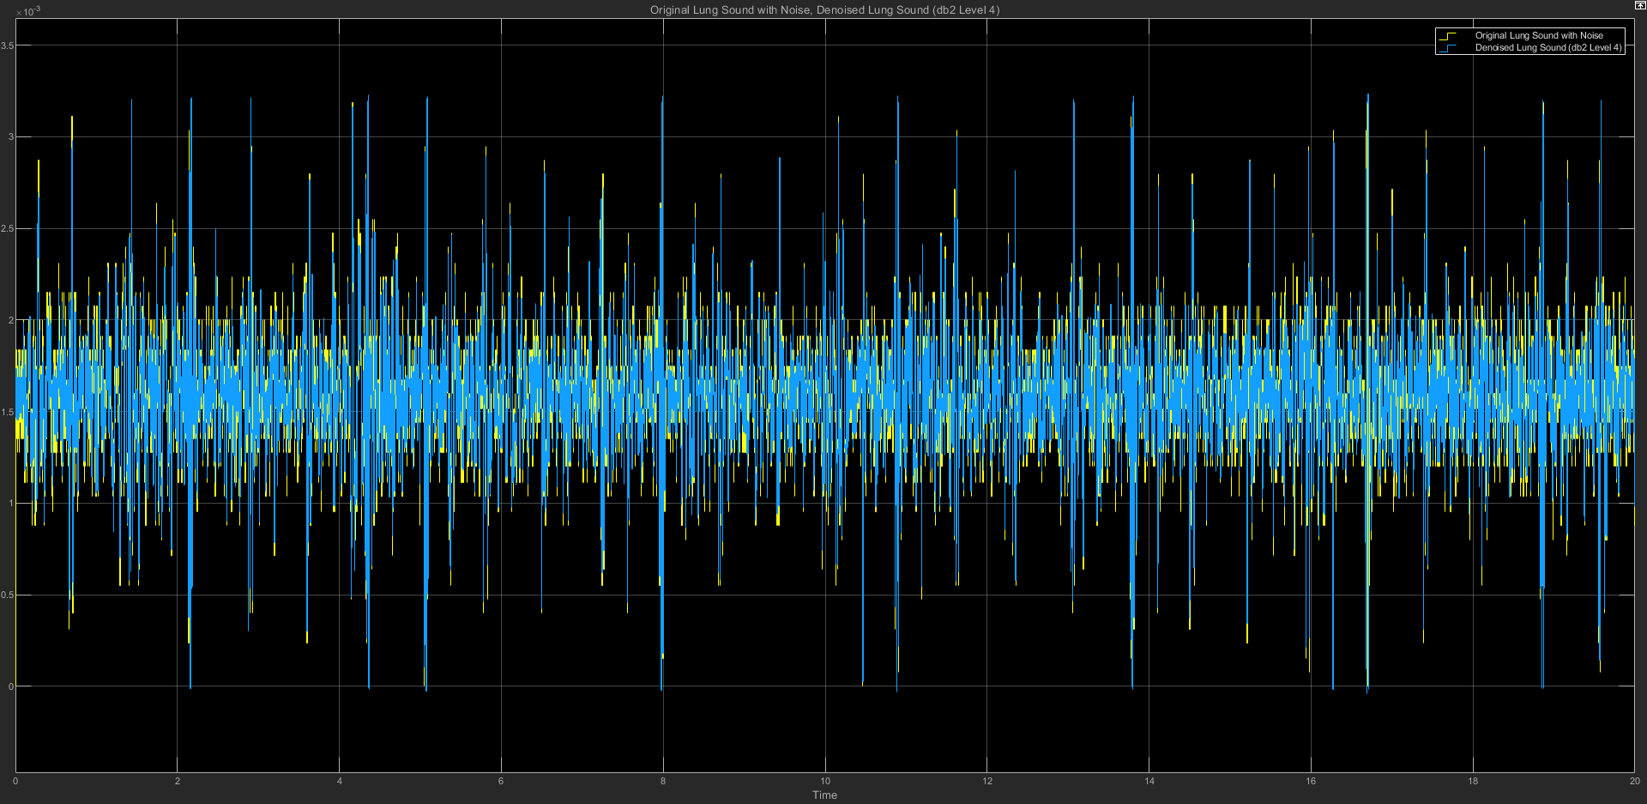

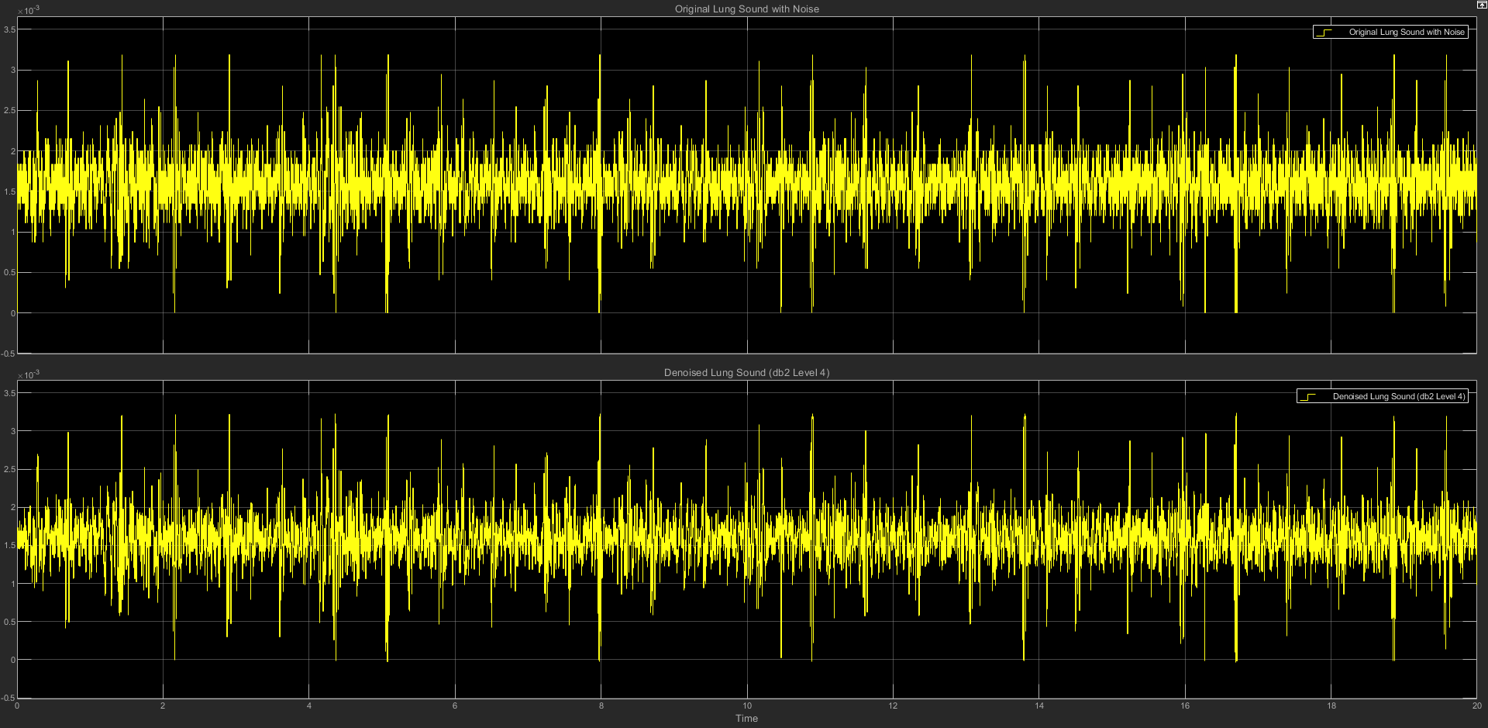

(c) db2 LEVEL 4 STATISTICS RESULT

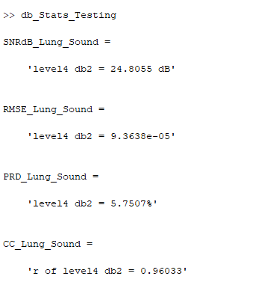

(d) db2 LEVEL 4 SCATTER PLOT RESULT

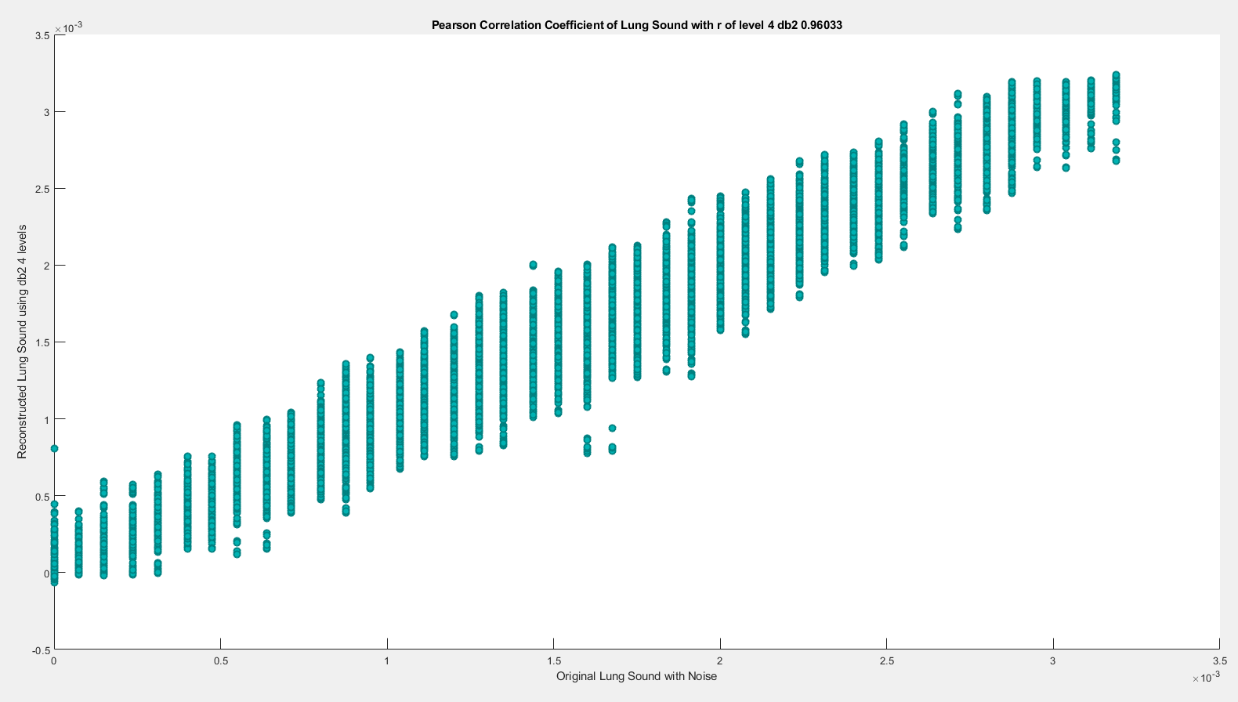

**(4) db2 LEVEL 5**

(a) db2 LEVEL 5 ARCHITECTURE

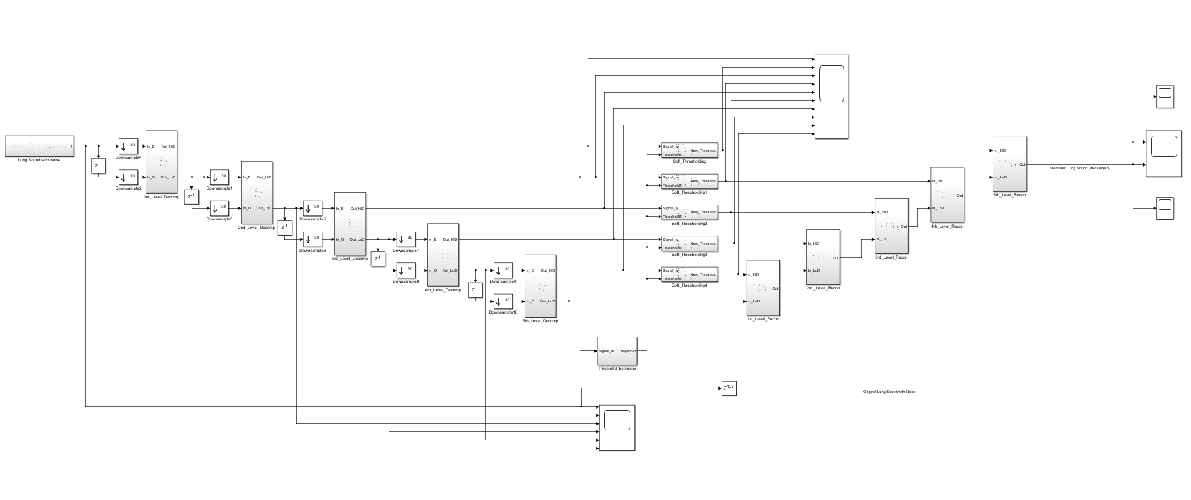

(b) db2 LEVEL 5 SIMULATION RESULT

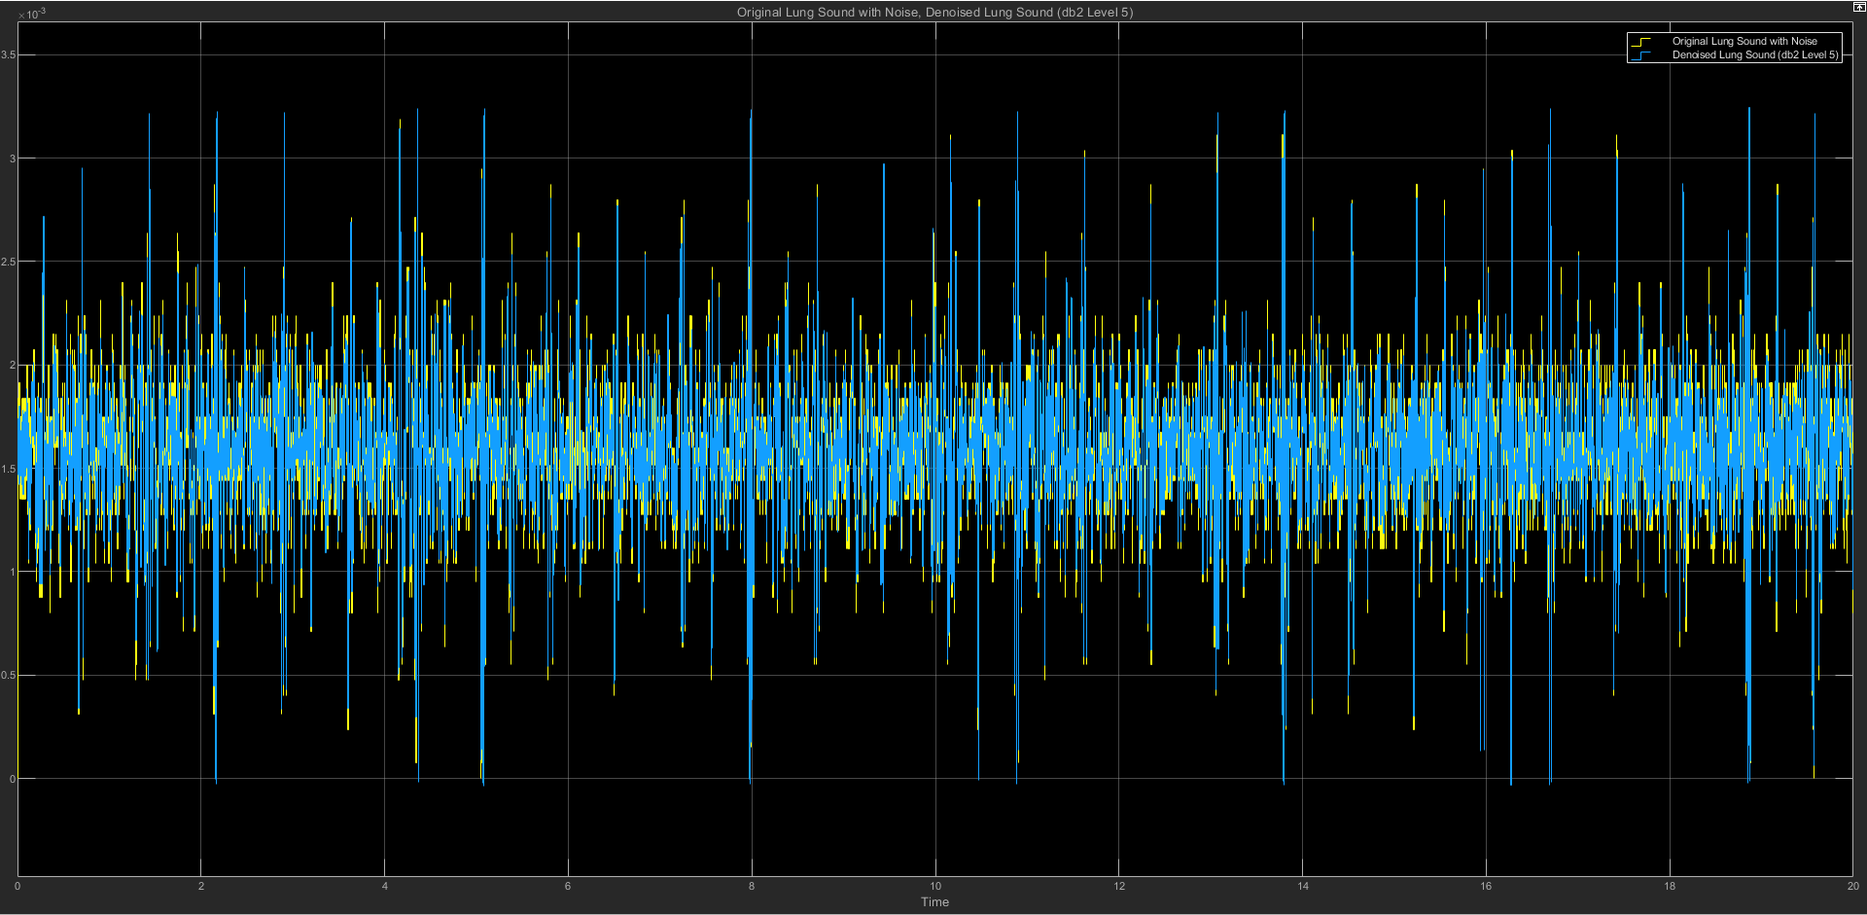

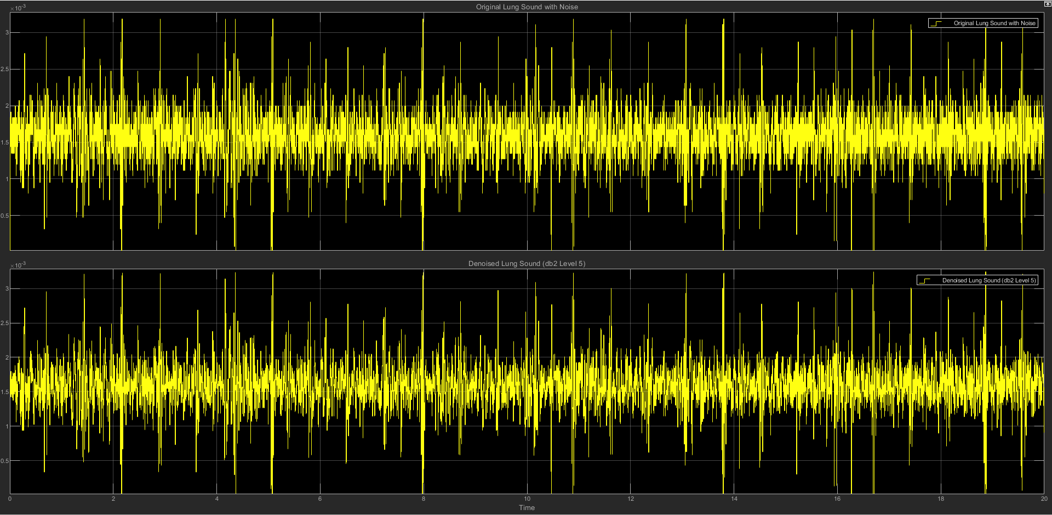

(c) db2 LEVEL 5 STATISTICS RESULT

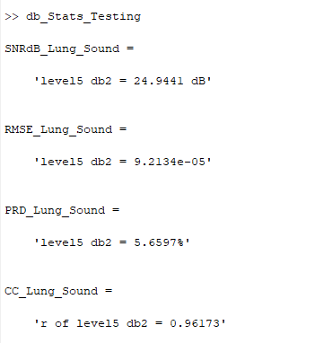

(d) db2 LEVEL 5 SCATTER PLOT RESULT

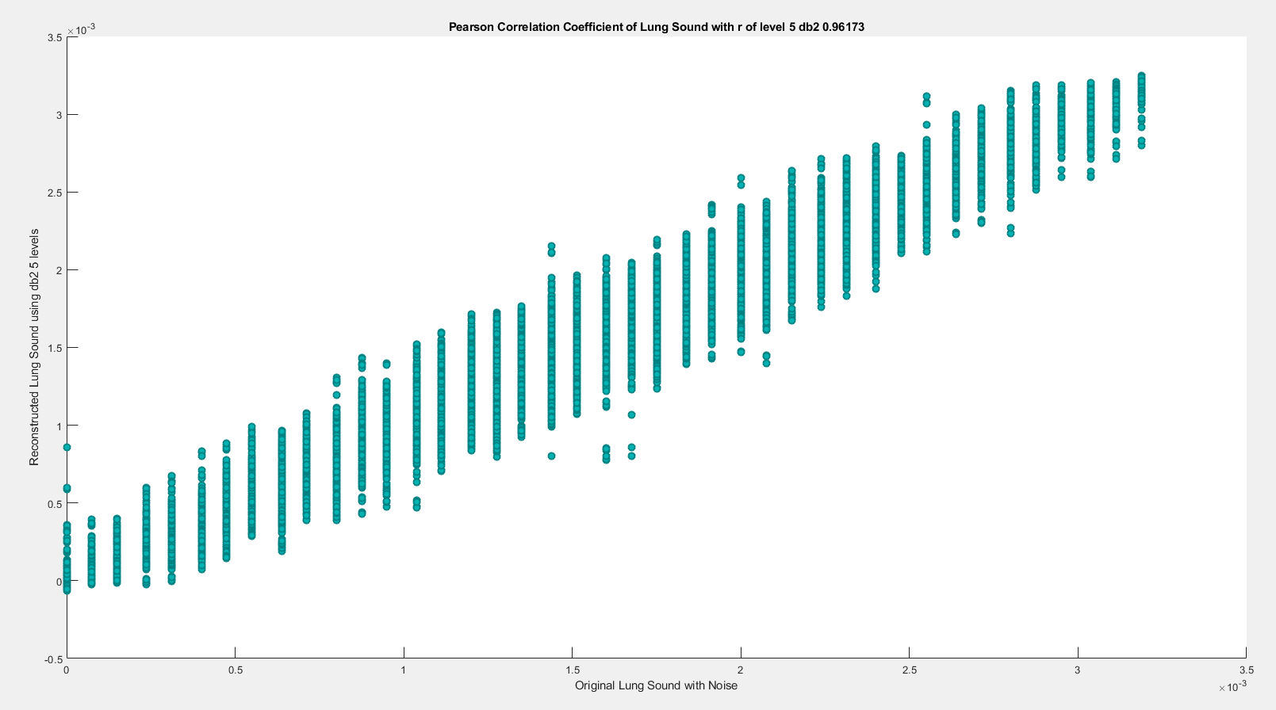

**(5) db2 LEVEL 6**

(a) db2 LEVEL 6 ARCHITECTURE

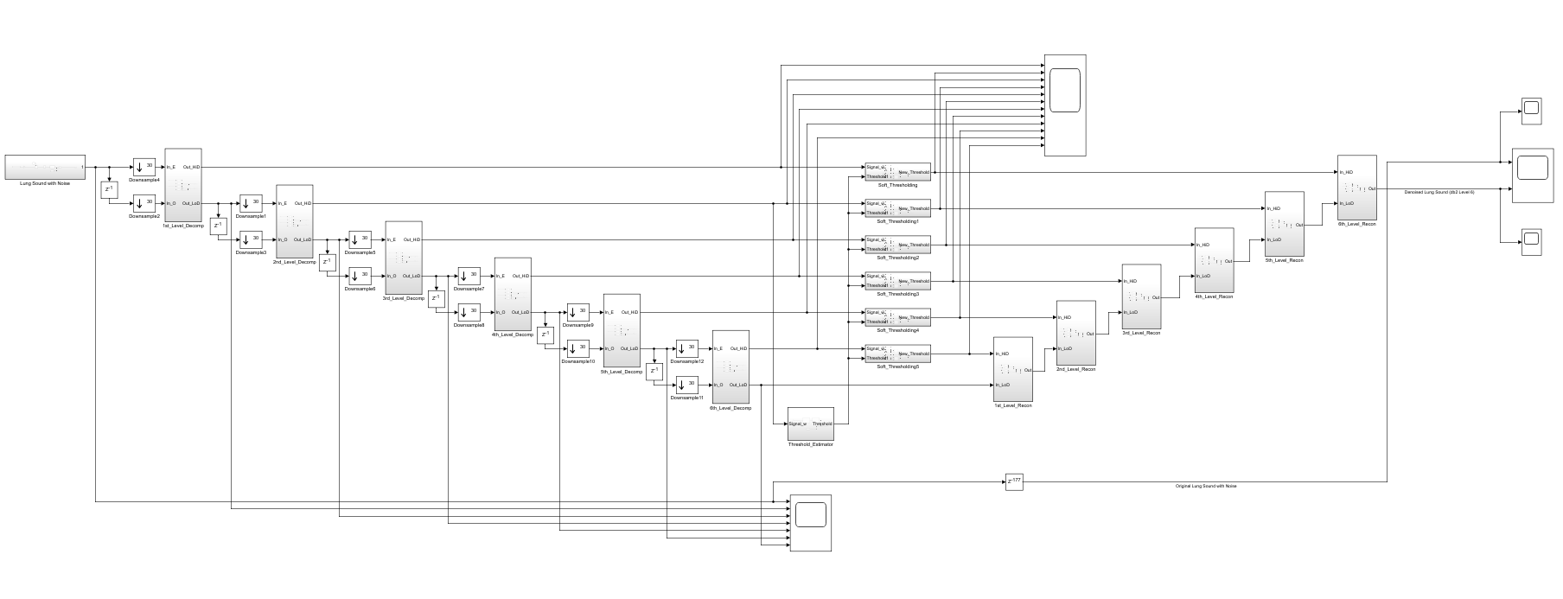

(b) db2 LEVEL 6 SIMULATION RESULT

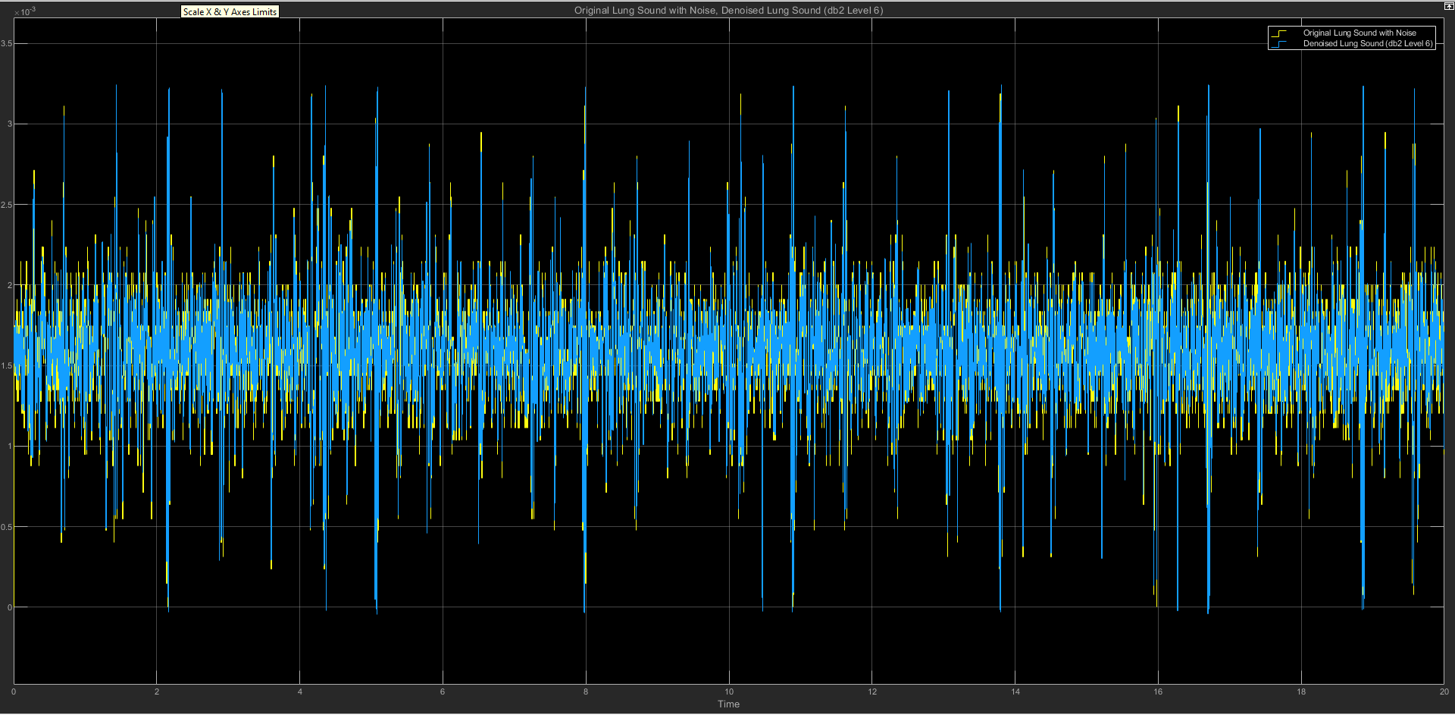

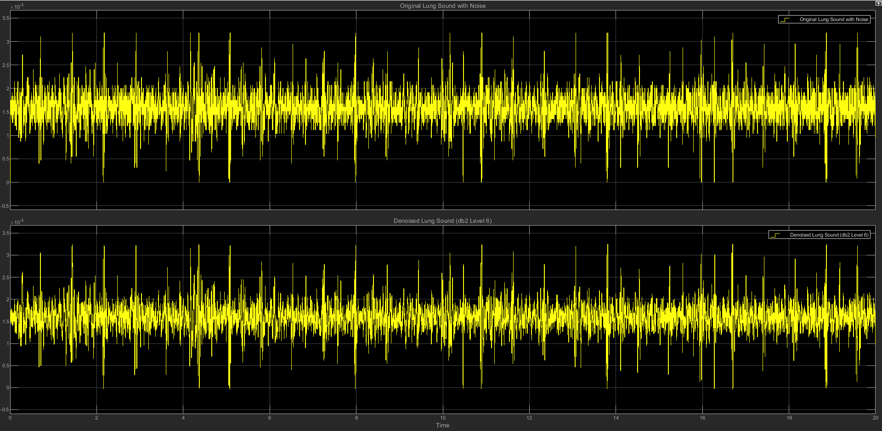

(c) db2 LEVEL 6 STATISTICS RESULT

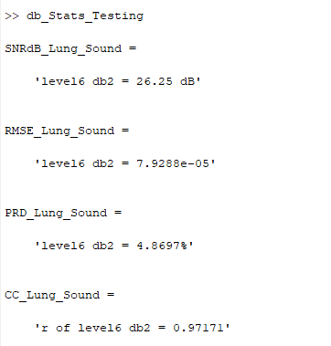

(d) db2 LEVEL 6 SCATTER PLOT RESULT

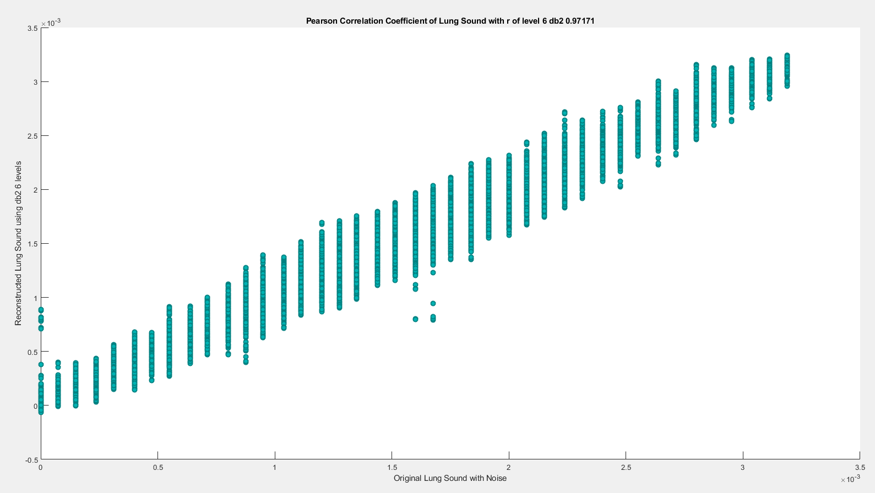

**(6) db2 LEVEL 7**

(a) db2 LEVEL 7 ARCHITECTURE

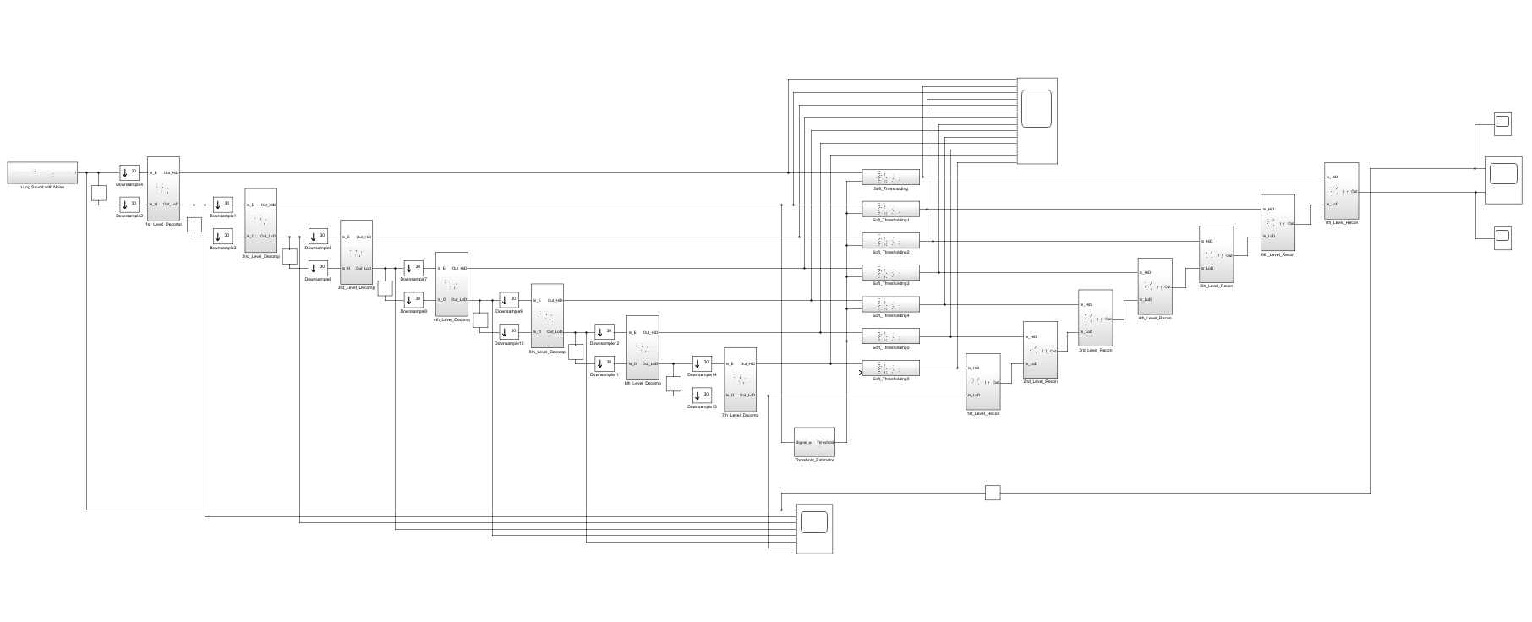

(b) db2 LEVEL 7 SIMULATION RESULT

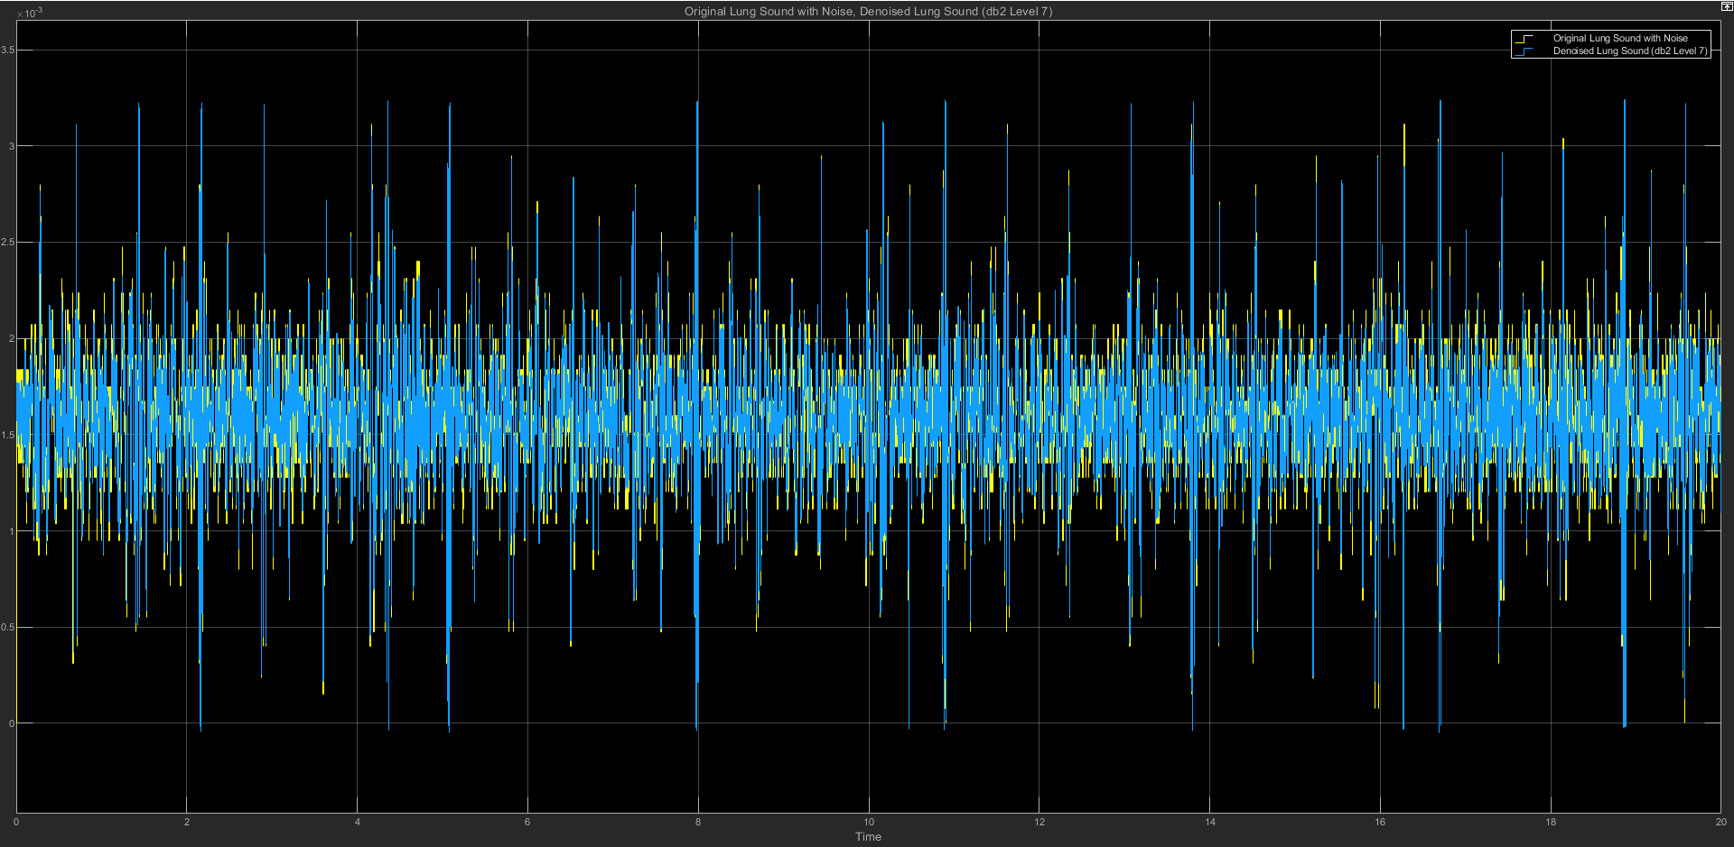

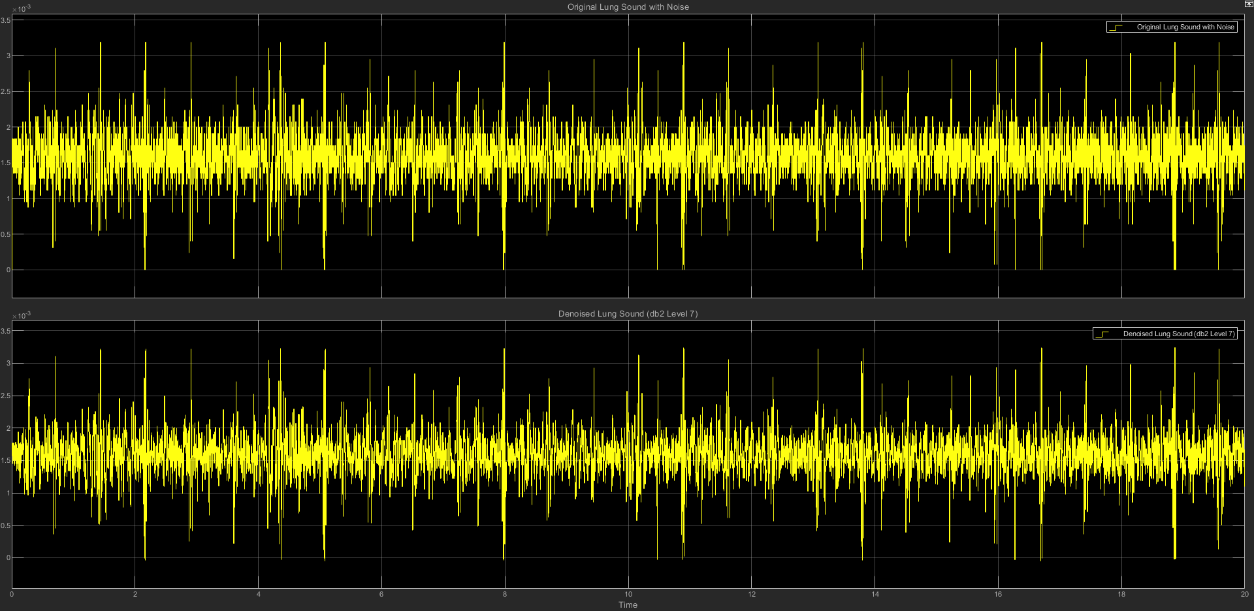

(c) db2 LEVEL 7 STATISTICS RESULT

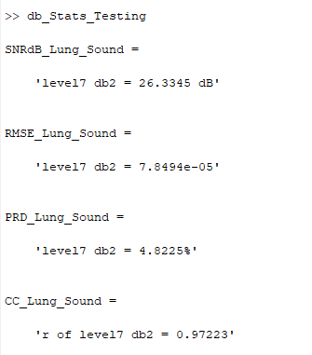

(d) db2 LEVEL 7 SCATTER PLOT RESULT

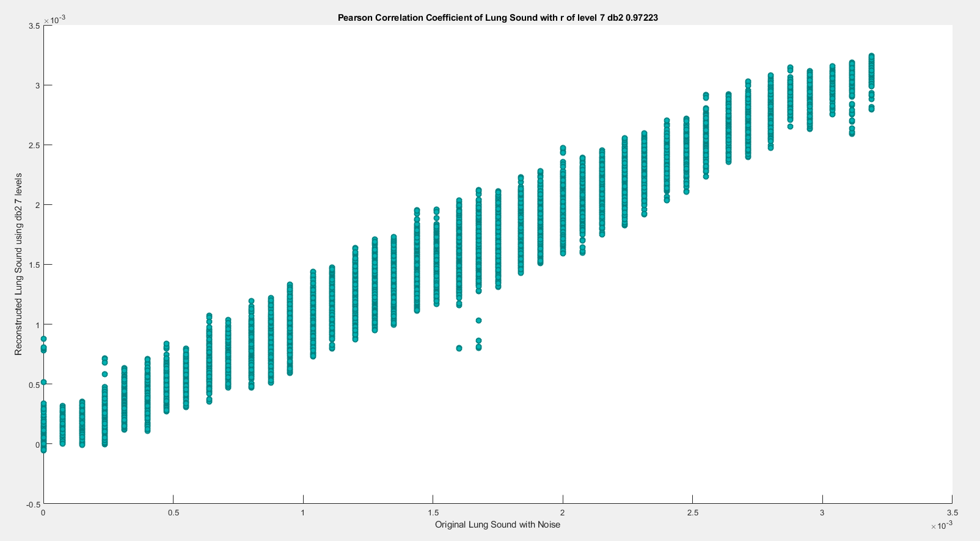

==================================================================

**db3**

| **db3** | **SNRdB_Lung**  **_Sound** | **RMSE_Lung**  **_Sound** | **PRD_Lung_Sound** | **CC_Lung**  **_Sound** |
| --- | --- | --- | --- | --- |
| Level 2 | 24.1012 dB | 0.00010152 | 6.2365% | 0.95321 |
| Level 3 | 24.3365 dB | 9.8774e-05 | 6.0698% | 0.95568 |
| Level 4 | 24.9978 dB | 9.1577e-05 | 5.6249% | 0.96209 |
| Level 5 | 25.7951 dB | 8.3554e-05 | 5.1315% | 0.96848 |
| Level 6 | 26.1683 dB | 8.002e-05 | 4.9157% | 0.9712 |
| Level 7 | 26.1686 dB | 8.0008e-05 | 4.9156% | 0.97115 |

**(1) db3 LEVEL 2**

(a) db3 LEVEL 2 ARCHITECTURE

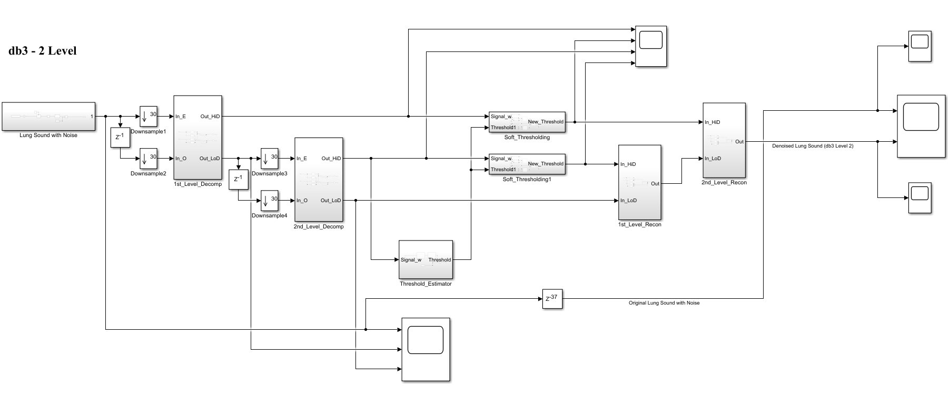

(b) db3 LEVEL 2 SIMULATION RESULT

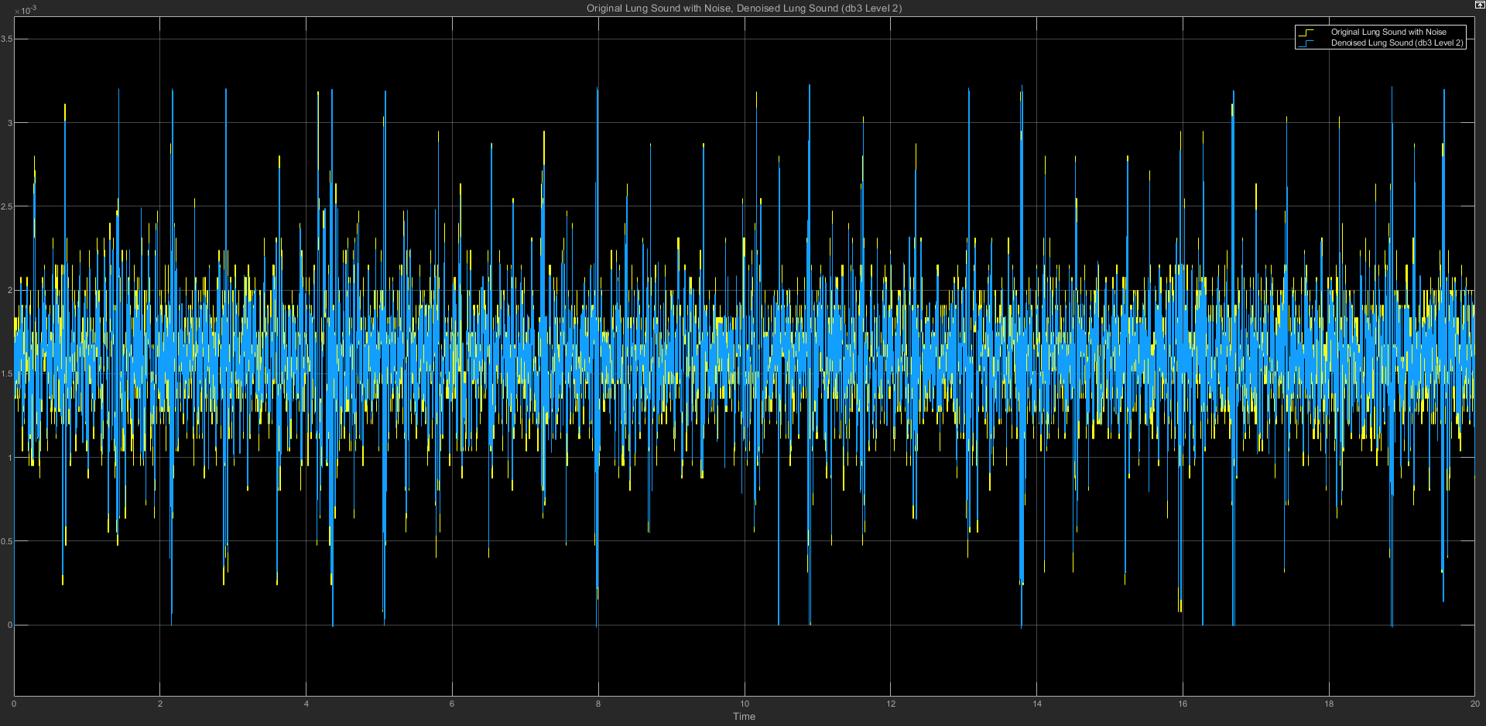

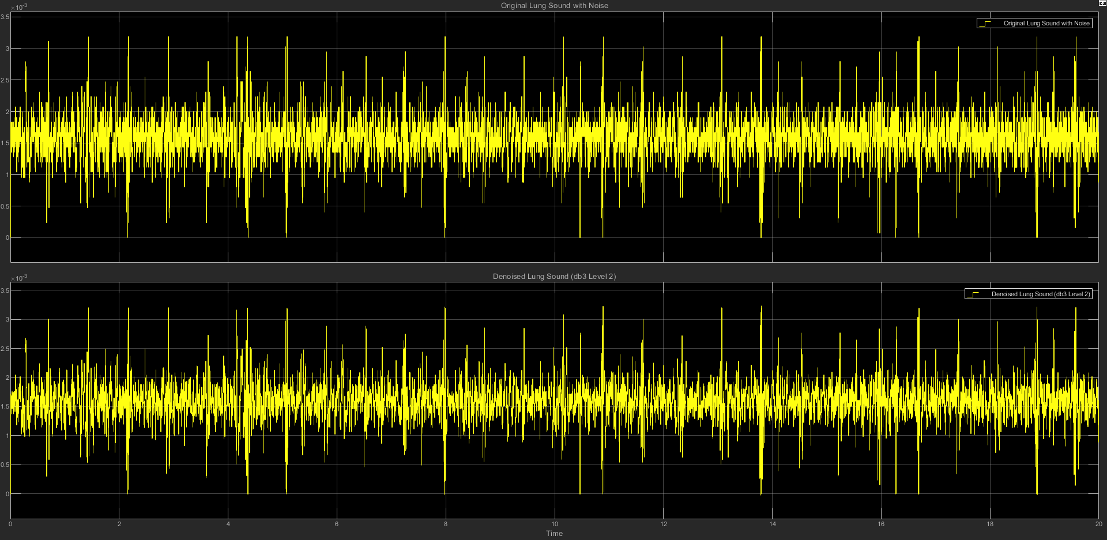

(c) db3 LEVEL 2 STATISTICS RESULT

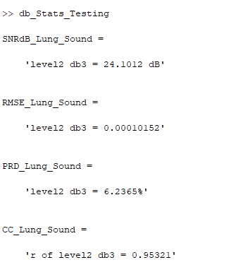

(d) db3 LEVEL 2 SCATTER PLOT RESULT

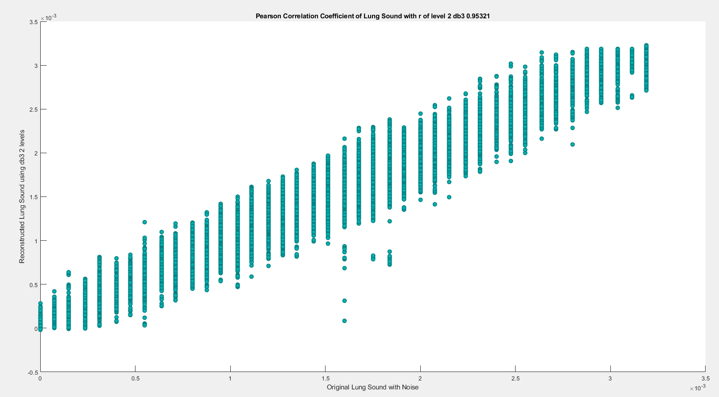

**(2) db3 LEVEL 3**

(a) db3 LEVEL 3 ARCHITECTURE

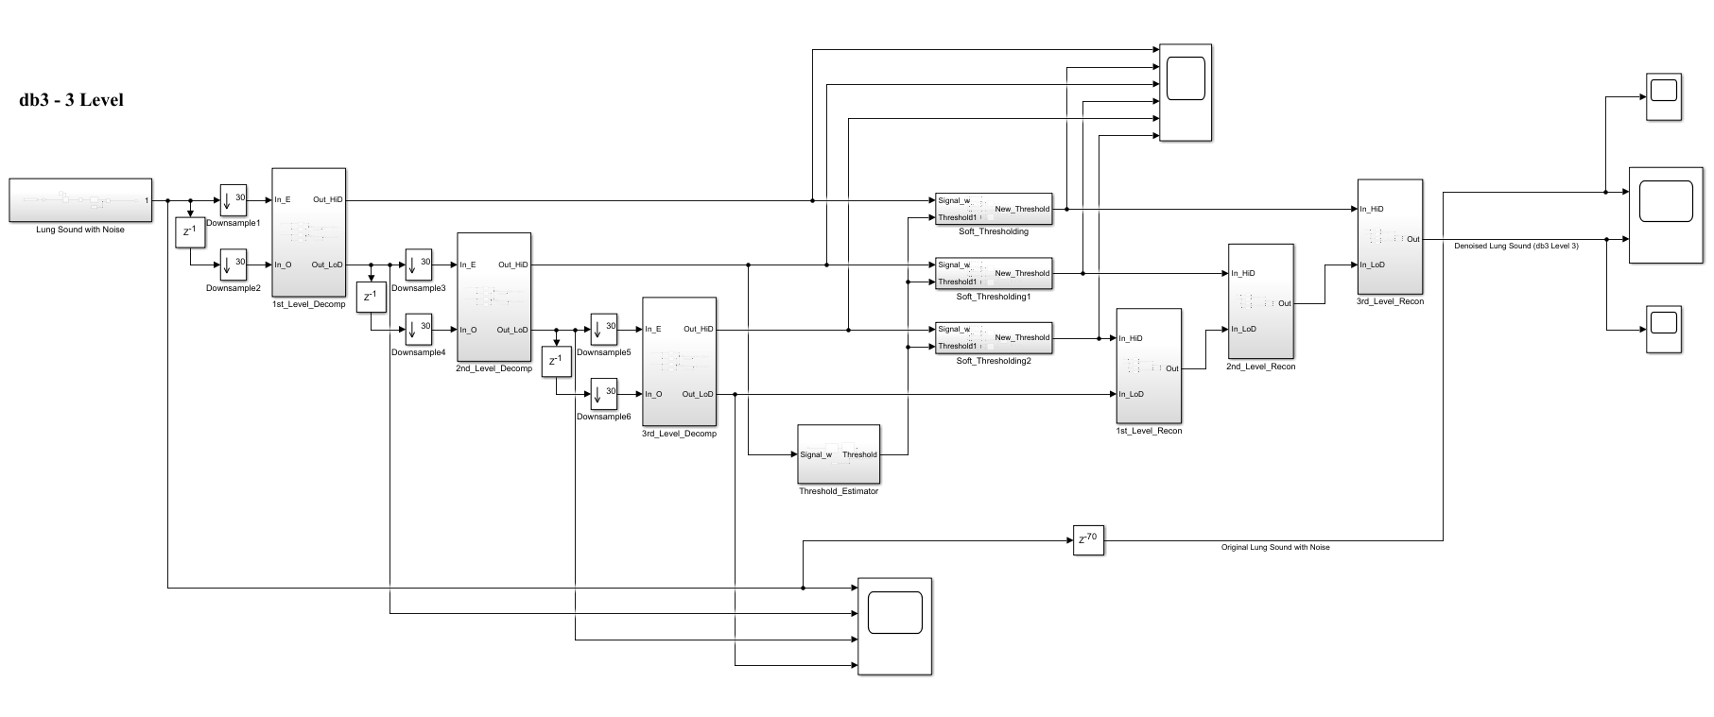

(b) db3 LEVEL 3 SIMULATION RESULT

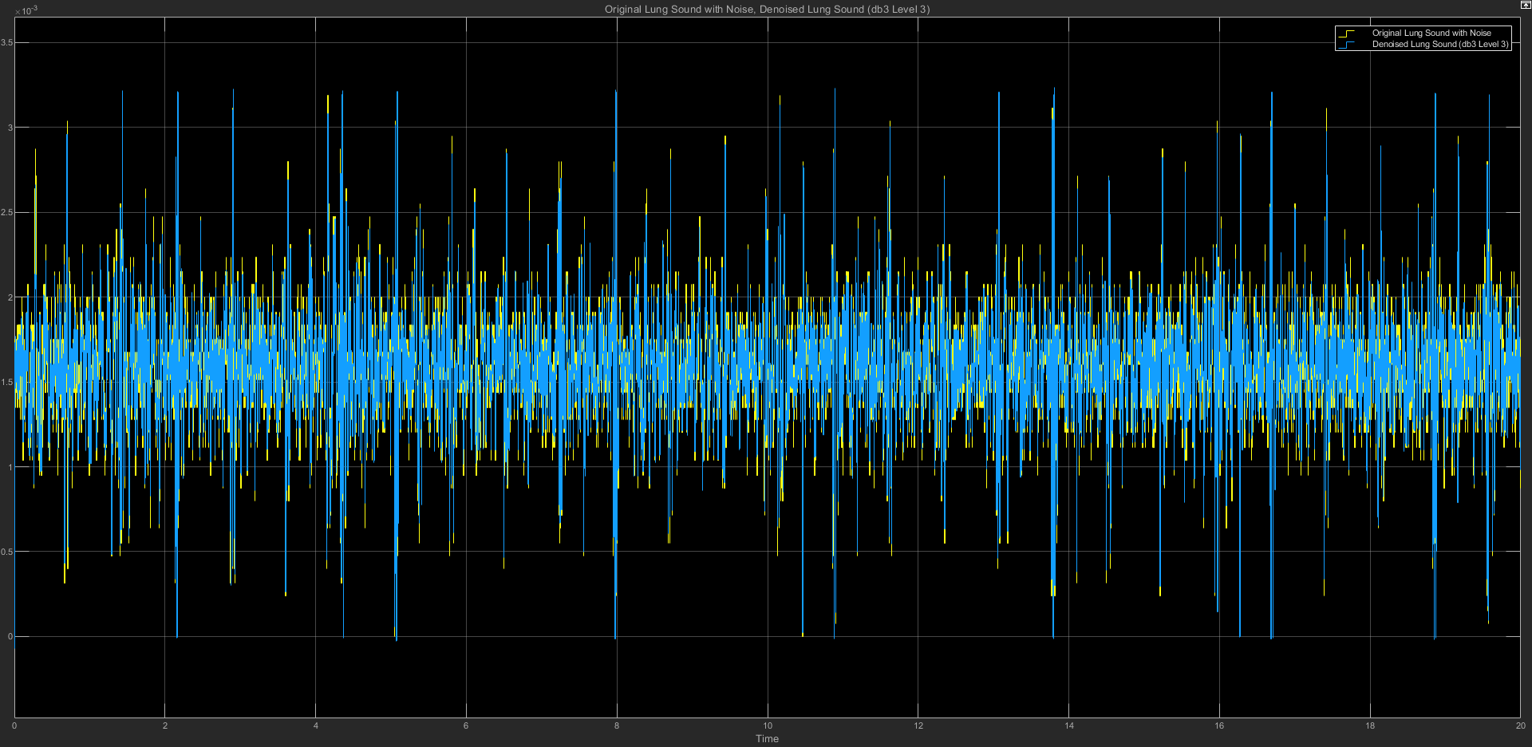

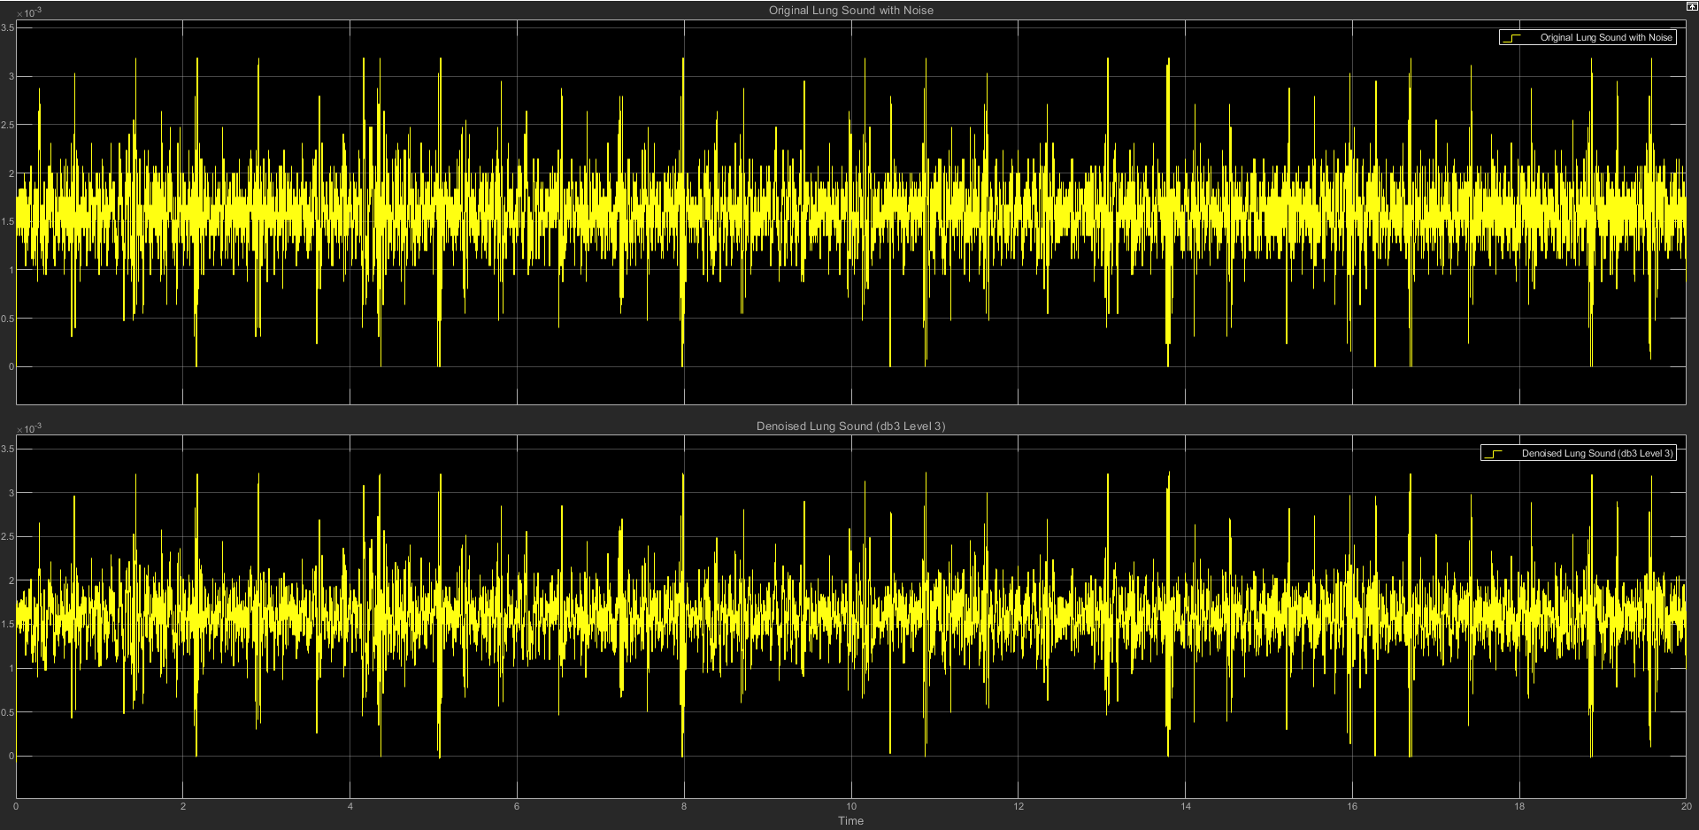

(c) db3 LEVEL 3 STATISTICS RESULT

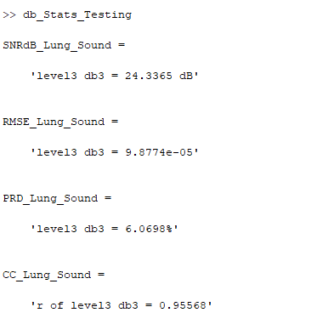

(d) db3 LEVEL 3 SCATTER PLOT RESULT

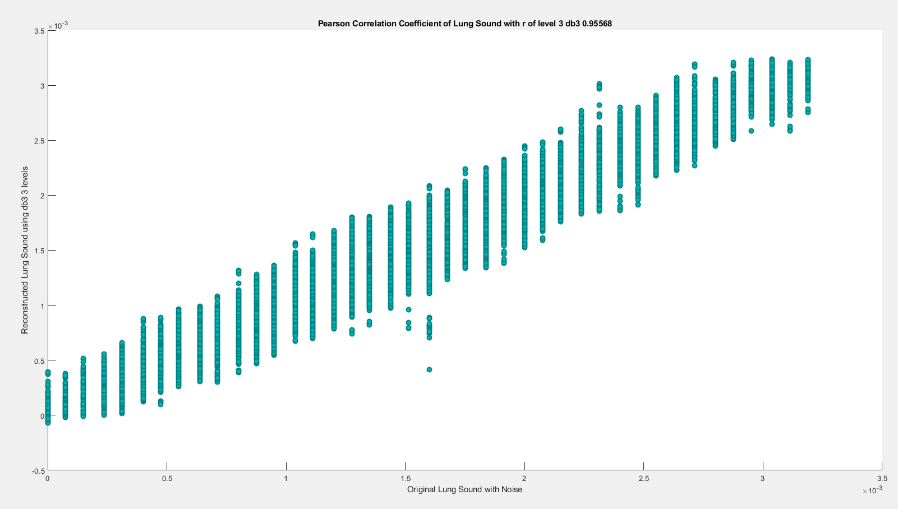

**(3) db3 LEVEL 4**

(a) db3 LEVEL 4 ARCHITECTURE

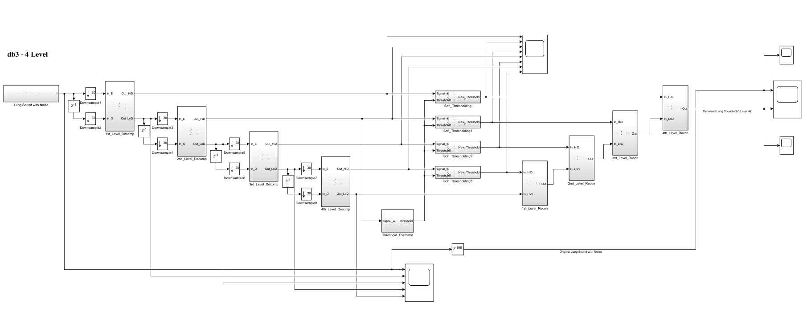

(b) db3 LEVEL 4 SIMULATION RESULT

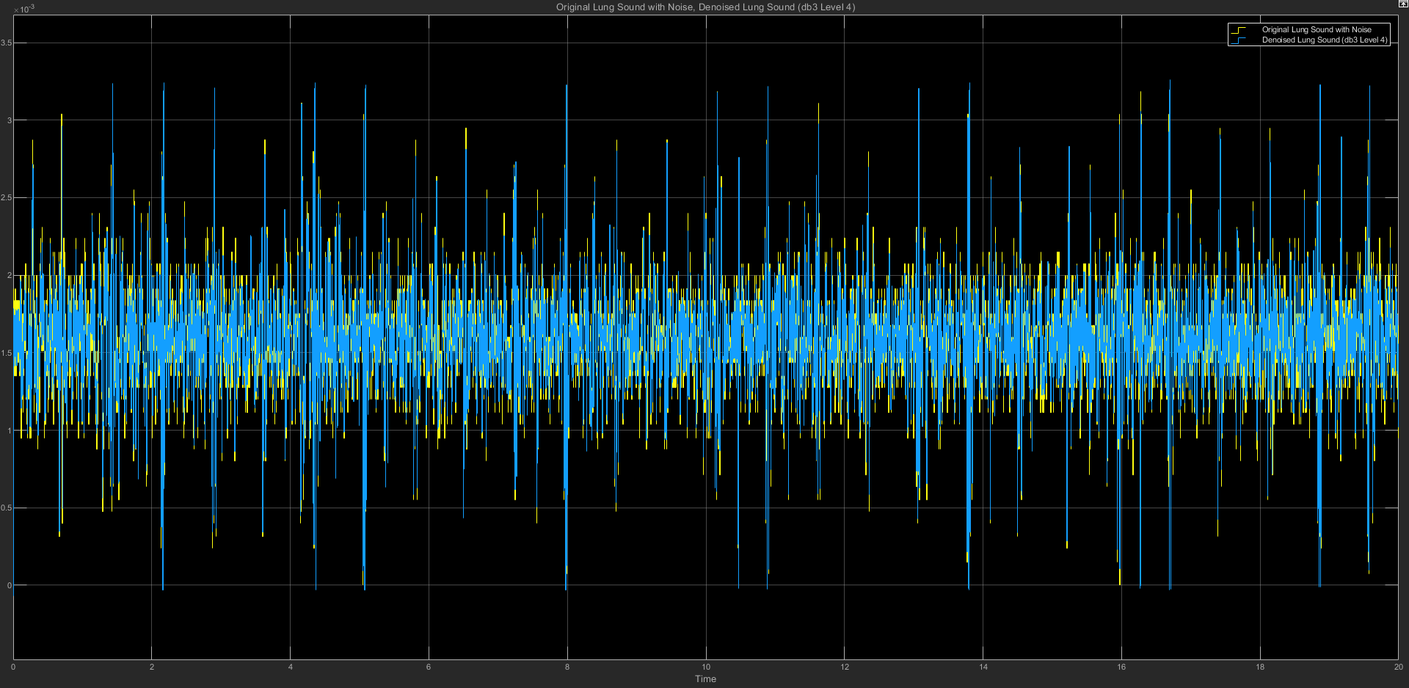

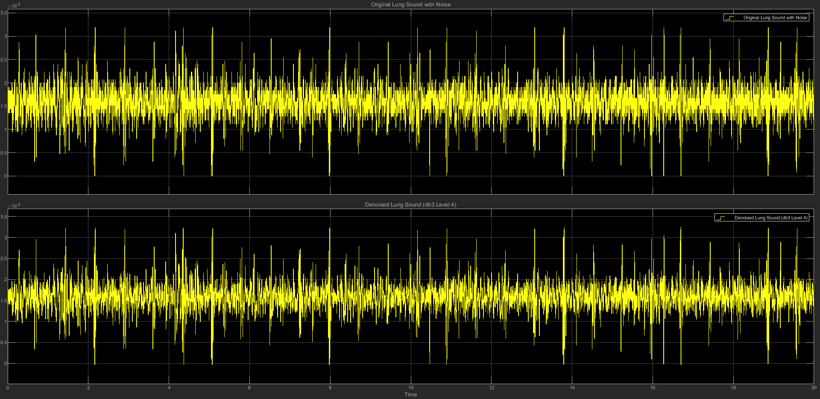

(c) db3 LEVEL 4 STATISTICS RESULT

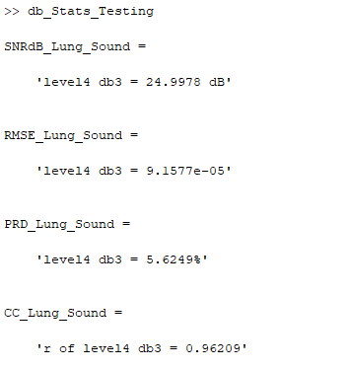

(d) db3 LEVEL 4 SCATTER PLOT RESULT

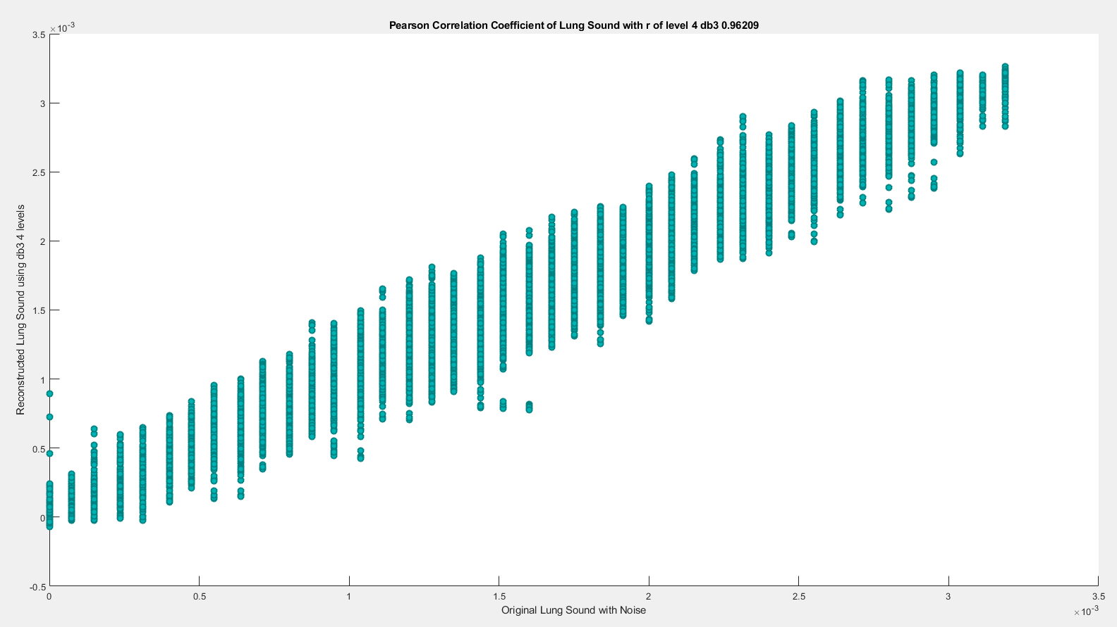

**(4) db3 LEVEL 5**

(a) db3 LEVEL 5 ARCHITECTURE

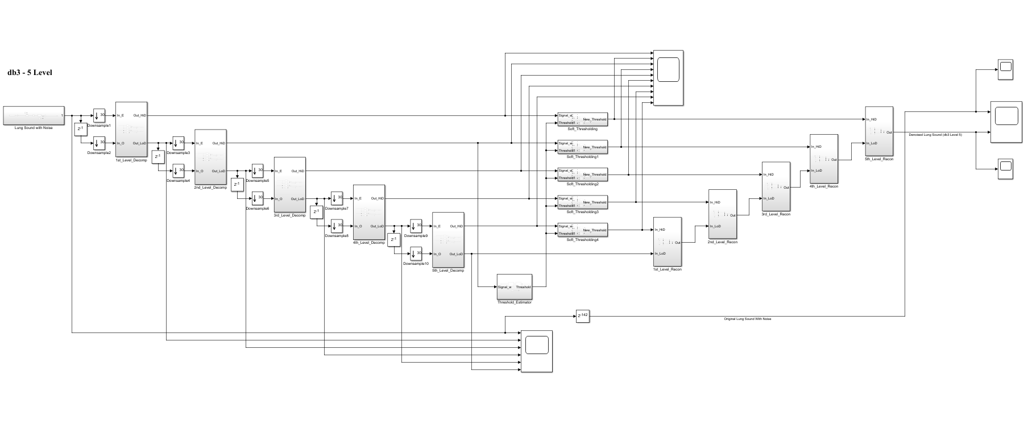

(b) db3 LEVEL 5 SIMULATION RESULT

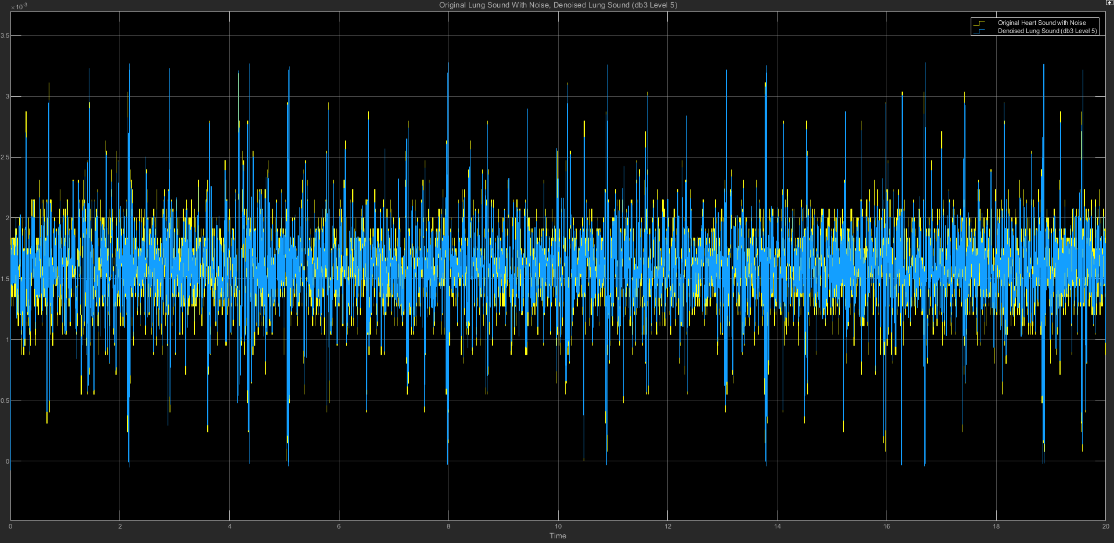

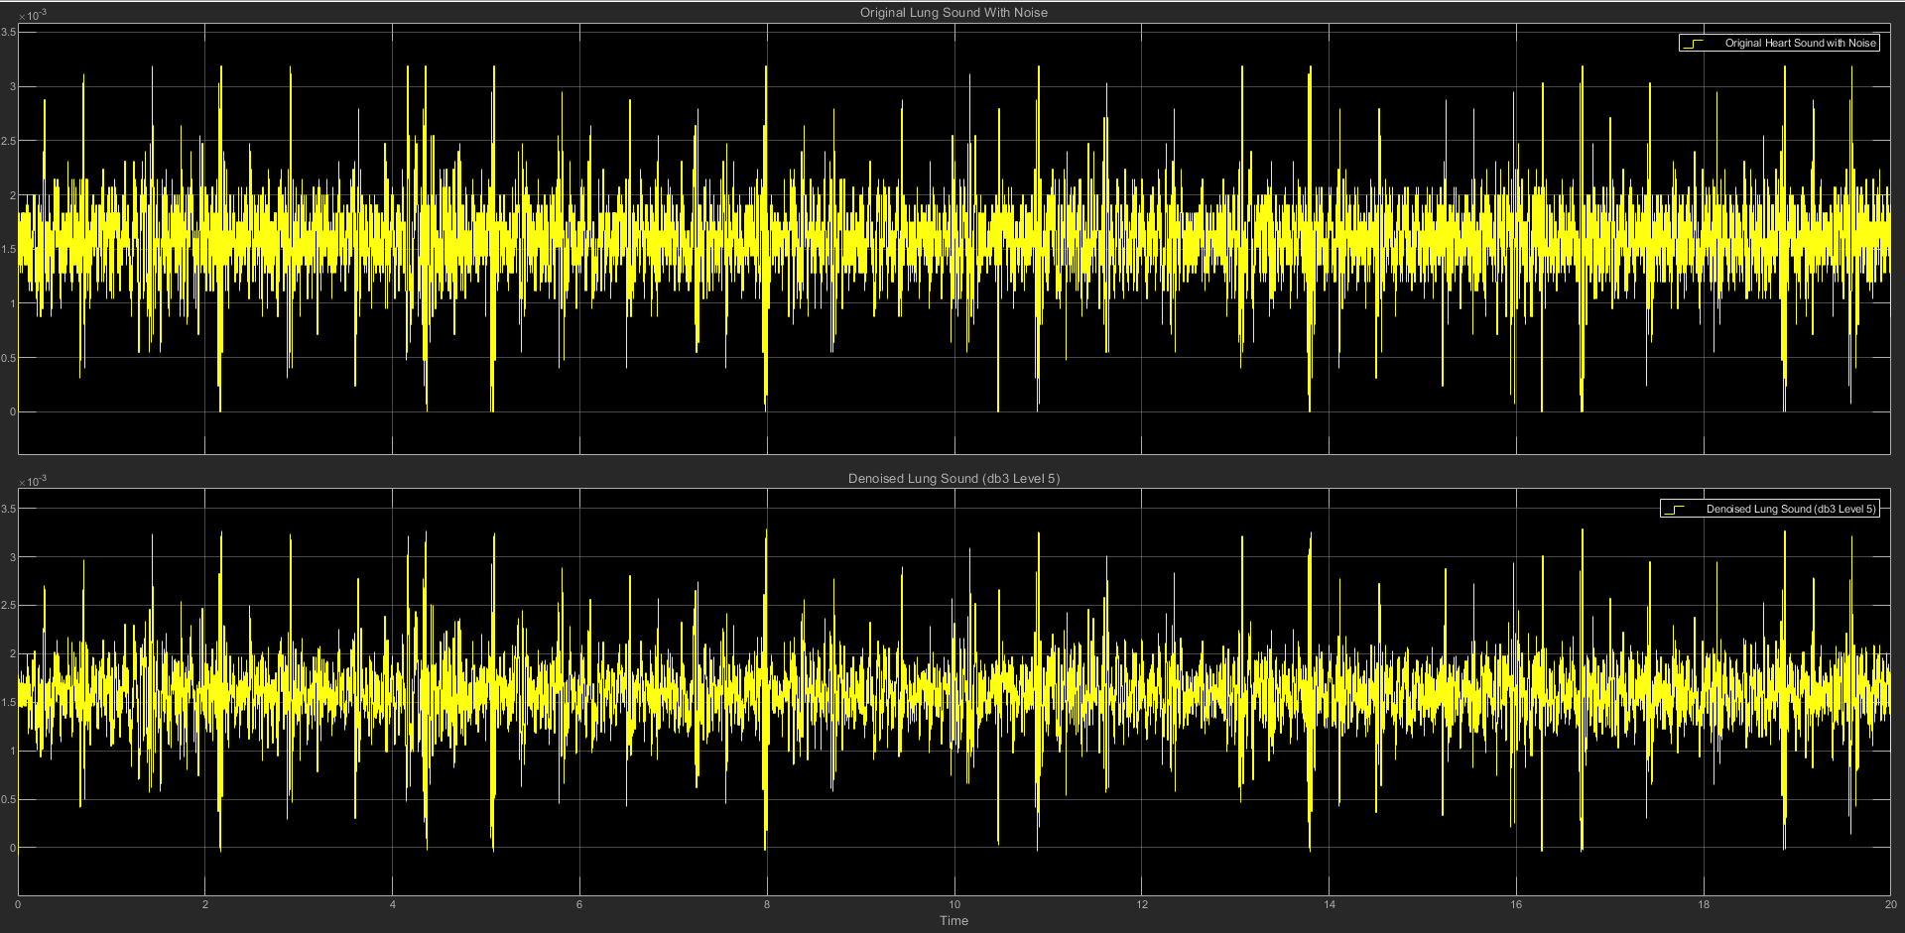

(c) db3 LEVEL 5 STATISTICS RESULT

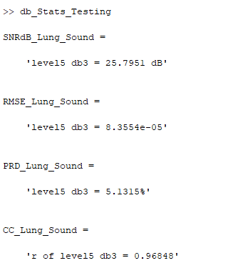

(d) db3 LEVEL 5 SCATTER PLOT RESULT

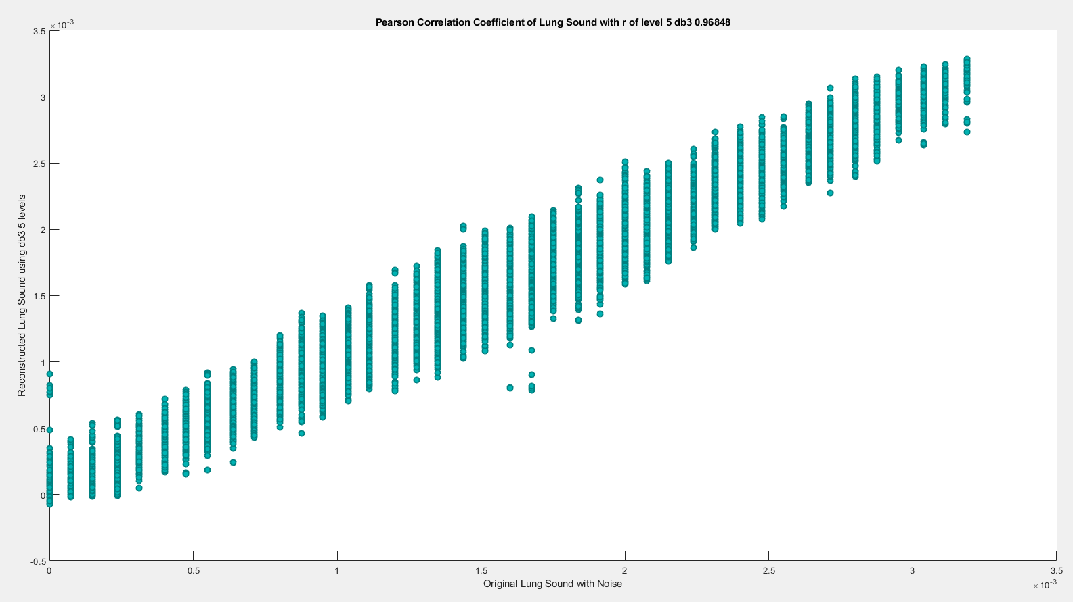

**(5) db3 LEVEL 6**

(a) db3 LEVEL 6 ARCHITECTURE

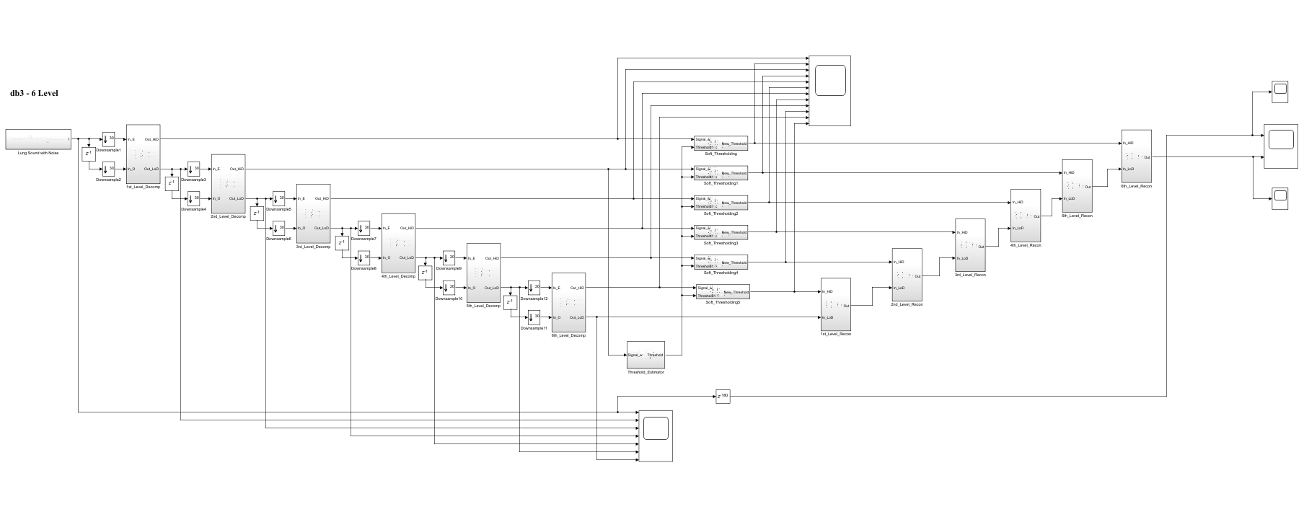

(b) db3 LEVEL 6 SIMULATION RESULT

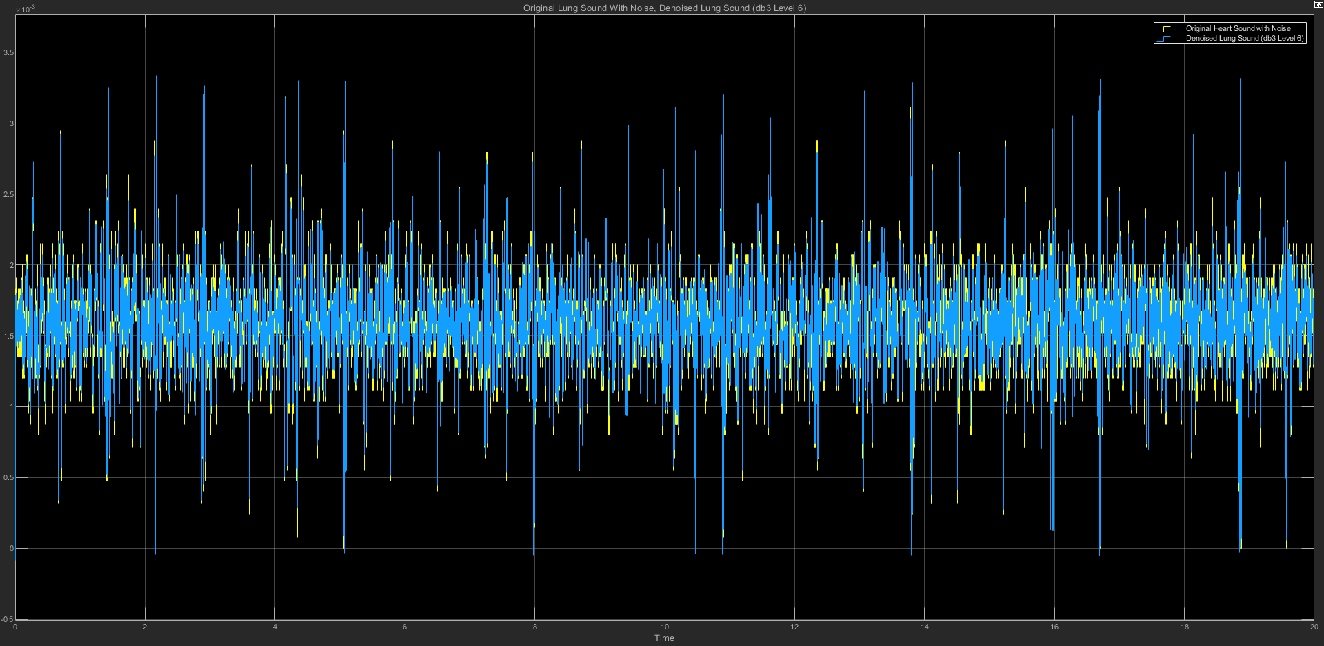

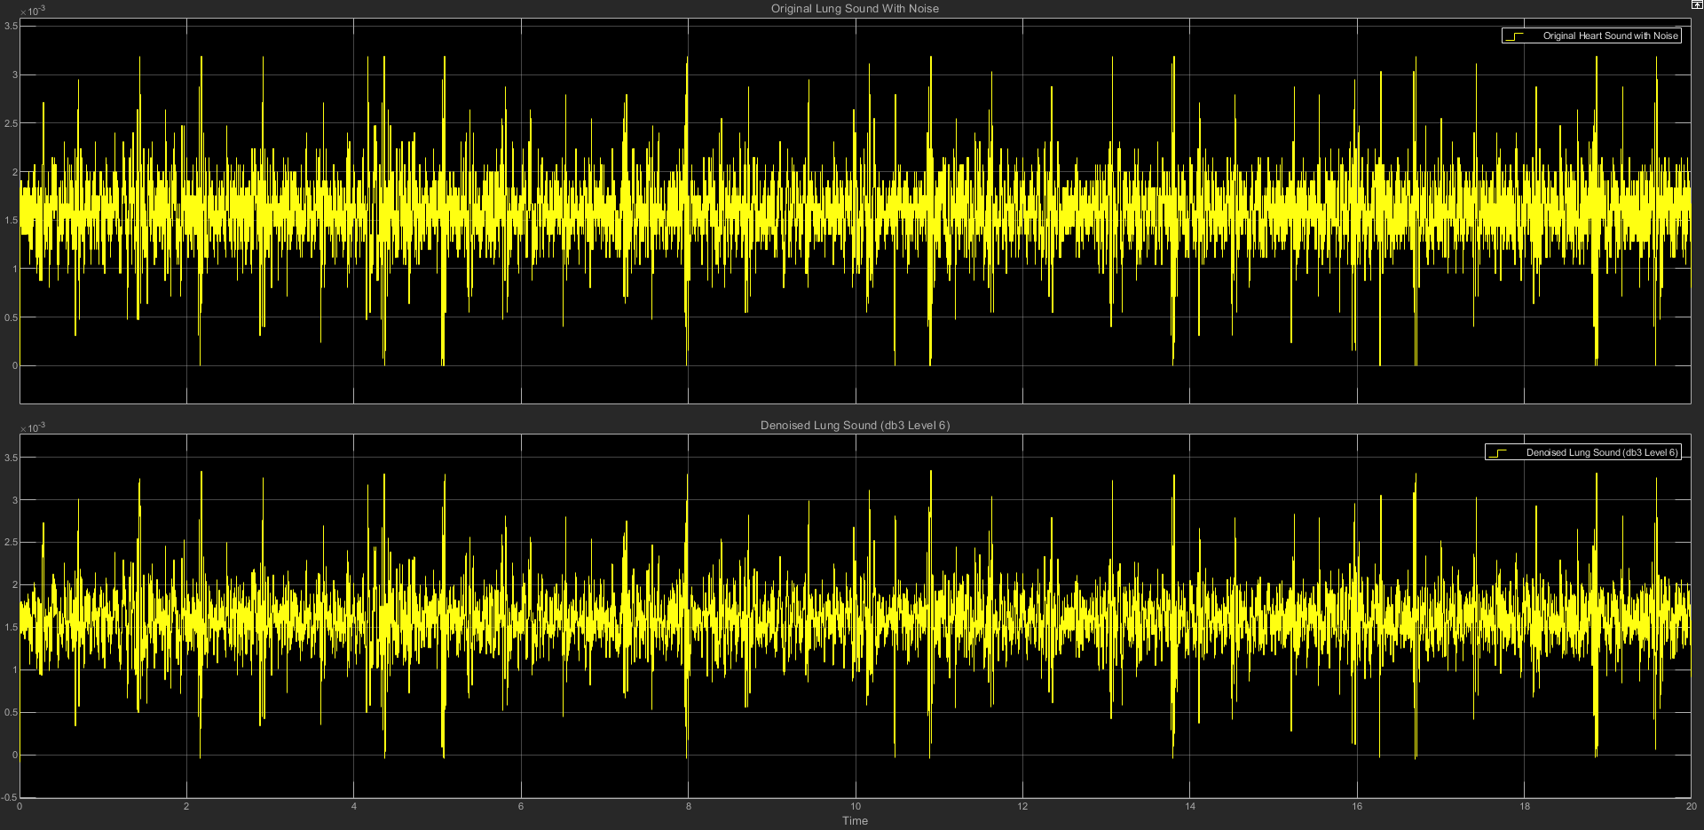

(c) db3 LEVEL 6 STATISTICS RESULT

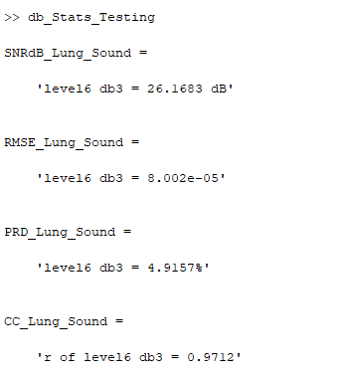

(d) db3 LEVEL 6 SCATTER PLOT RESULT

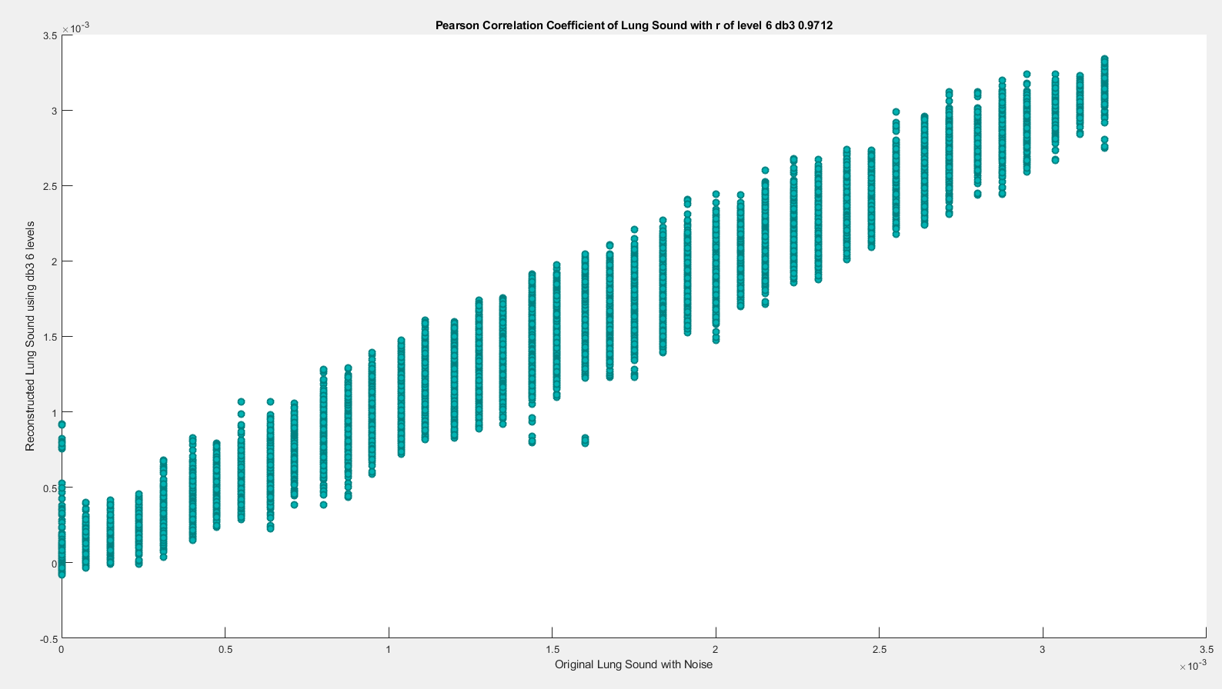

**(6) db3 LEVEL 7**

(a) db3 LEVEL 7 ARCHITECTURE

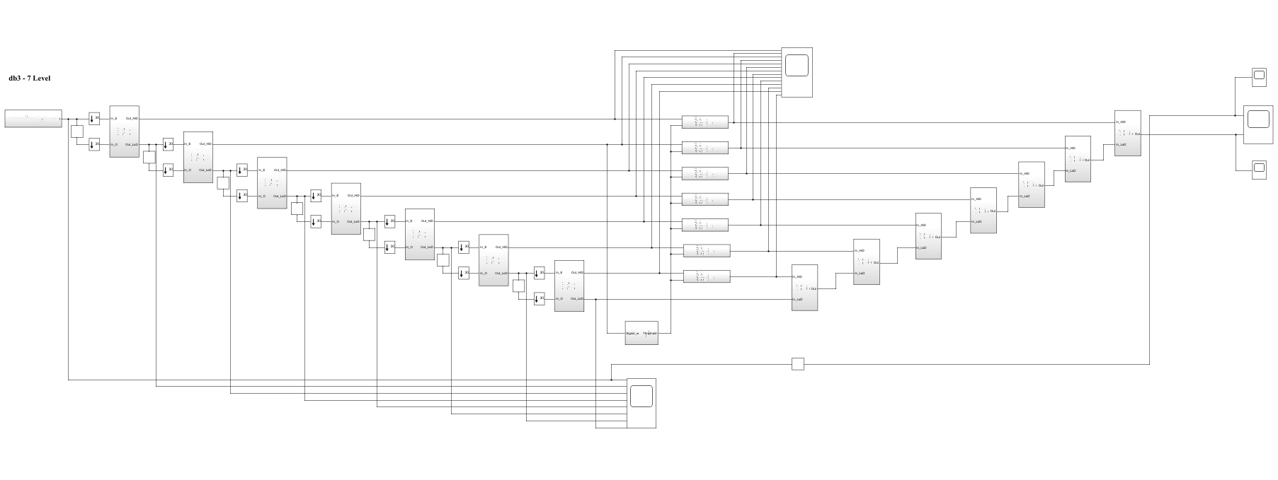

(b) db3 LEVEL 7 SIMULATION RESULT

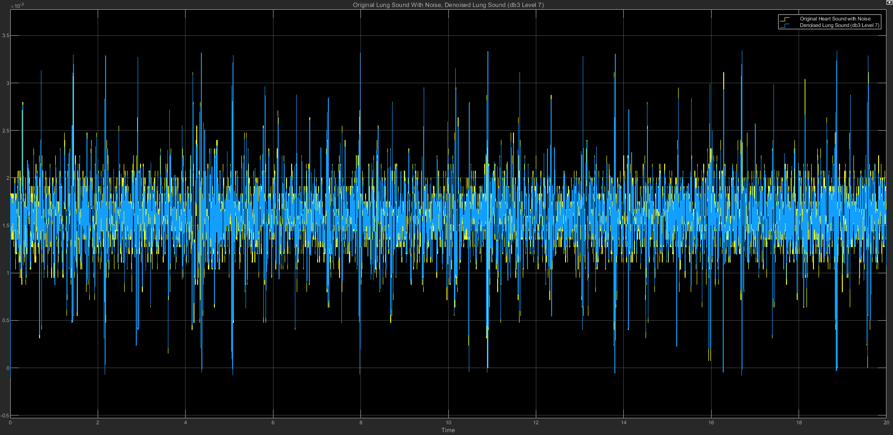

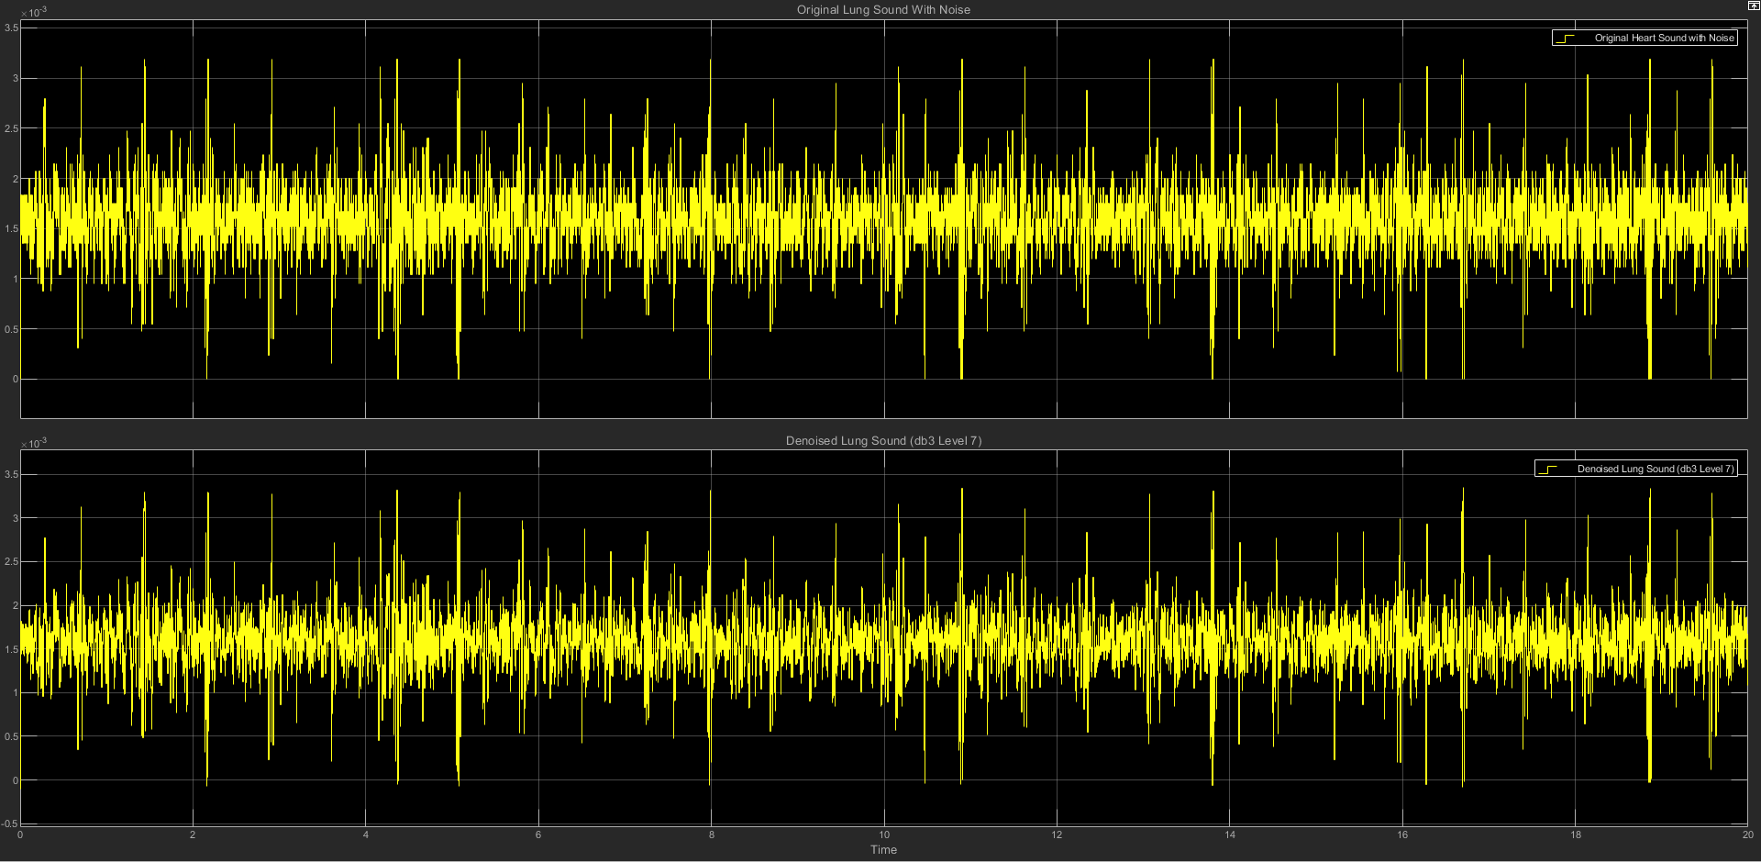

(c) db3 LEVEL 7 STATISTICS RESULT

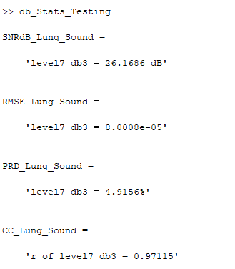

(d) db3 LEVEL 7 SCATTER PLOT RESULT

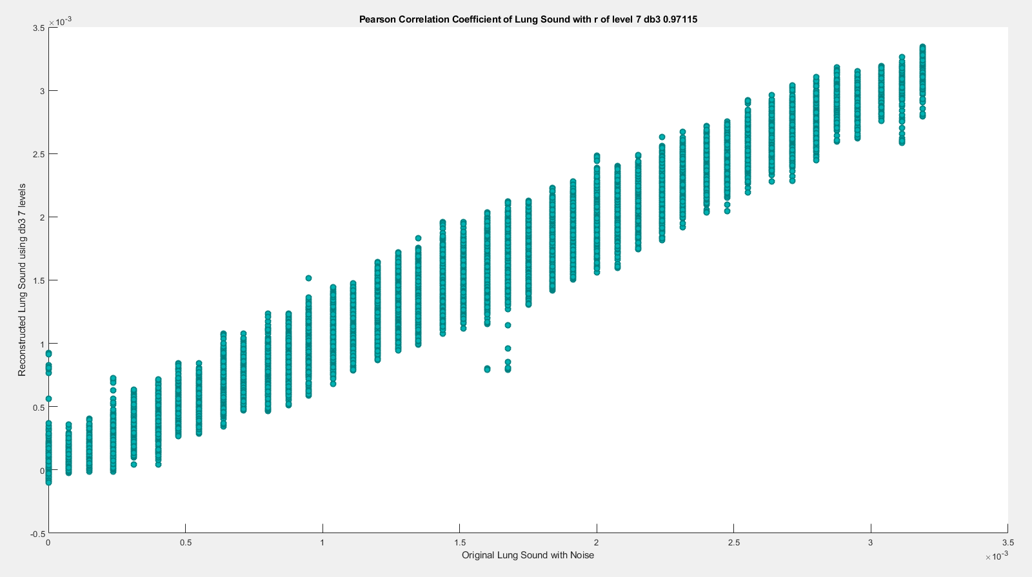

========================================================================

**db4**

| **db4** | **SNRdB_Lung**  **_Sound** | **RMSE_Lung**  **_Sound** | **PRD_Lung_Sound** | **CC_Lung**  **_Sound** |
| --- | --- | --- | --- | --- |
| Level 2 | 24.0271 dB | 0.00010239 | 6.2899% | 0.95245 |
| Level 3 | 24.2565 dB | 9.9729e-05 | 6.126% | 0.95482 |
| Level 4 | 24.5486 dB | 9.6427e-05 | 5.9234% | 0.95795 |
| Level 5 | 24.9286 dB | 9.2318e-05 | 5.6699% | 0.96148 |
| Level 6 | 25.4563 dB | 8.6852e-05 | 5.3356% | 0.9659 |
| Level 7 | 26.1023 dB | 8.0626e-05 | 4.9532% | 0.97071 |

**(1) db4 LEVEL 2**

(a) db4 LEVEL 2 ARCHITECTURE

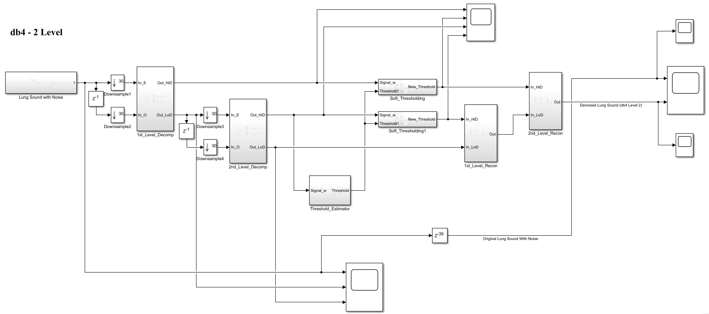

(b) db4 LEVEL 2 SIMULATION RESULT

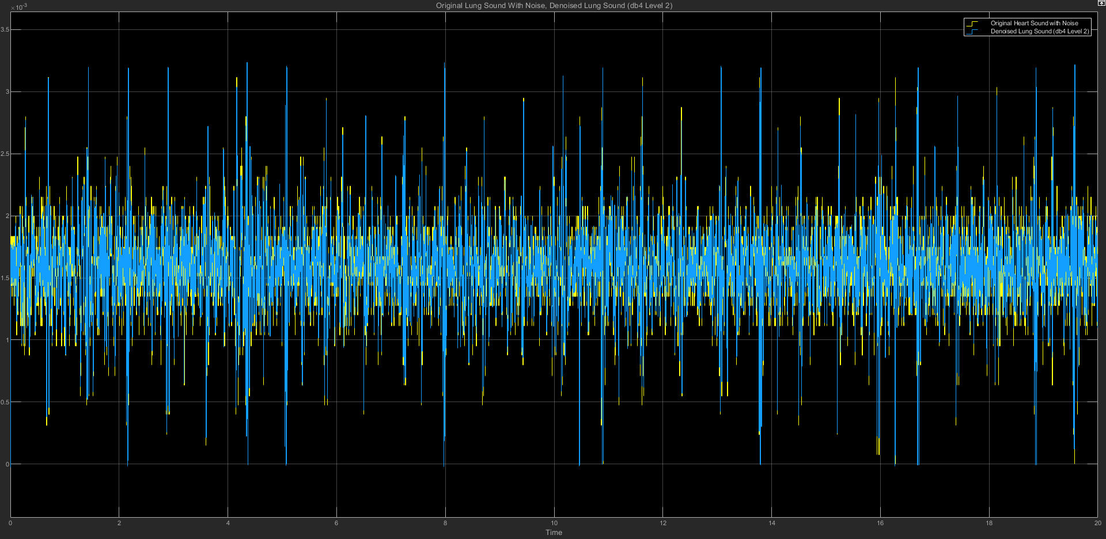

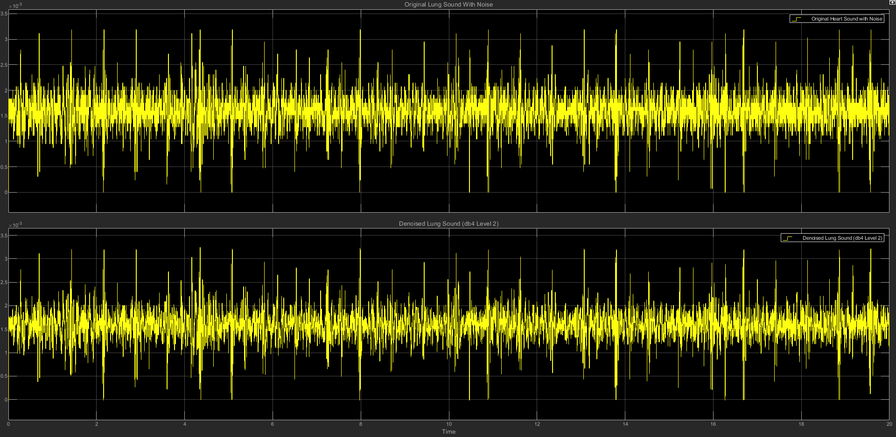

(c) db4 LEVEL 2 STATISTICS RESULT

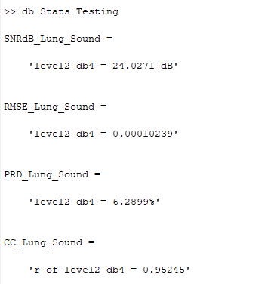

(d) db4 LEVEL 2 SCATTER PLOT RESULT

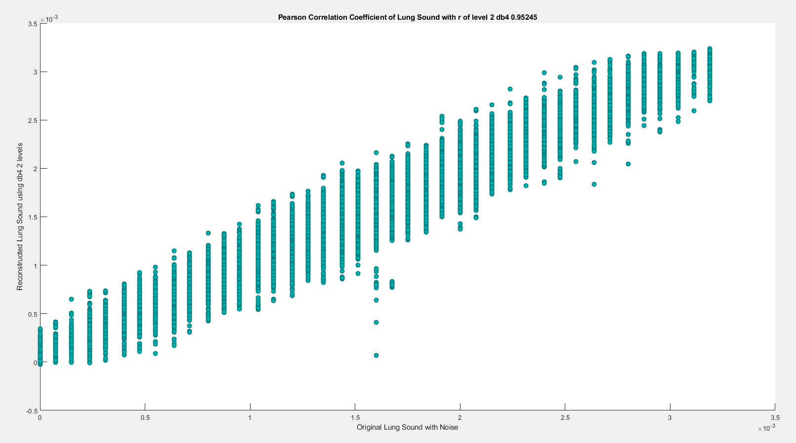

**(2) db4 LEVEL 3**

(a) db4 LEVEL 3 ARCHITECTURE

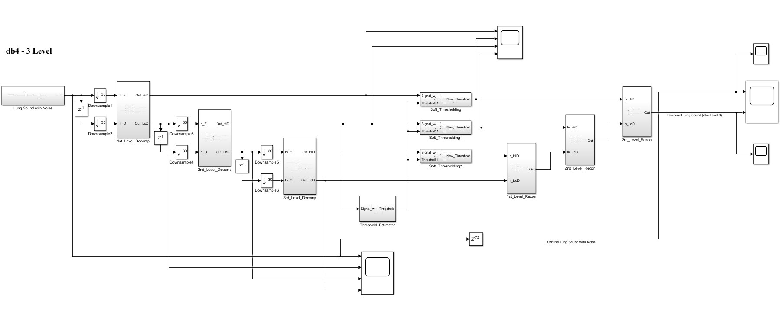

(b) db4 LEVEL 3 SIMULATION RESULT

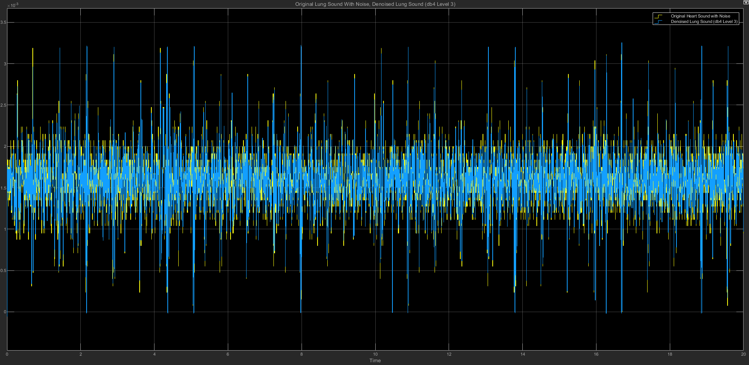

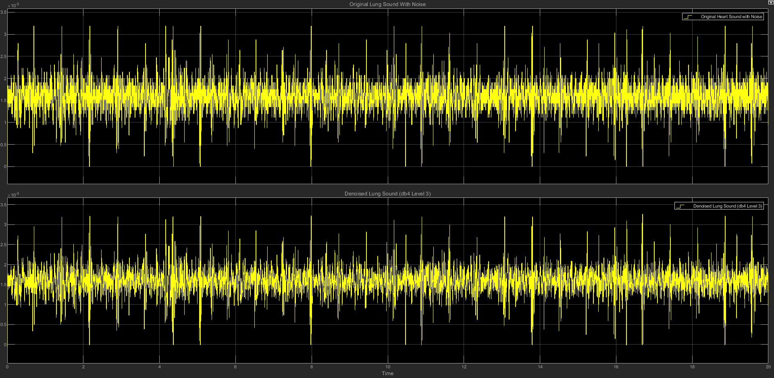

(c) db4 LEVEL 3 STATISTICS RESULT

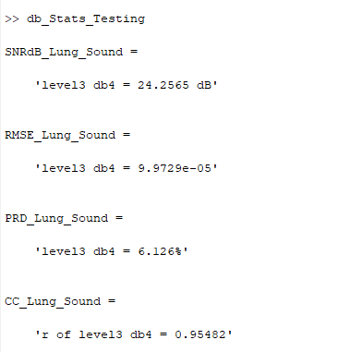

(d) db4 LEVEL 3 SCATTER PLOT RESULT

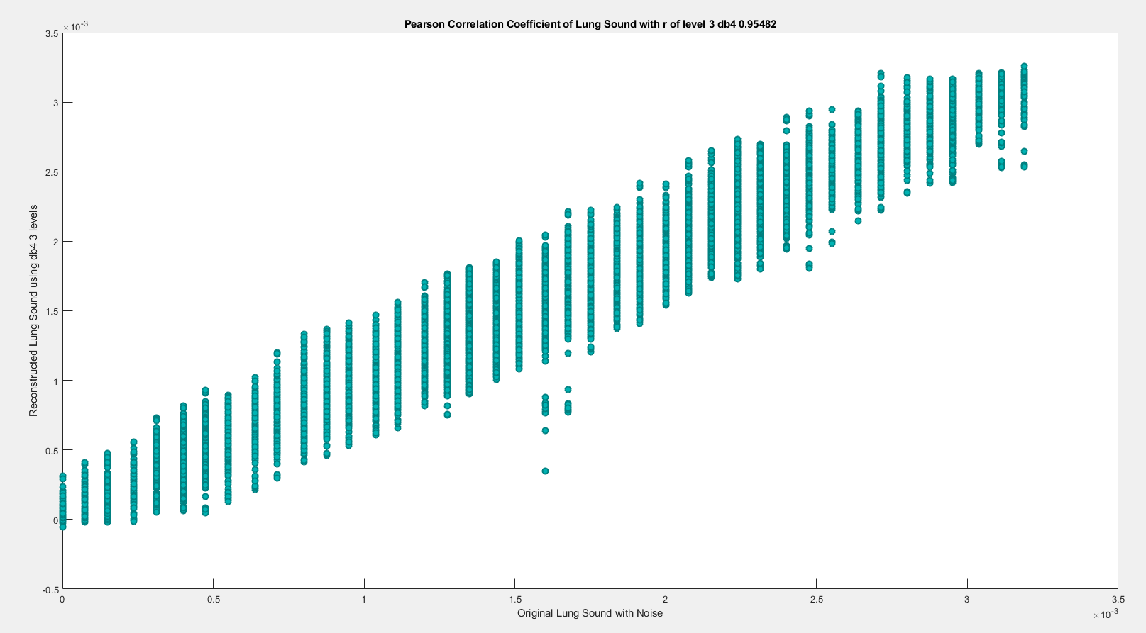

**(3) db4 LEVEL 4**

(a) db4 LEVEL 4 ARCHITECTURE

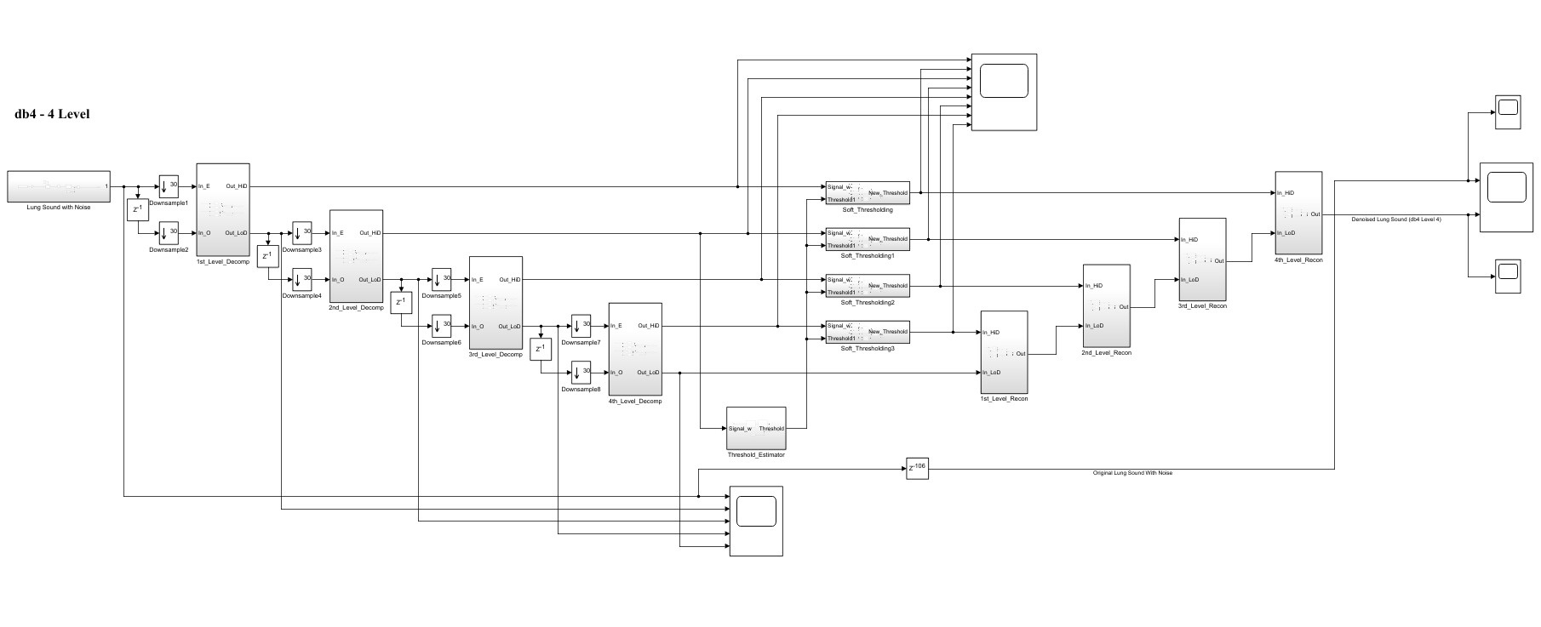

(b) db4 LEVEL 4 SIMULATION RESULT

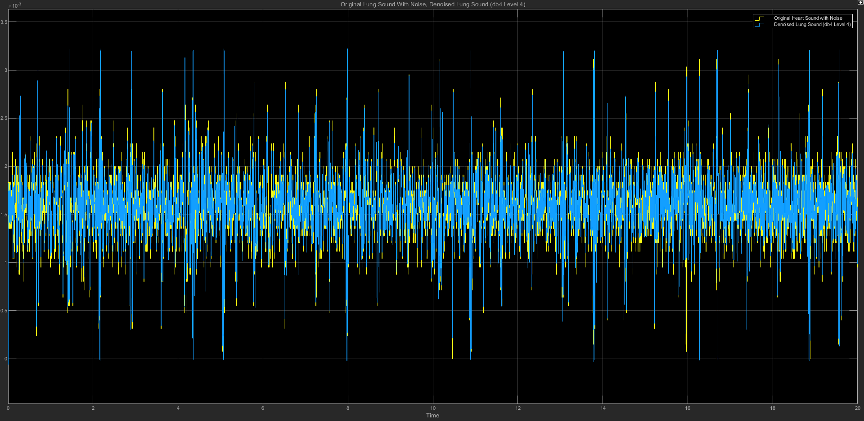

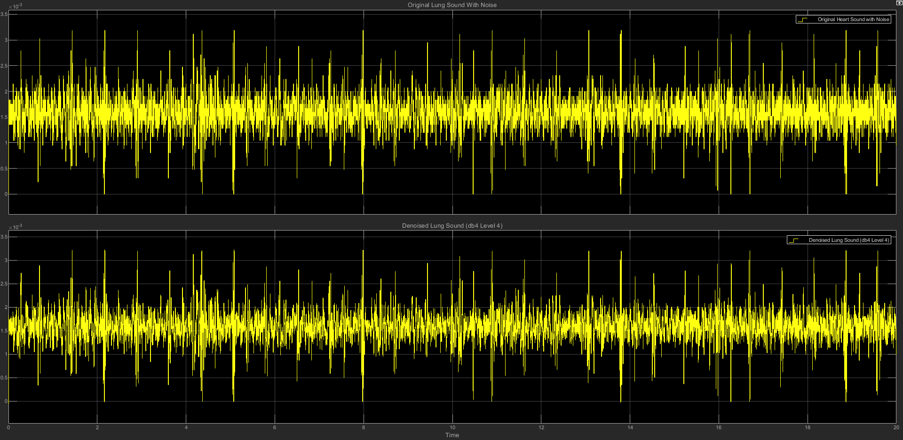

(c) db4 LEVEL 4 STATISTICS RESULT

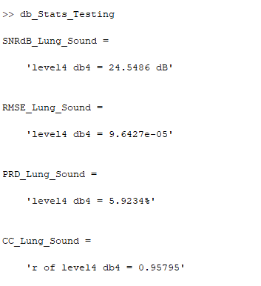

(d) db4 LEVEL 4 SCATTER PLOT RESULT

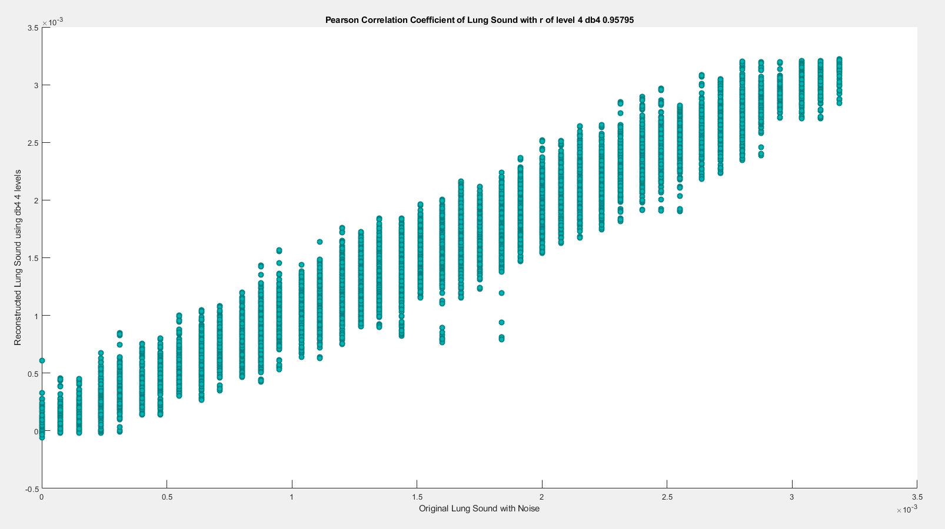

**(4) db4 LEVEL 5**

(a) db4 LEVEL 5 ARCHITECTURE

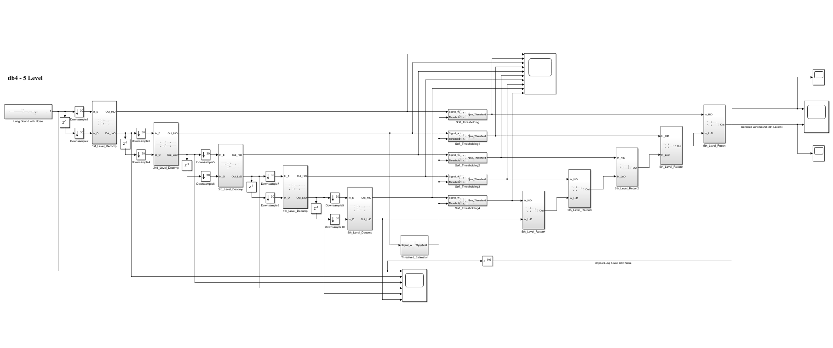

(b) db4 LEVEL 5 SIMULATION RESULT

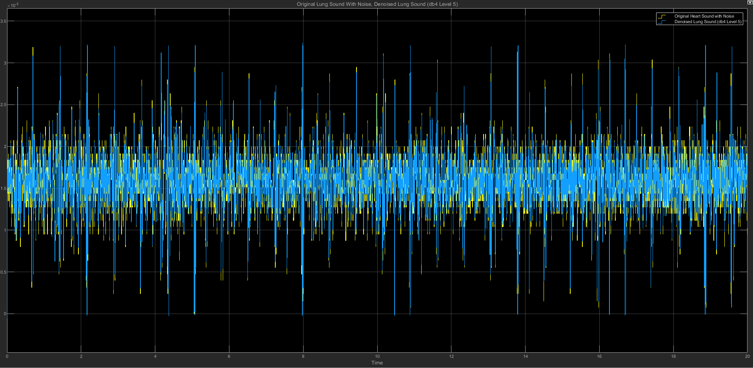

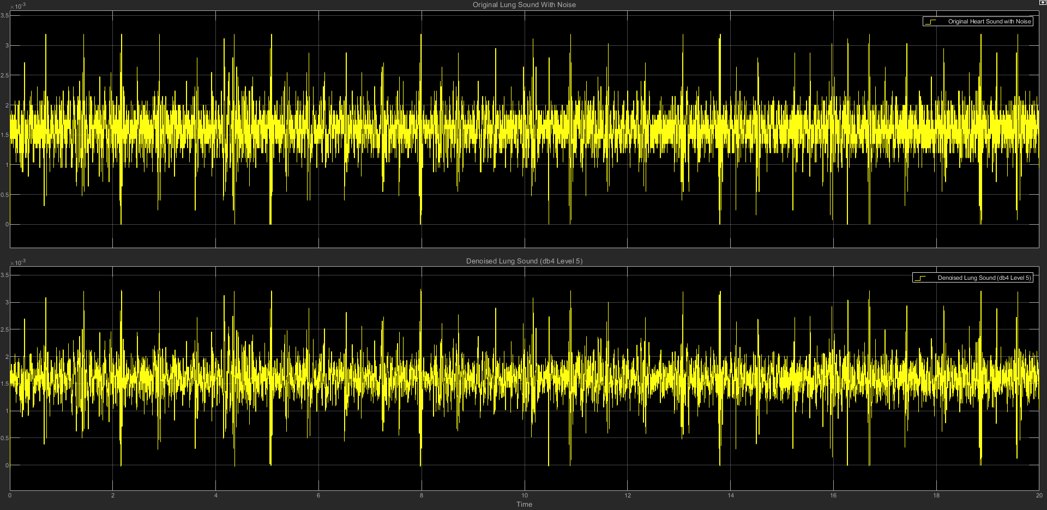

(c) db4 LEVEL 5 STATISTICS RESULT

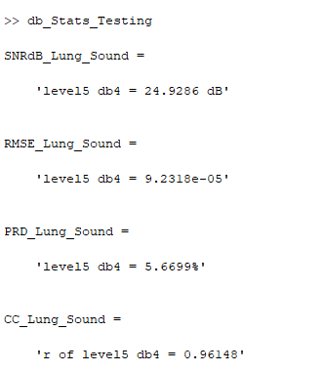

(d) db4 LEVEL 5 SCATTER PLOT RESULT

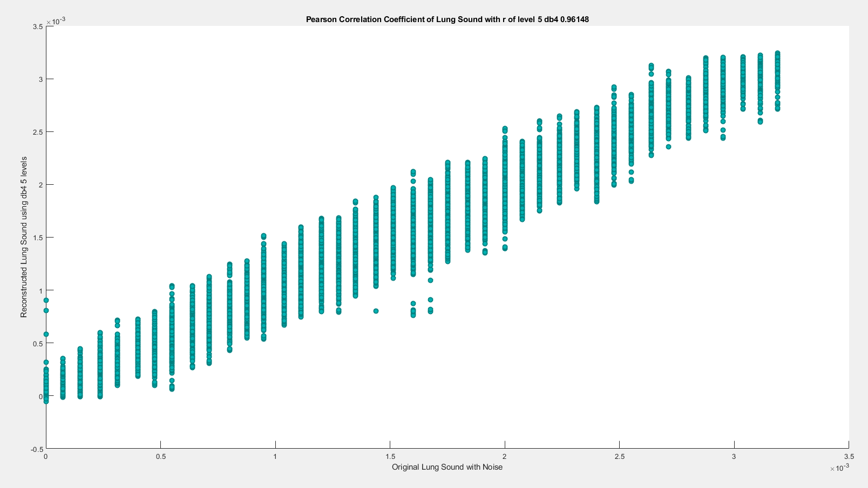

**(5) db4 LEVEL 6**

(a) db4 LEVEL 6 ARCHITECTURE

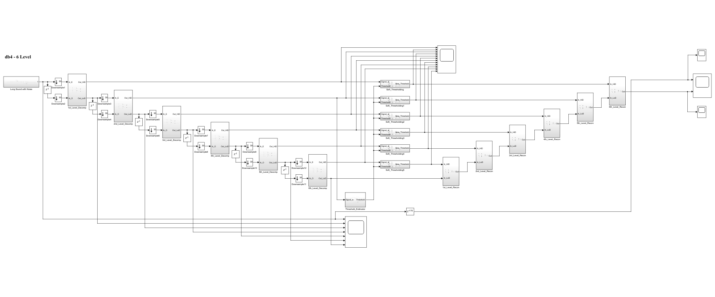

(b) db4 LEVEL 6 SIMULATION RESULT

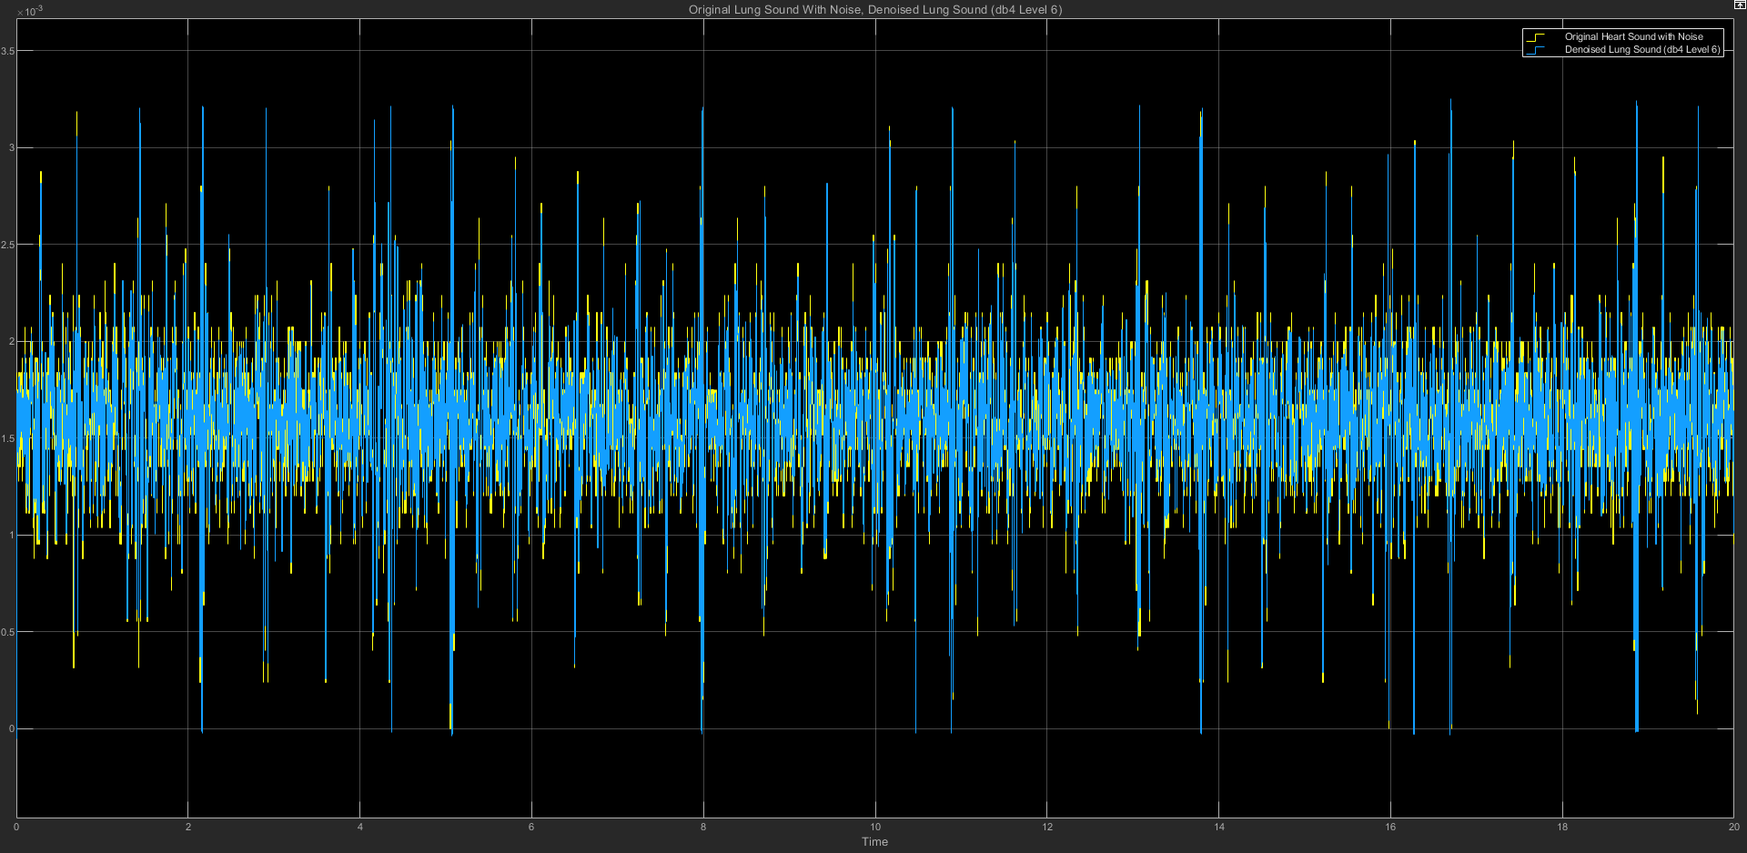

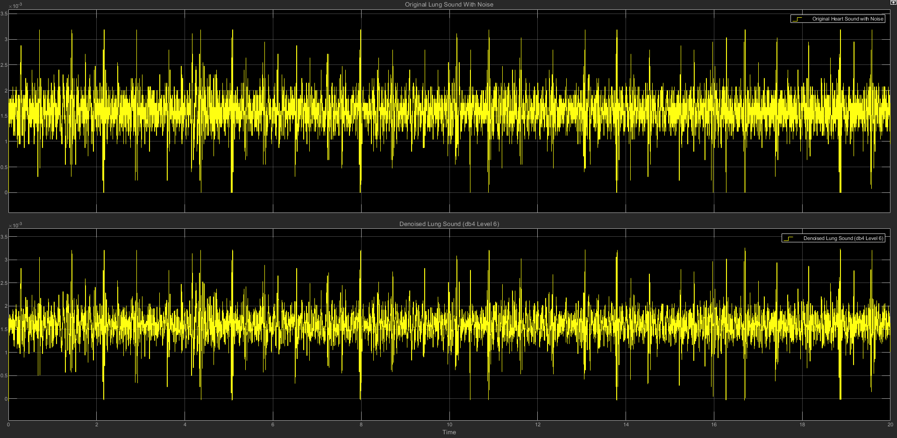

(c) db4 LEVEL 6 STATISTICS RESULT

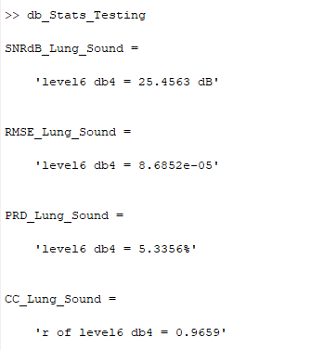

(d) db4 LEVEL 6 SCATTER PLOT RESULT

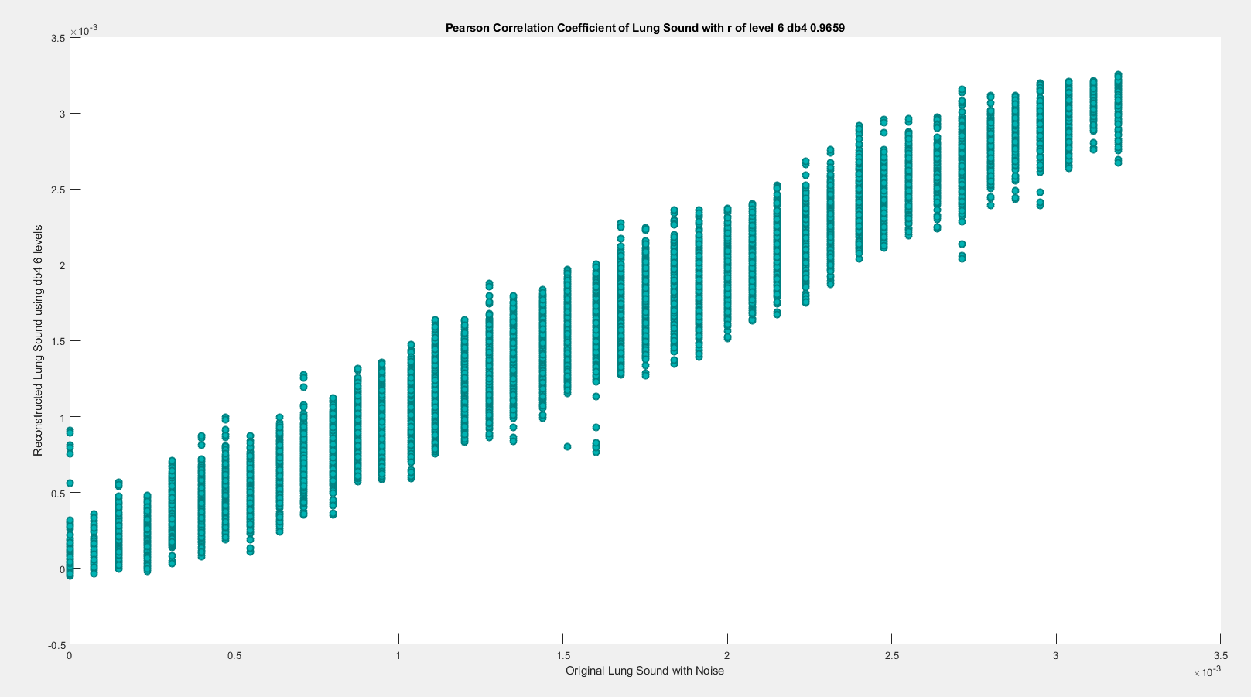

**(6) db4 LEVEL 7**

(a) db4 LEVEL 7 ARCHITECTURE

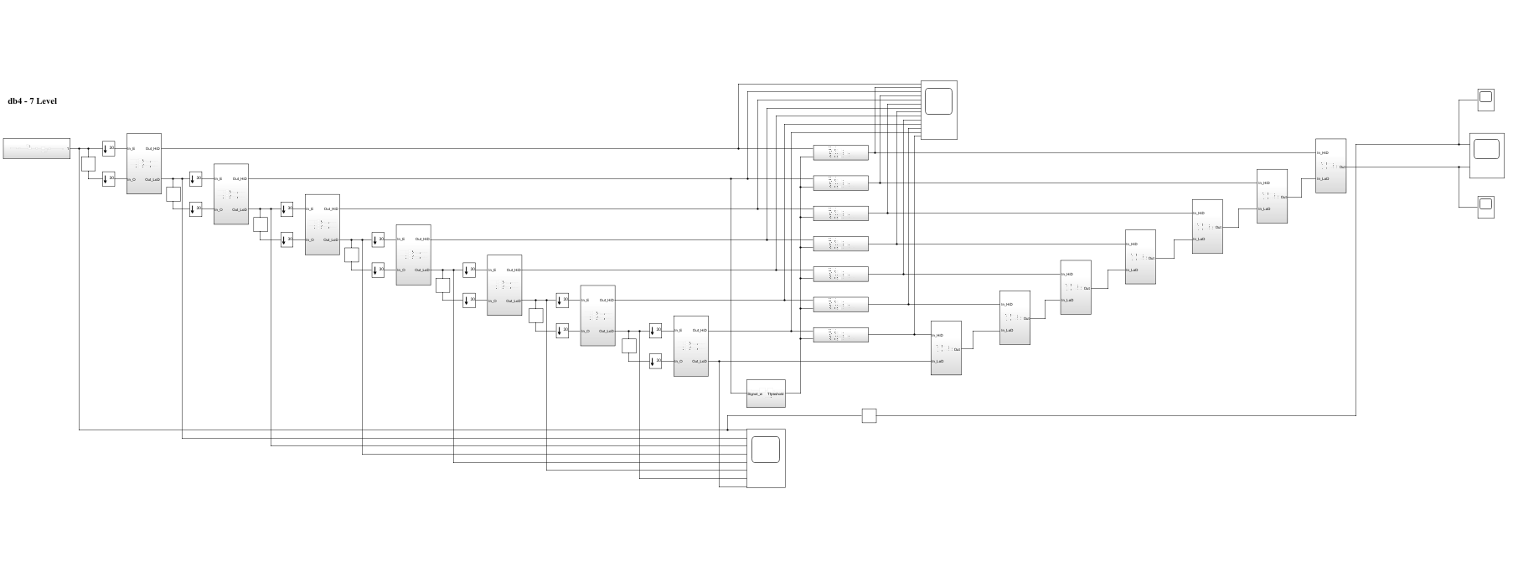

(b) db4 LEVEL 7 SIMULATION RESULT

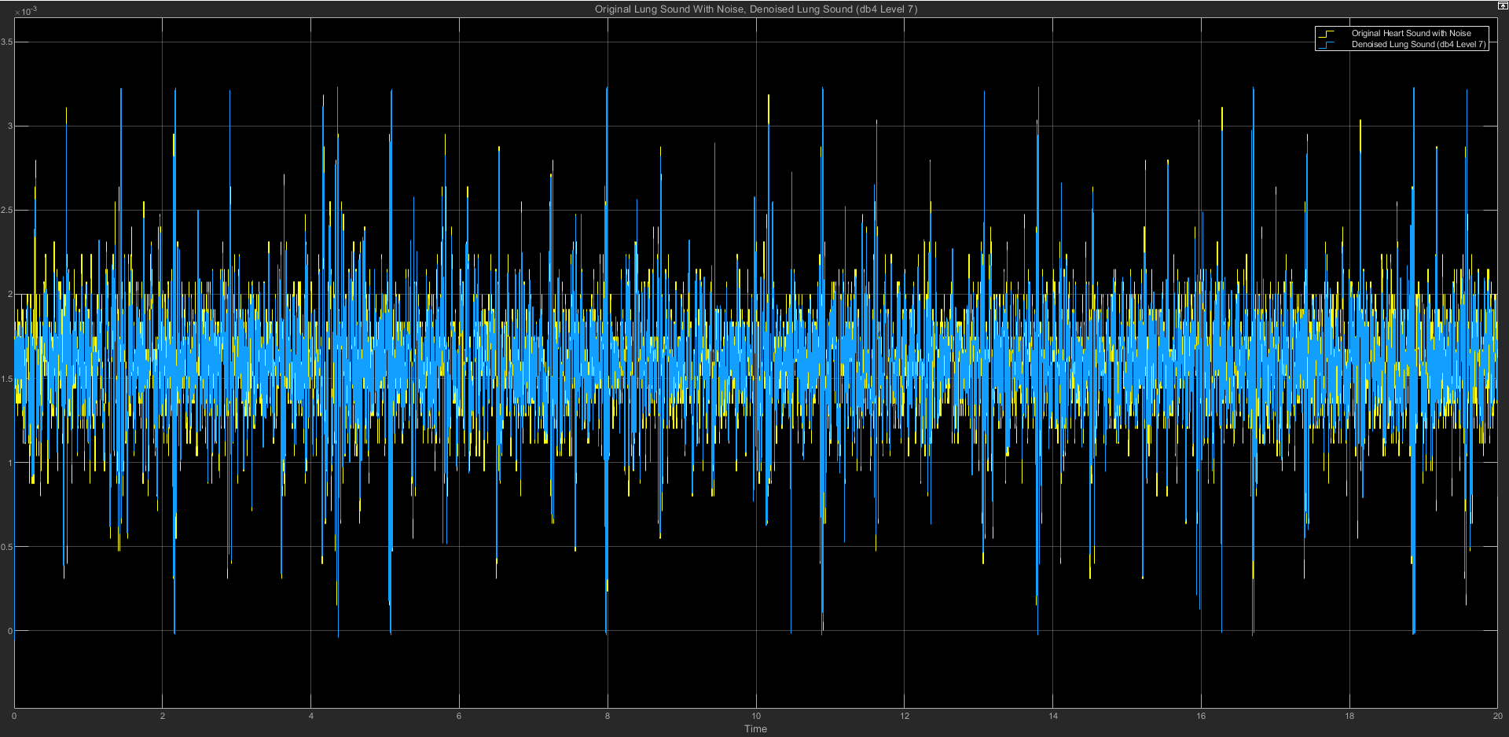

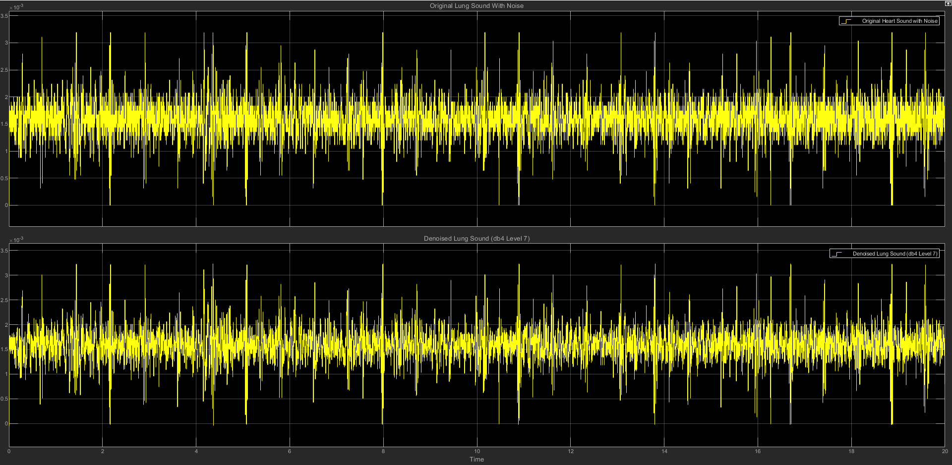

(c) db4 LEVEL 7 STATISTICS RESULT

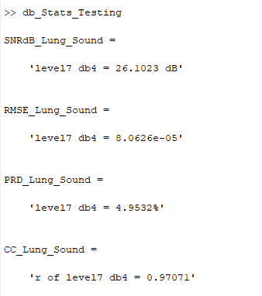

(d) db4 LEVEL 7 SCATTER PLOT RESULT

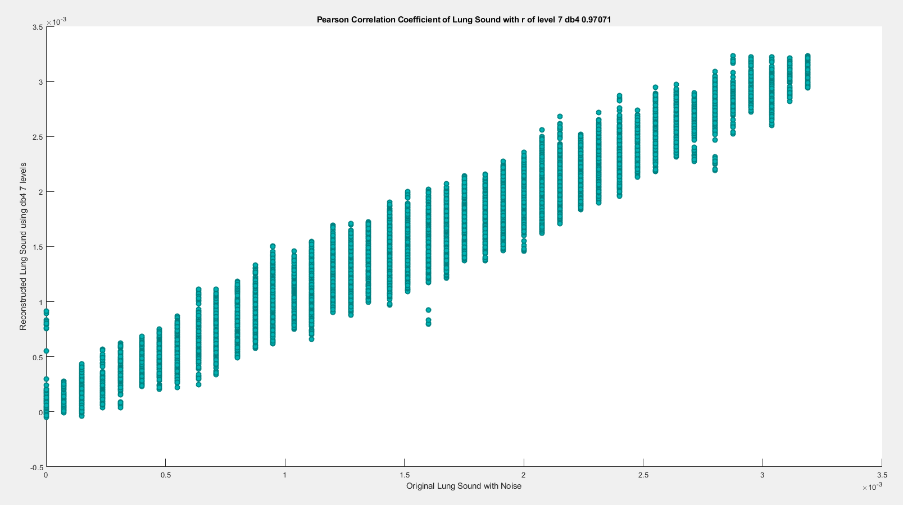

========================================================================

**db5**

| **db5** | **SNRdB_Lung**  **_Sound** | **RMSE_Lung**  **_Sound** | **PRD_Lung_Sound** | **CC_Lung**  **_Sound** |
| --- | --- | --- | --- | --- |
| Level 2 | 24.0398 dB | 0.00010224 | 6.2807% | 0.95256 |
| Level 3 | 24.1521 dB | 0.00010092 | 6.2% | 0.95383 |
| Level 4 | 24.4762 dB | 9.7194e-05 | 5.973% | 0.9572 |
| Level 5 | 24.9311 dB | 9.2263e-05 | 5.6682% | 0.96153 |
| Level 6 | 25.4739 dB | 8.667e-05 | 5.3248% | 0.96599 |
| Level 7 | 26.2453 dB | 7.9334e-05 | 4.8723% | 0.97166 |

**(1) db5 LEVEL 2**

(a) db5 LEVEL 2 ARCHITECTURE

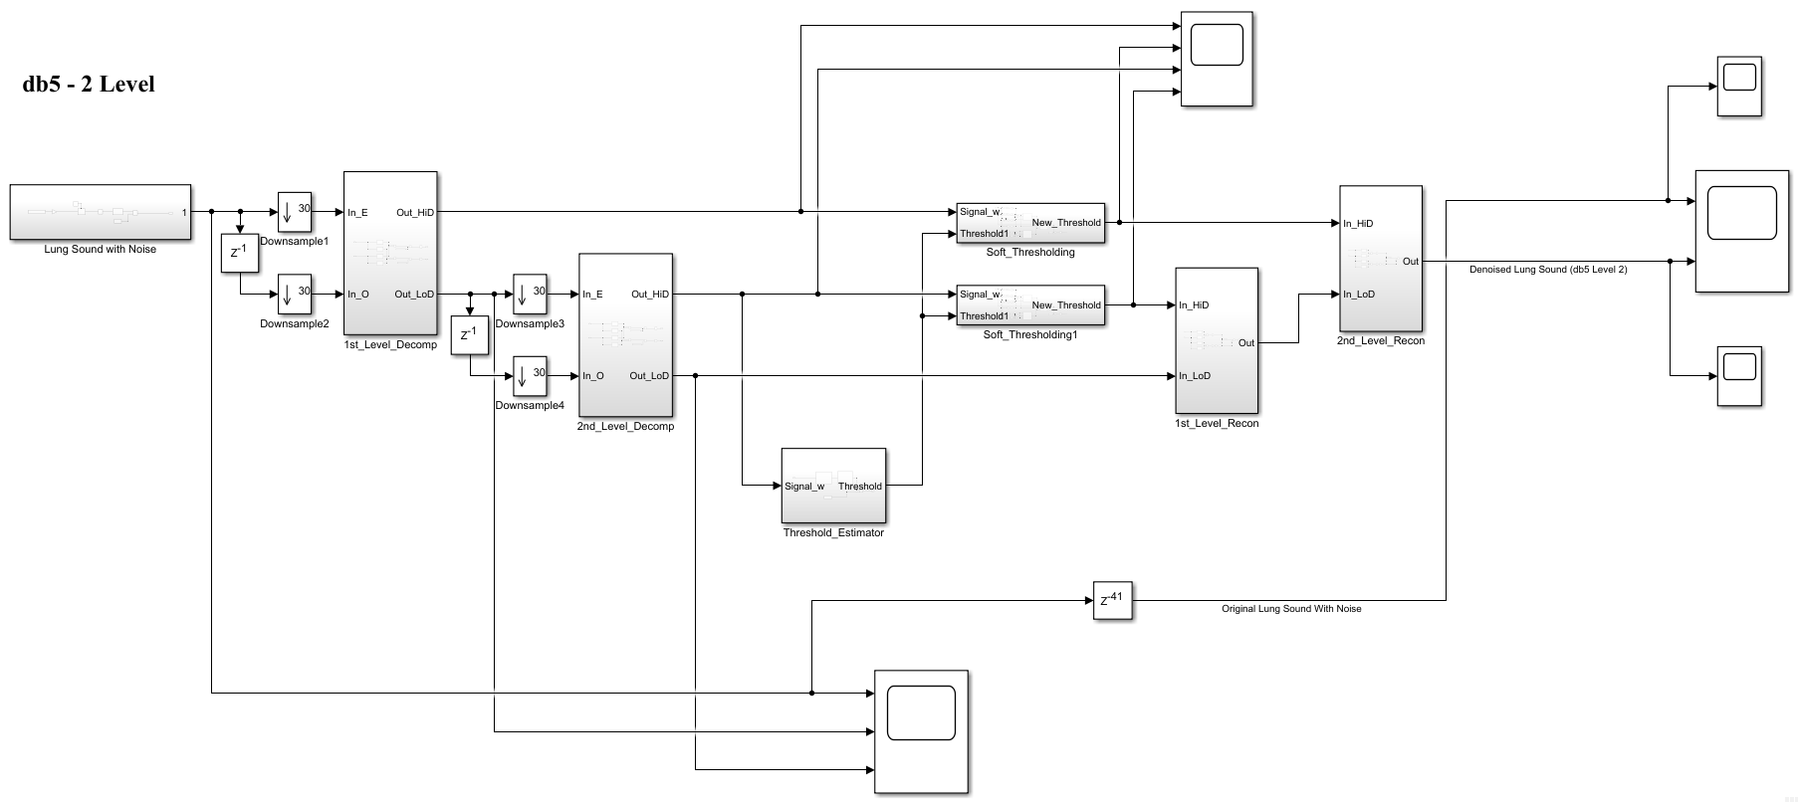

(b) db5 LEVEL 2 SIMULATION RESULT

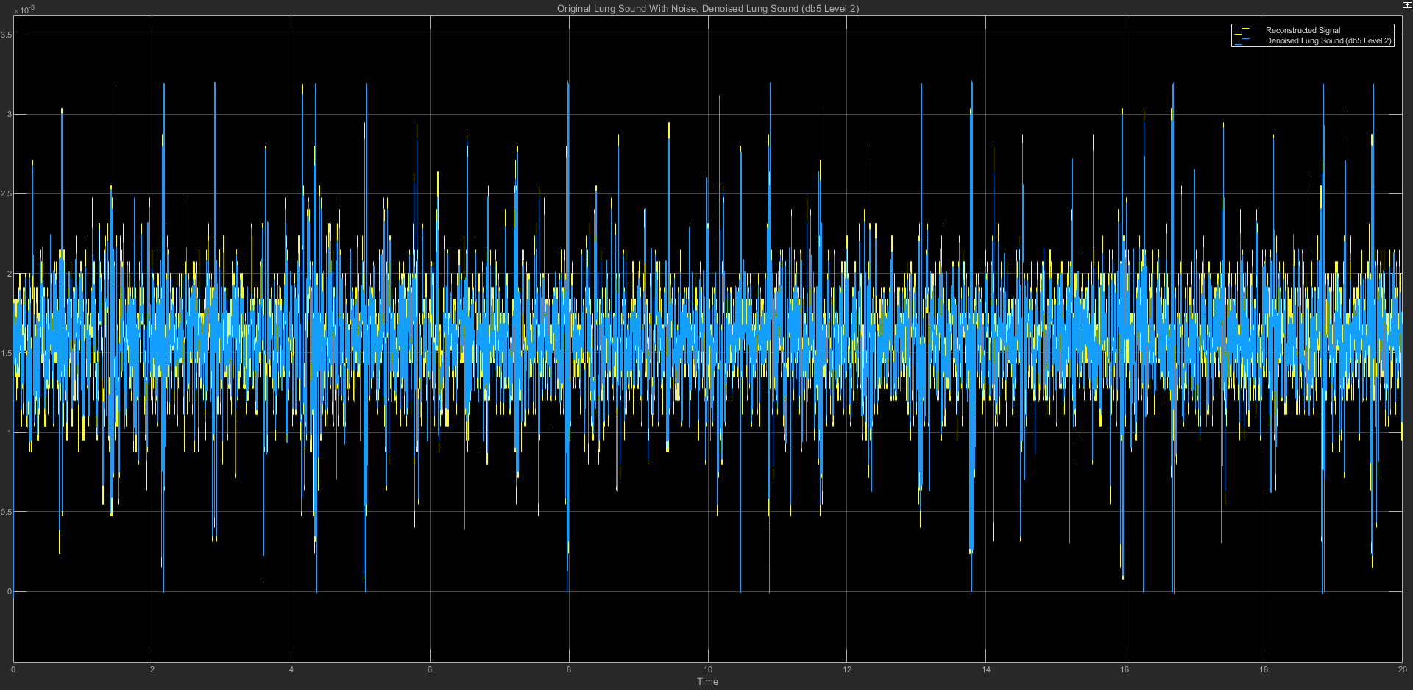

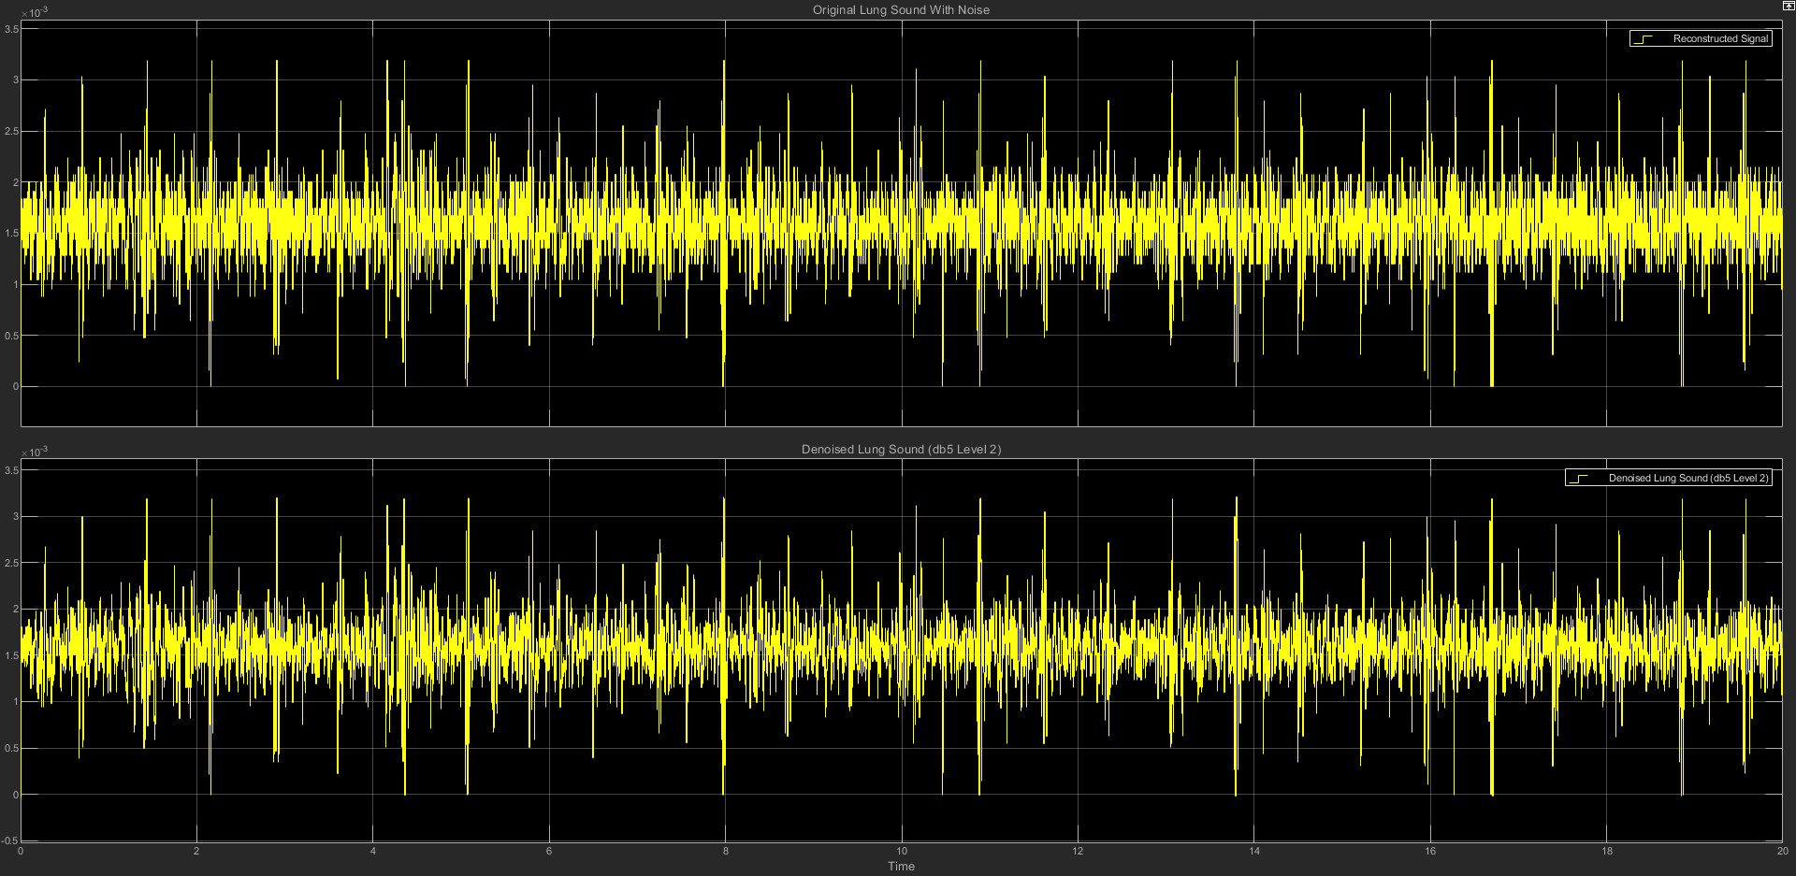

(c) db5 LEVEL 2 STATISTICS RESULT

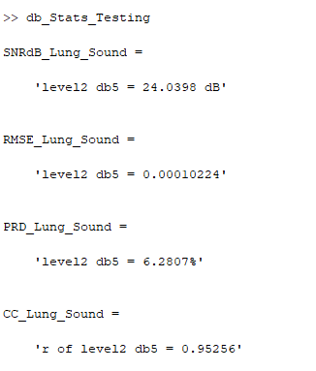

(d) db5 LEVEL 2 SCATTER PLOT RESULT

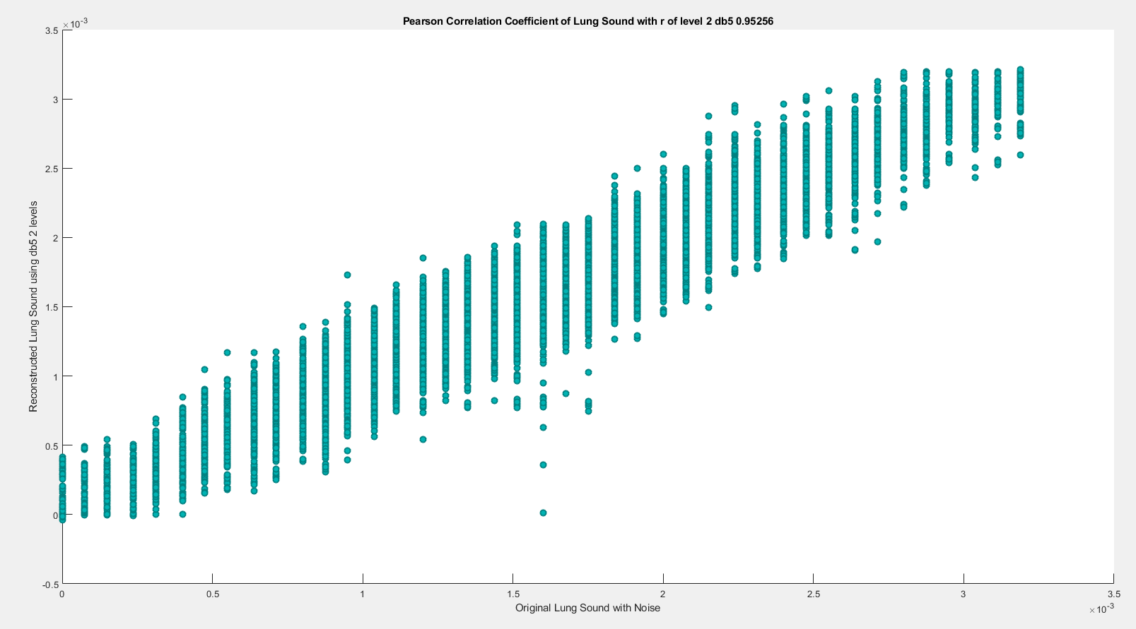

**(2) db5 LEVEL 3**

(a) db5 LEVEL 3 ARCHITECTURE

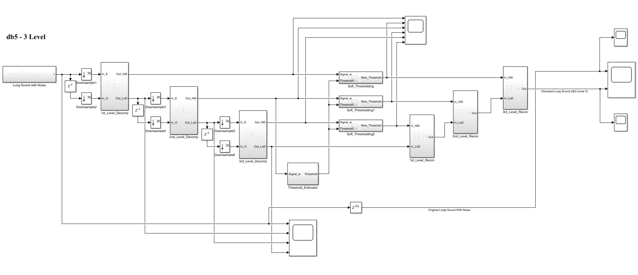

(b) db5 LEVEL 3 SIMULATION RESULT

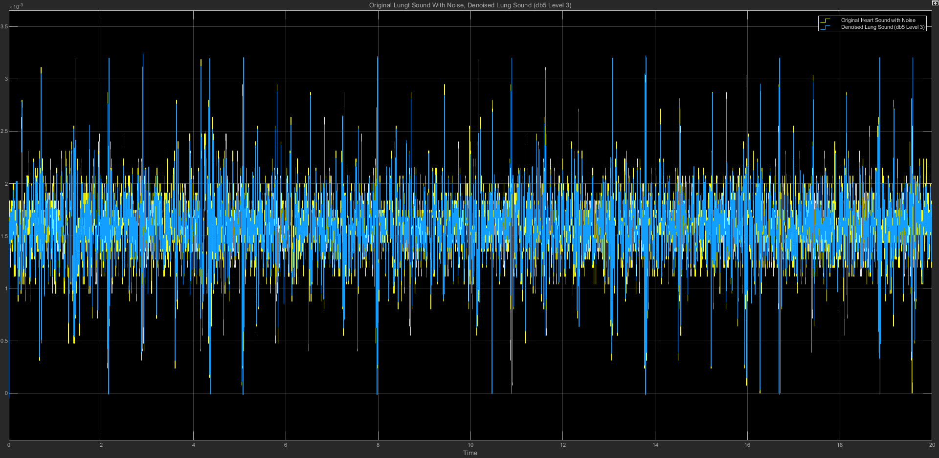

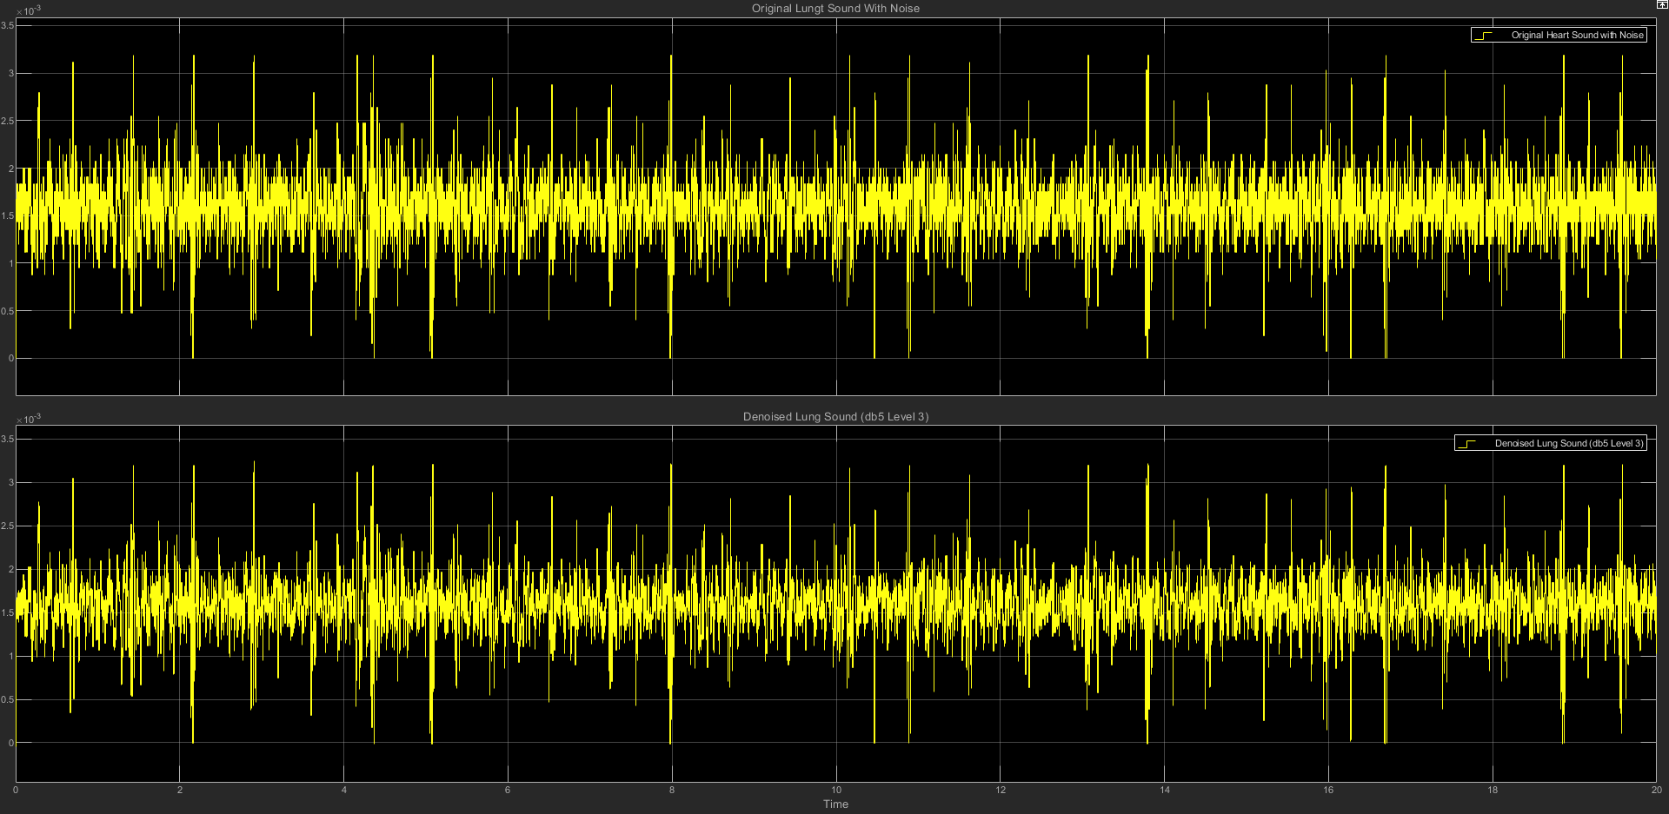

(c) db5 LEVEL 3 STATISTICS RESULT

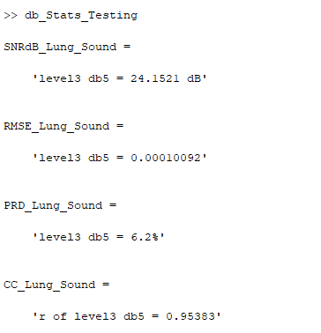

(d) db5 LEVEL 3 SCATTER PLOT RESULT

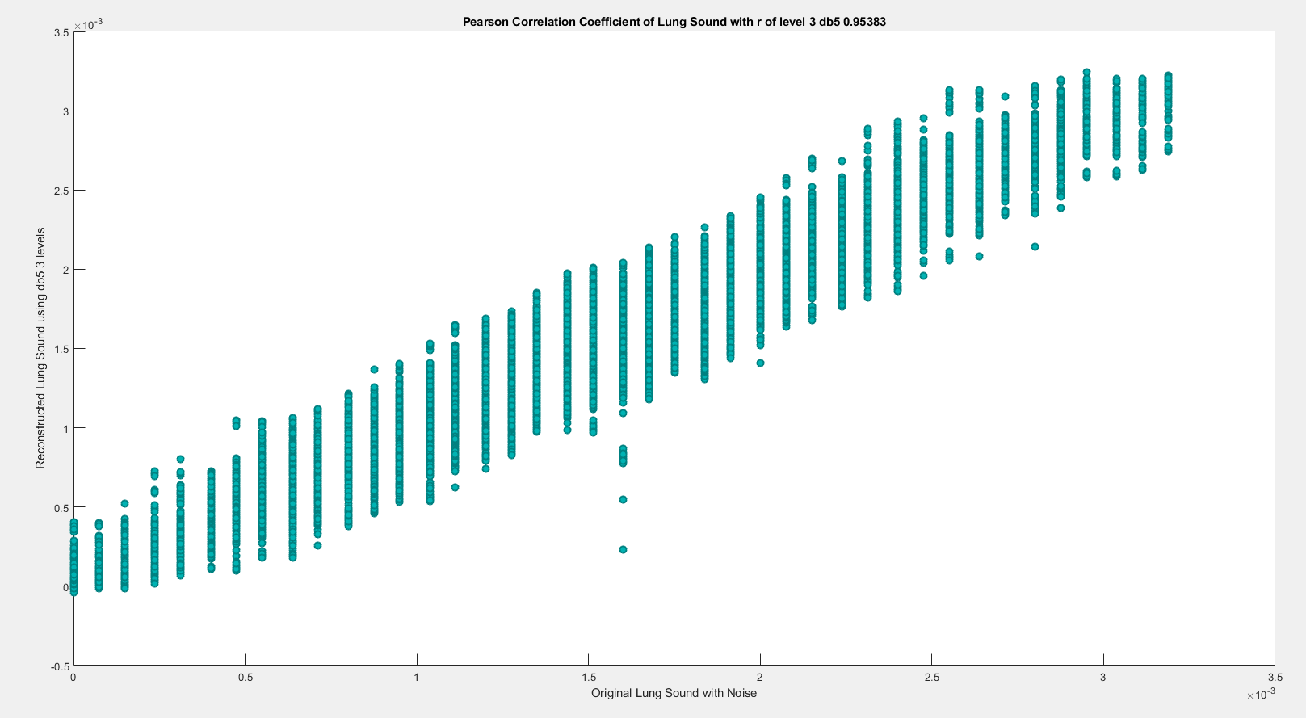

**(3) db5 LEVEL 4**

(a) db5 LEVEL 4 ARCHITECTURE

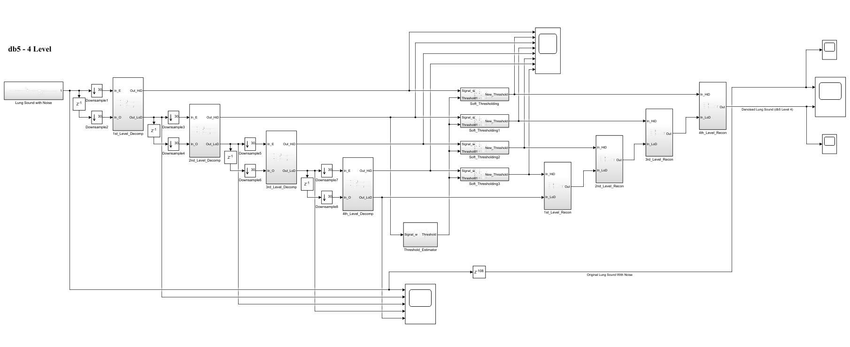

(b) db5 LEVEL 4 SIMULATION RESULT

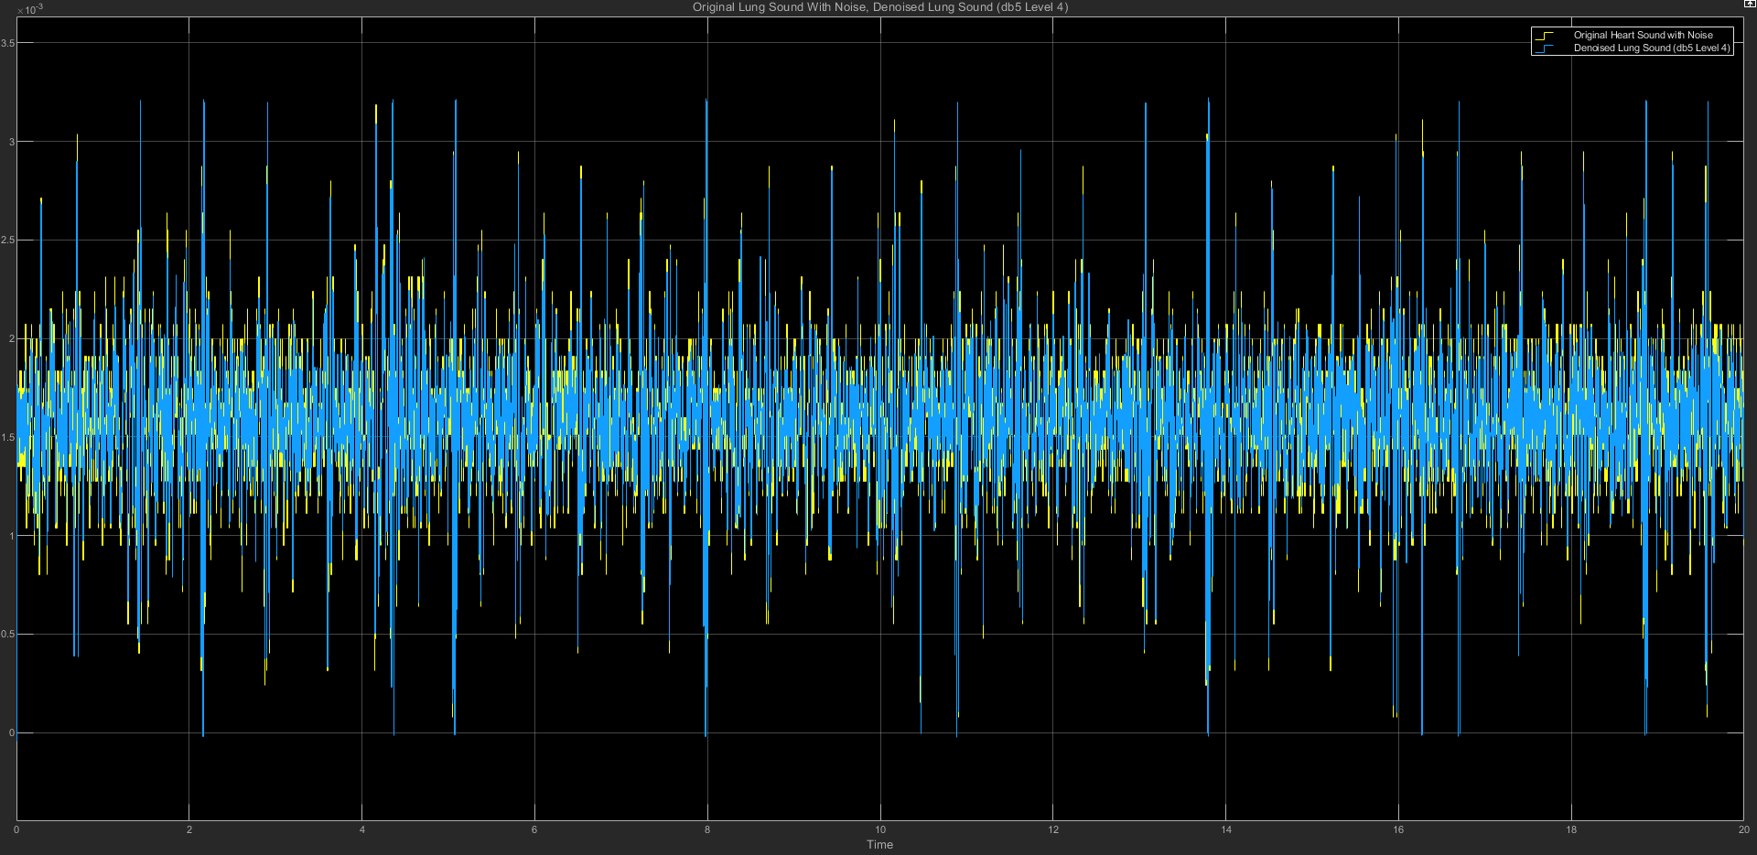

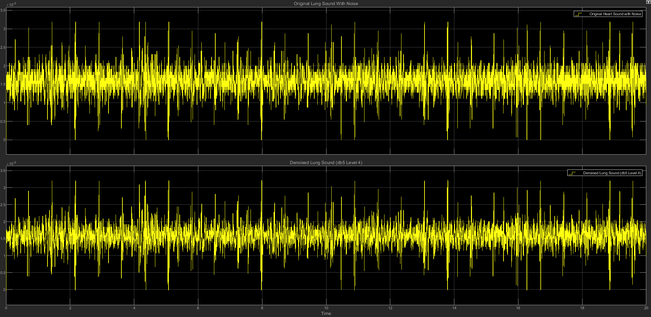

(c) db5 LEVEL 4 STATISTICS RESULT

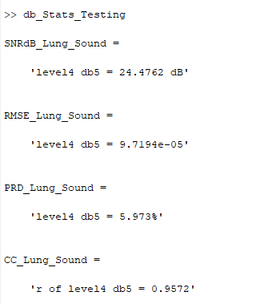

(d) db5 LEVEL 4 SCATTER PLOT RESULT

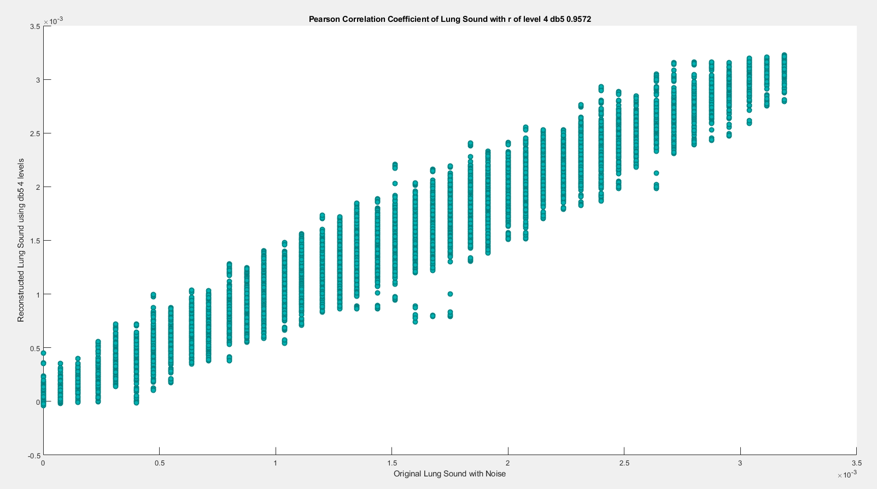

**(4) db5 LEVEL 5**

(a) db5 LEVEL 5 ARCHITECTURE

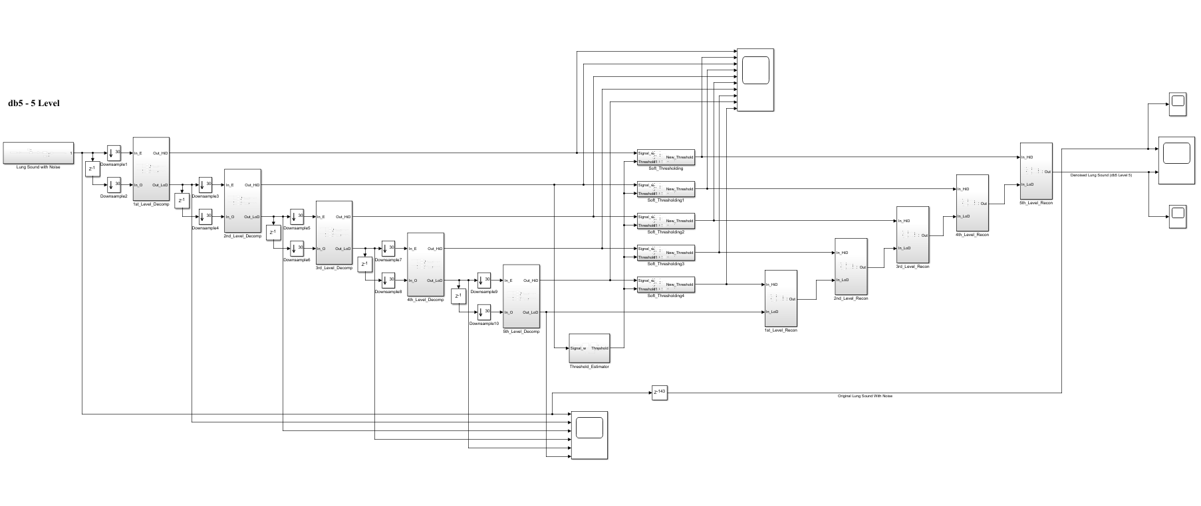

(b) db5 LEVEL 5 SIMULATION RESULT

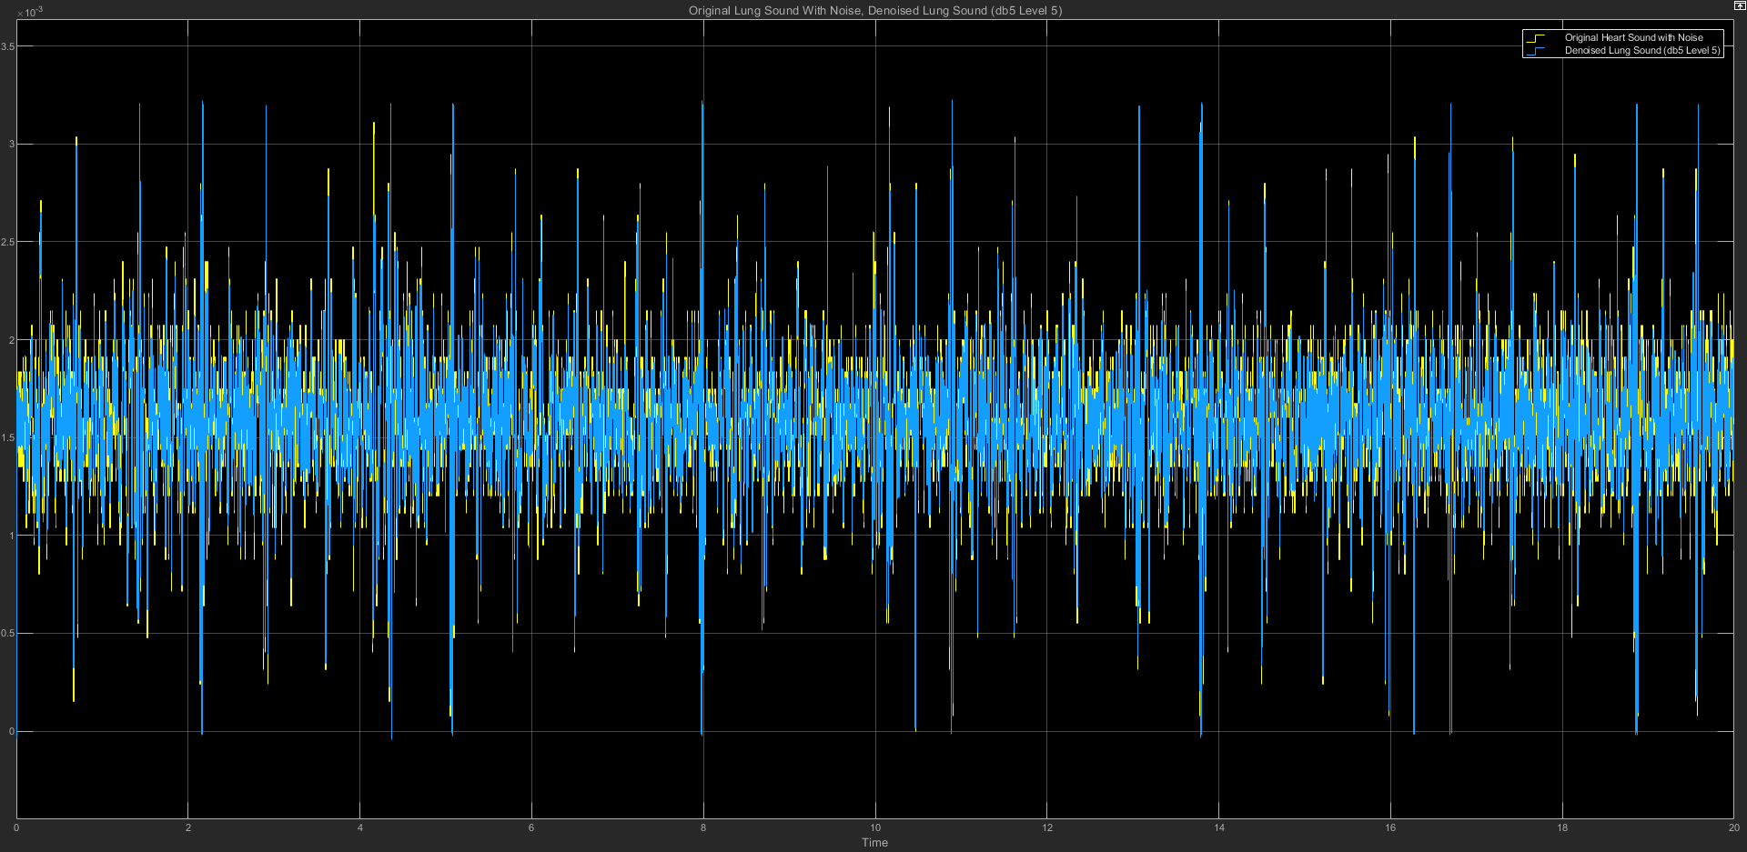

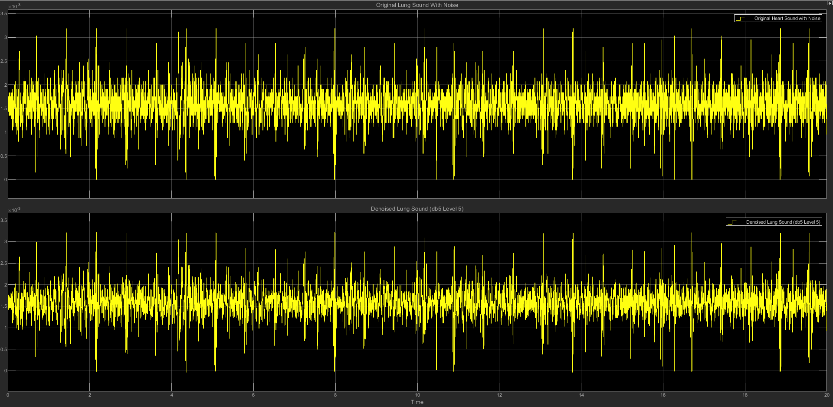

(c) db5 LEVEL 5 STATISTICS RESULT

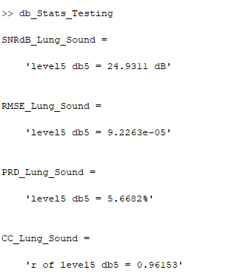

(d) db5 LEVEL 5 SCATTER PLOT RESULT

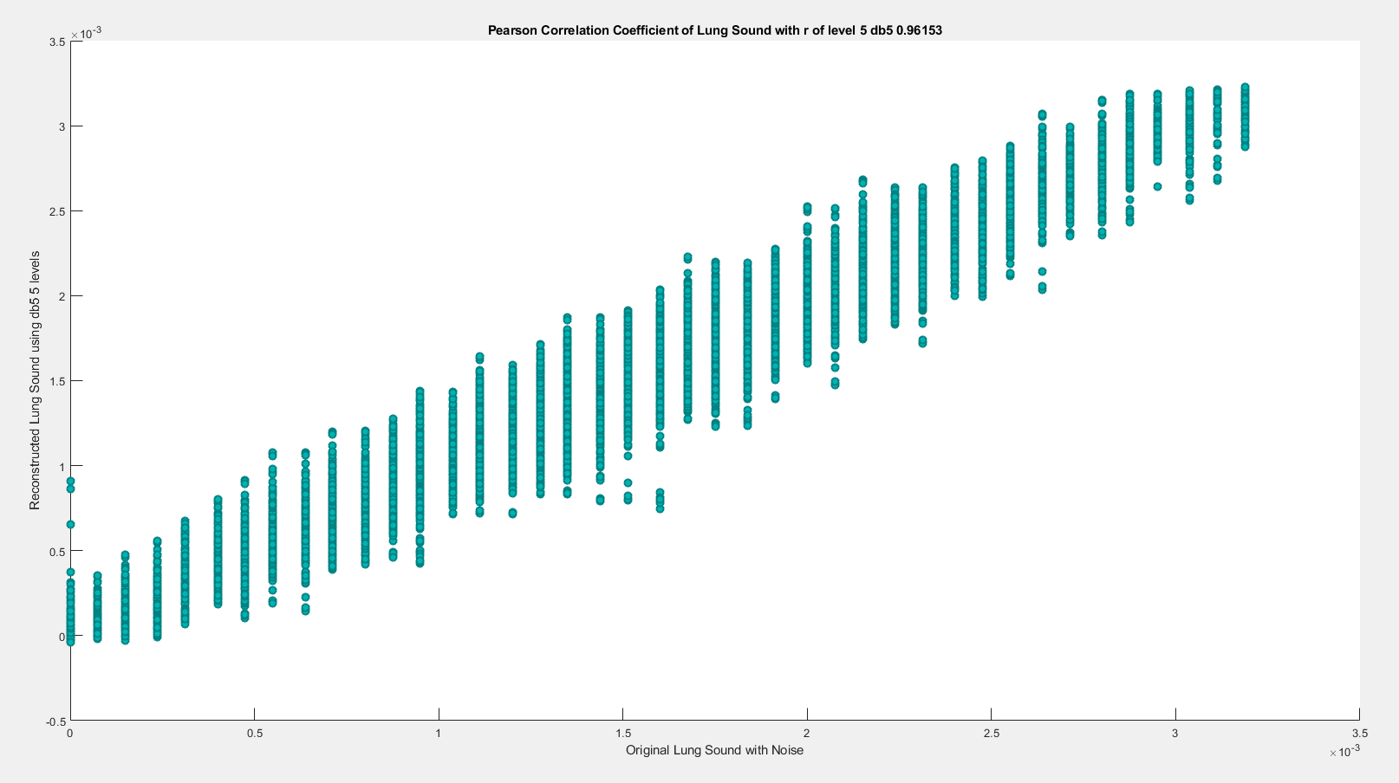

**(5) db5 LEVEL 6**

(a) db5 LEVEL 6 ARCHITECTURE

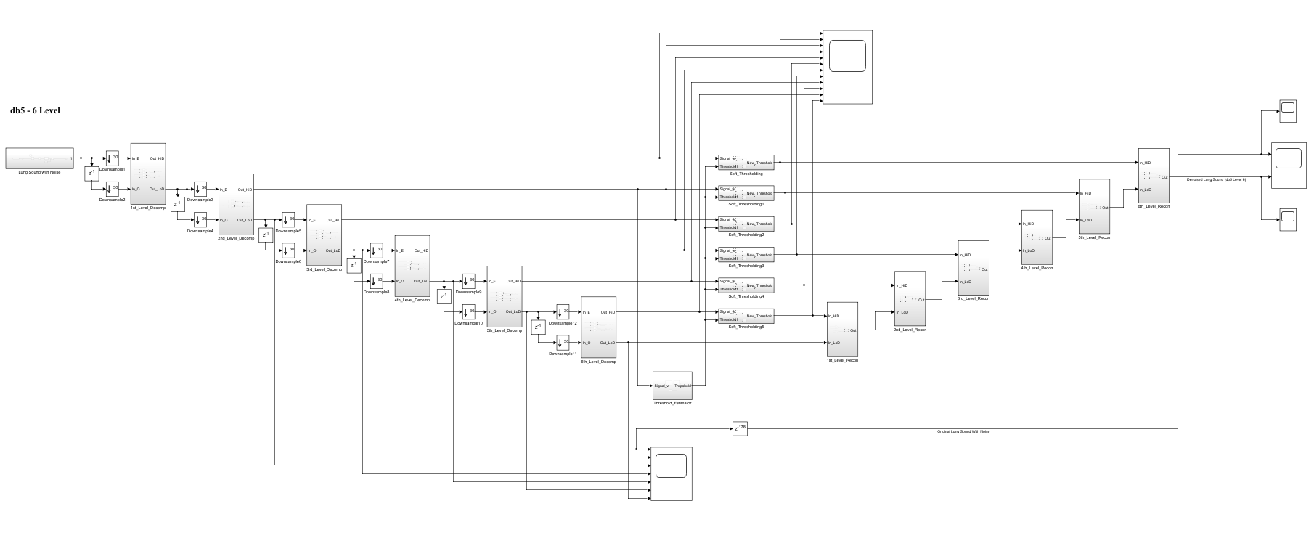

(b) db5 LEVEL 6 SIMULATION RESULT

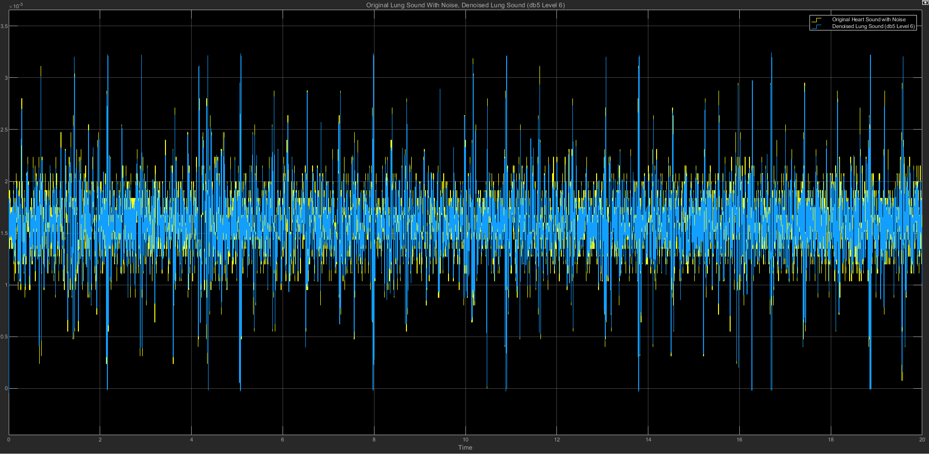

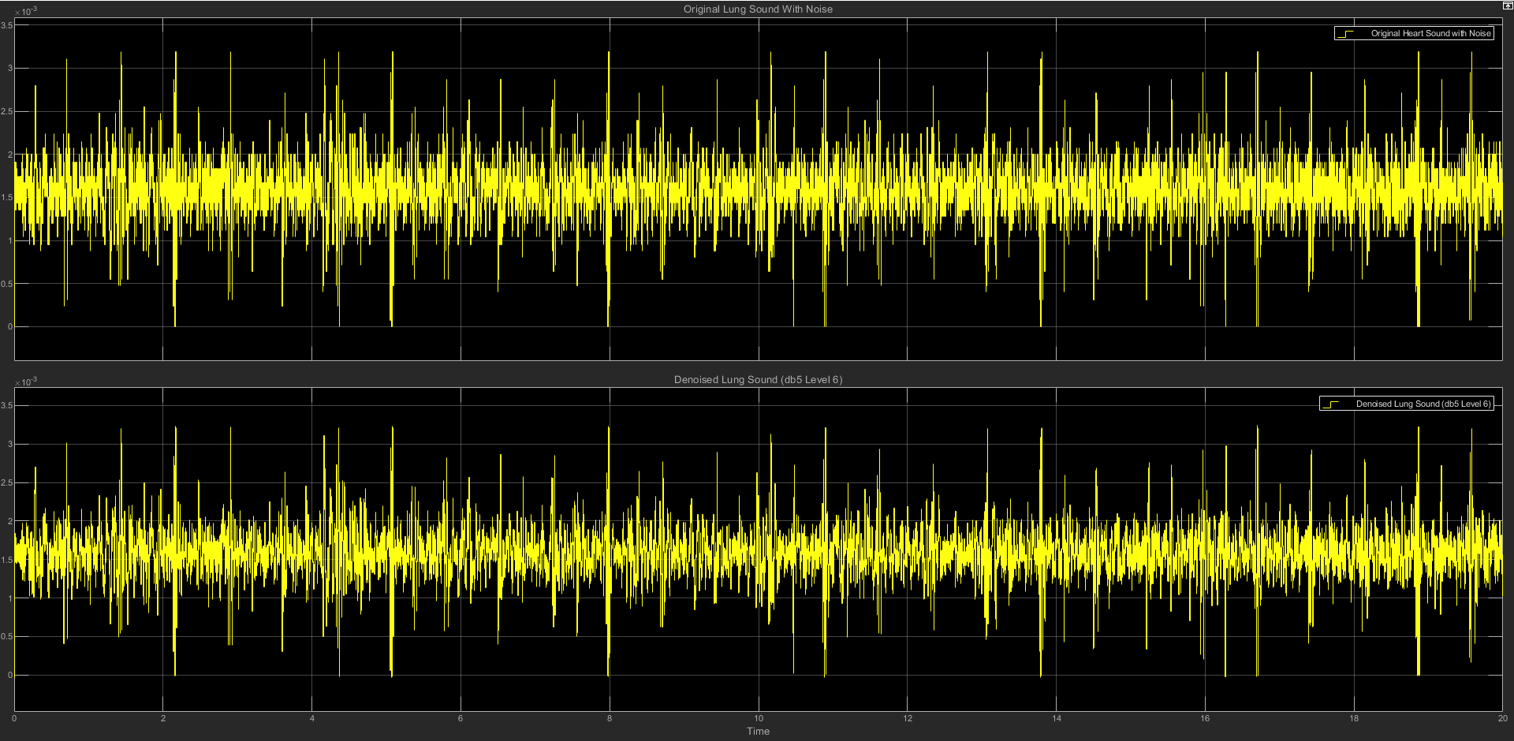

(c) db5 LEVEL 6 STATISTICS RESULT

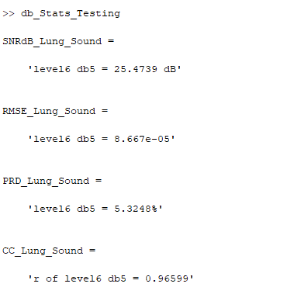

(d) db5 LEVEL 6 SCATTER PLOT RESULT

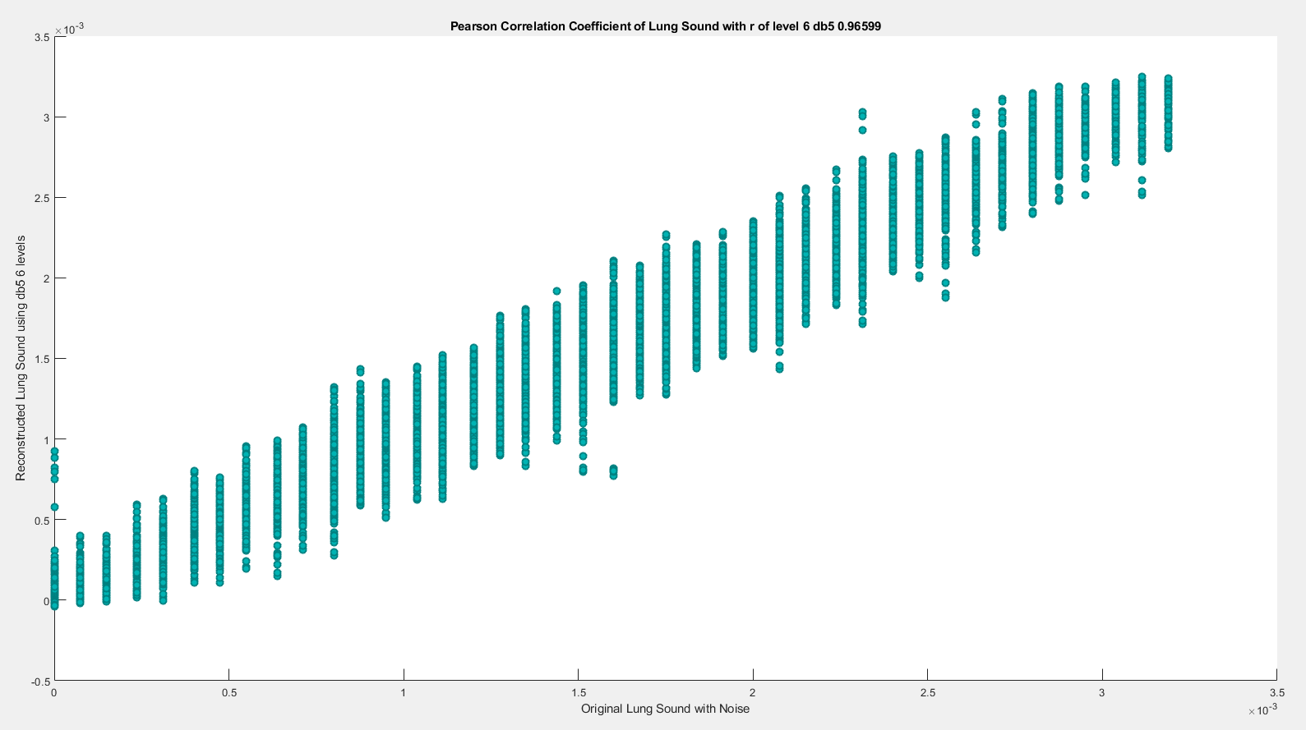

**(6) db5 LEVEL 7**

(a) db5 LEVEL 7 ARCHITECTURE

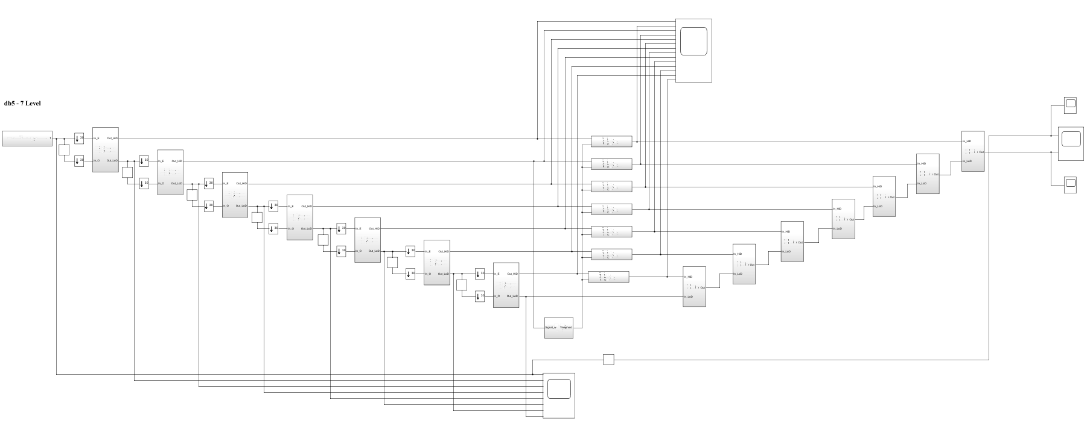

(b) db5 LEVEL 7 SIMULATION RESULT

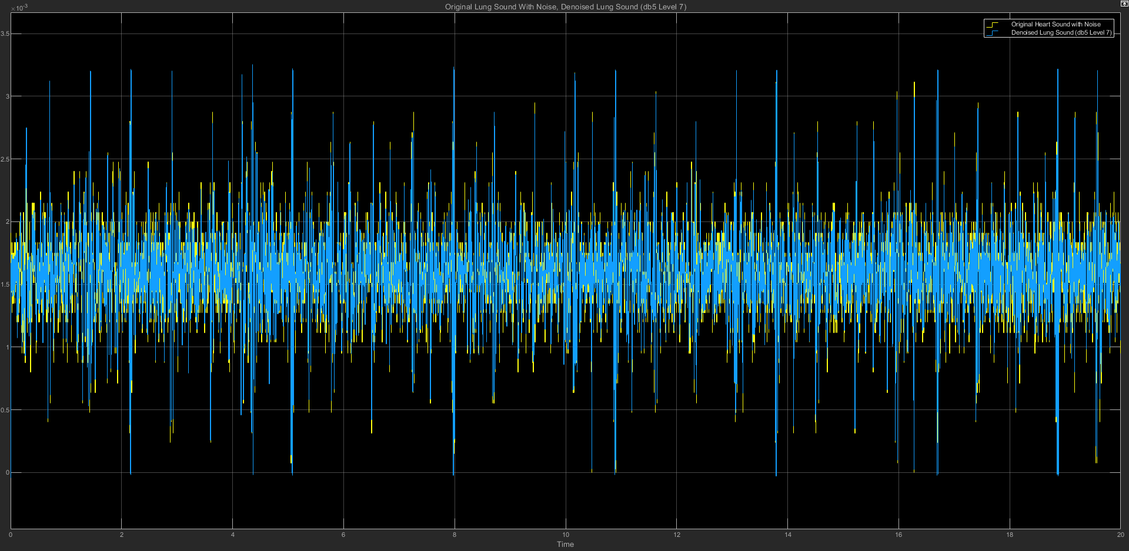

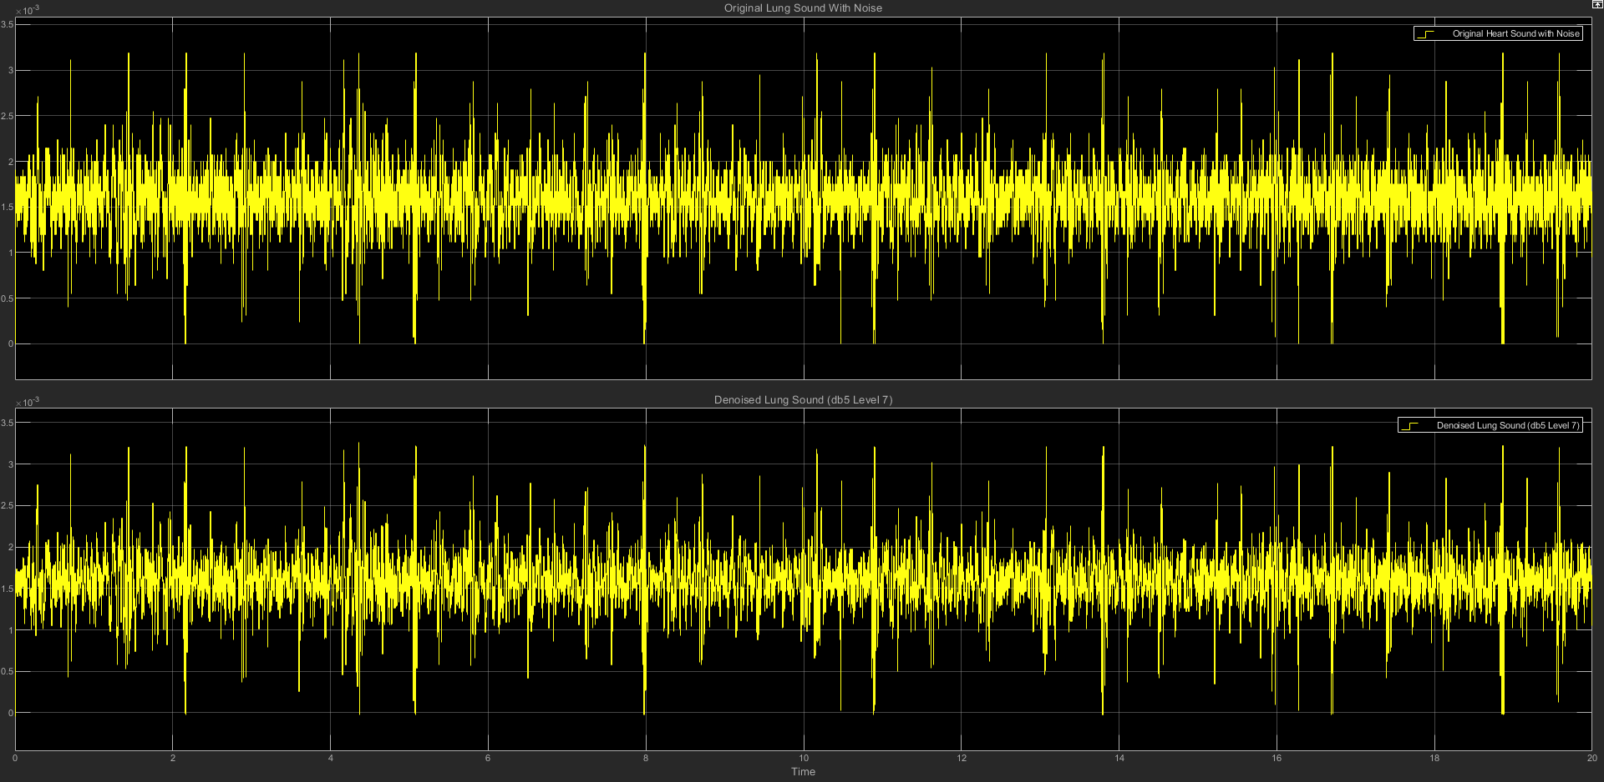

(c) db5 LEVEL 7 STATISTICS RESULT

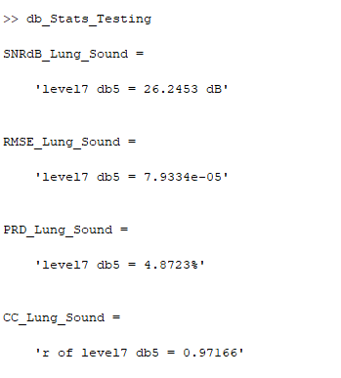

(d) db5 LEVEL 7 SCATTER PLOT RESULT

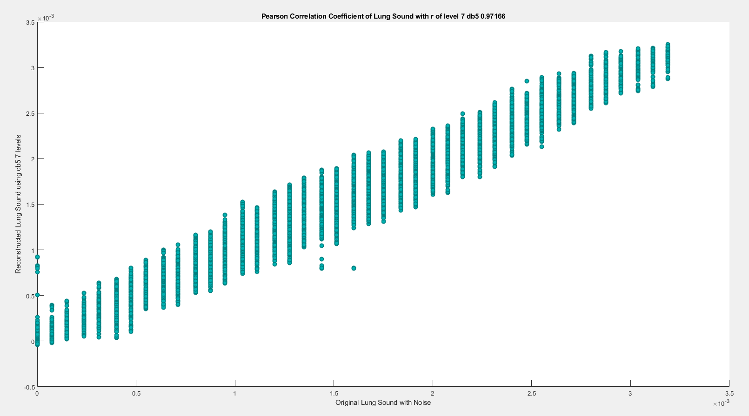

========================================================================

**db6**

| **db6** | **SNRdB_Lung**  **_Sound** | **RMSE_Lung**  **_Sound** | **PRD_Lung_Sound** | **CC_Lung**  **_Sound** |
| --- | --- | --- | --- | --- |
| Level 2 | 24.1635 dB | 0.00010085 | 6.1919% | 0.95389 |
| Level 3 | 24.6451 dB | 9.5354e-05 | 5.8579% | 0.95891 |
| Level 4 | 24.9009 dB | 9.259e-05 | 5.6879% | 0.96118 |
| Level 5 | 25.5623 dB | 8.577e-05 | 5.2709% | 0.96669 |
| Level 6 | 25.8565 dB | 8.2953e-05 | 5.0953% | 0.96899 |
| Level 7 | 26.2363 dB | 7.9413e-05 | 4.8774% | 0.9716 |

**(1) db6 LEVEL 2**

(a) db6 LEVEL 2 ARCHITECTURE

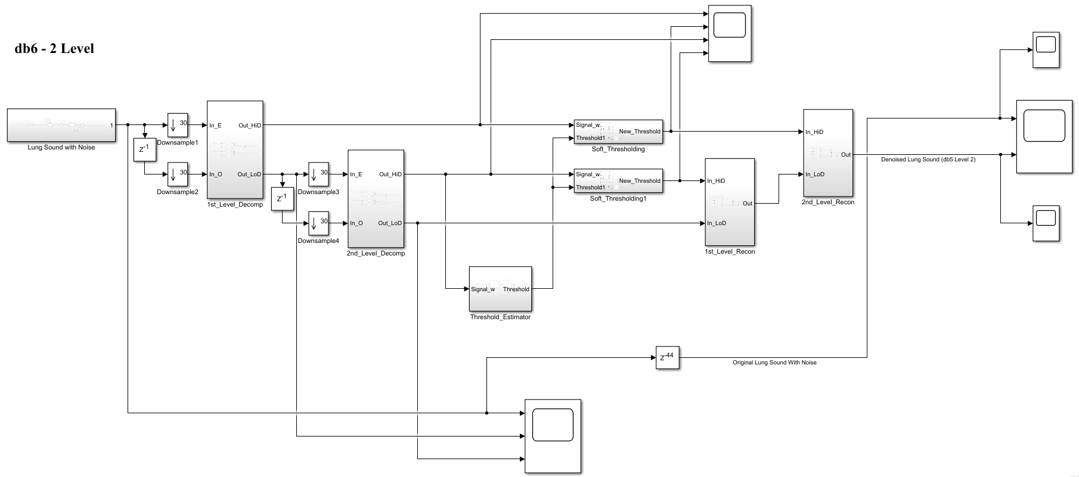

(b) db6 LEVEL 2 SIMULATION RESULT

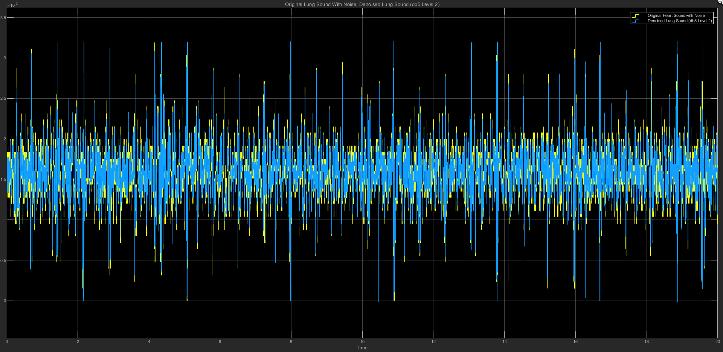

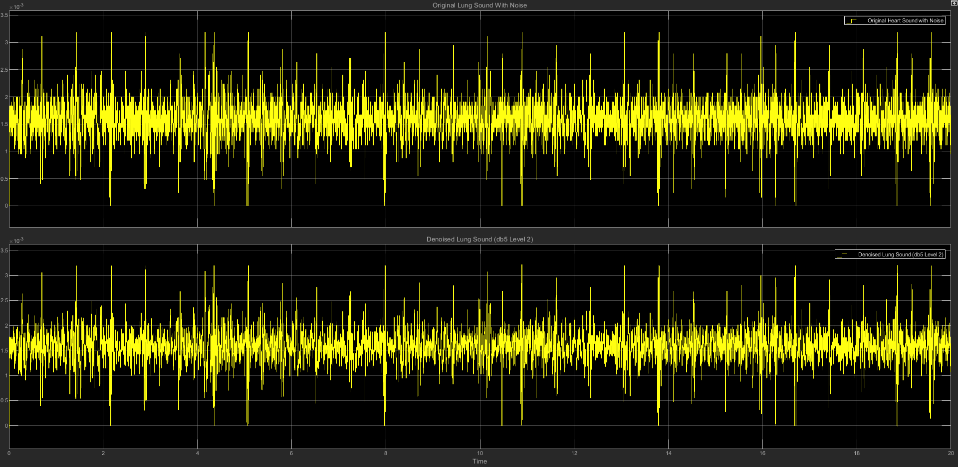

(c) db6 LEVEL 2 STATISTICS RESULT

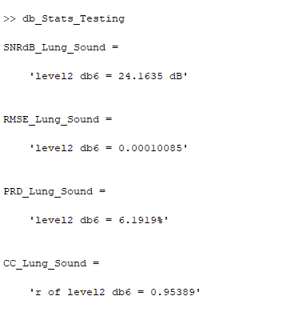

(d) db6 LEVEL 2 SCATTER PLOT RESULT

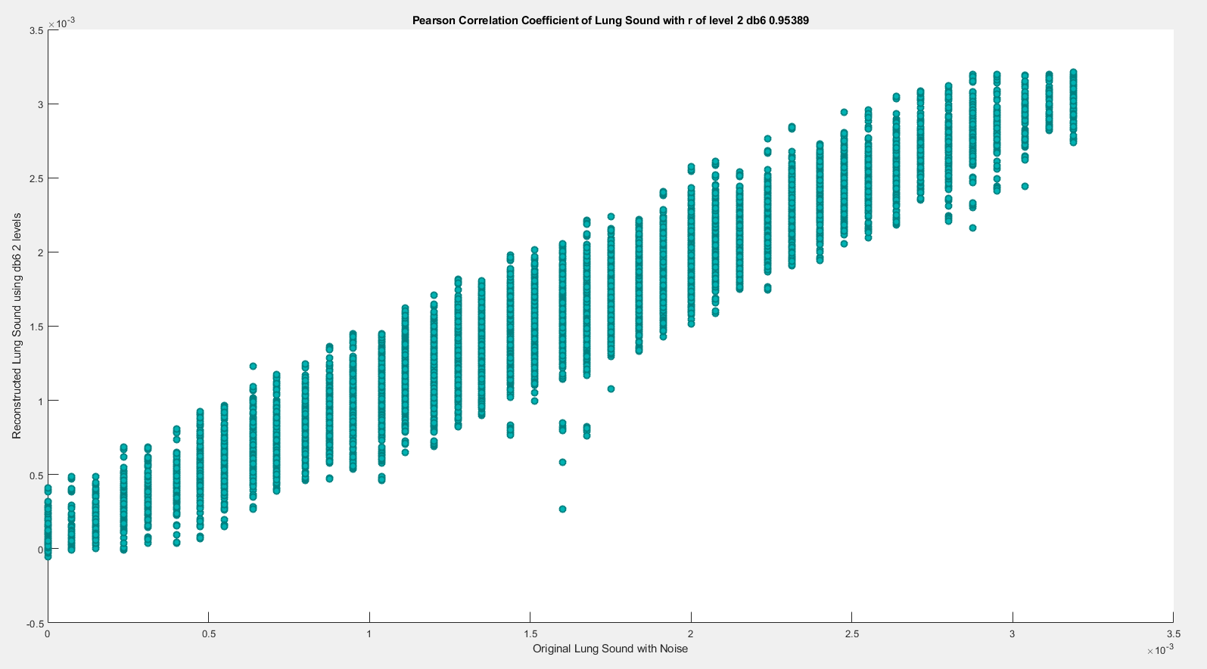

**(2) db6 LEVEL 3**

(a) db6 LEVEL 3 ARCHITECTURE

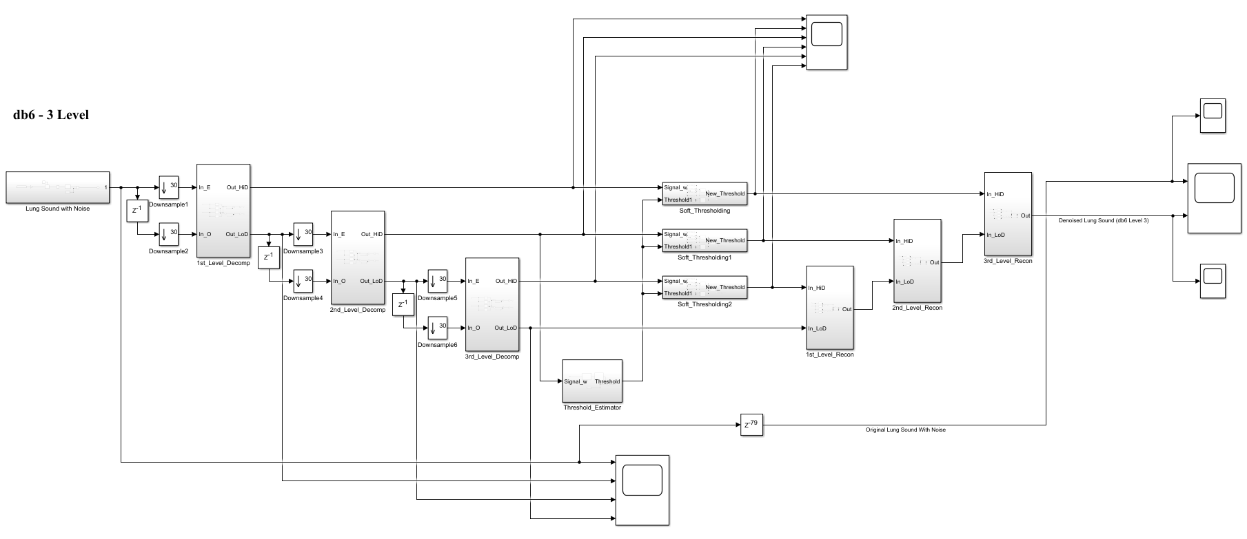

(b) db6 LEVEL 3 SIMULATION RESULT

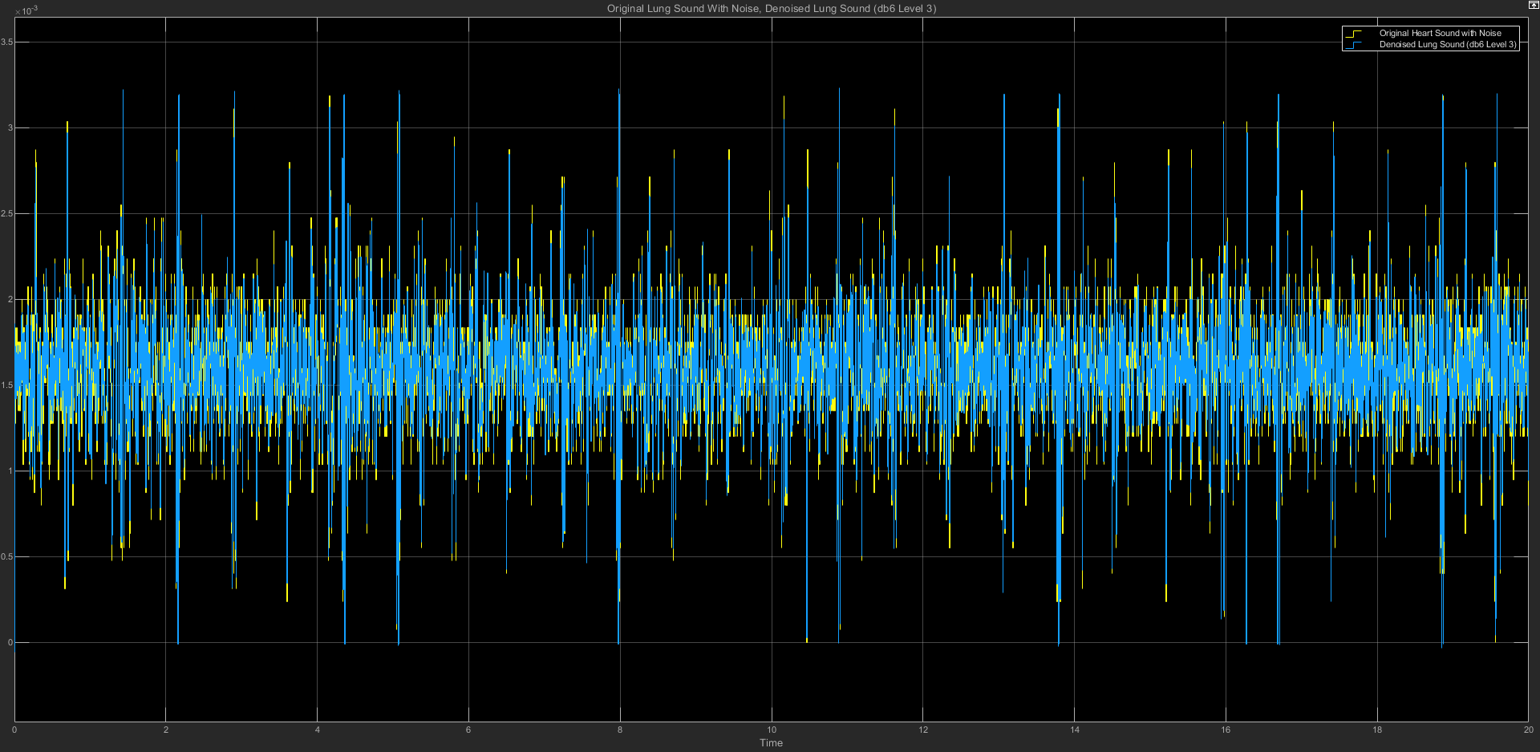

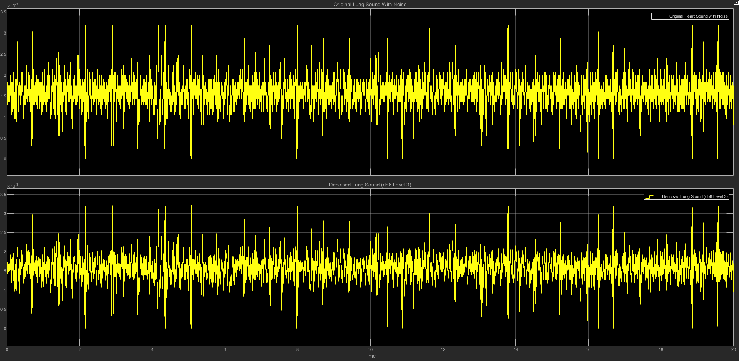

(c) db6 LEVEL 3 STATISTICS RESULT

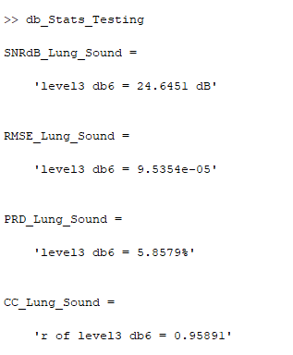

(d) db6 LEVEL 3 SCATTER PLOT RESULT

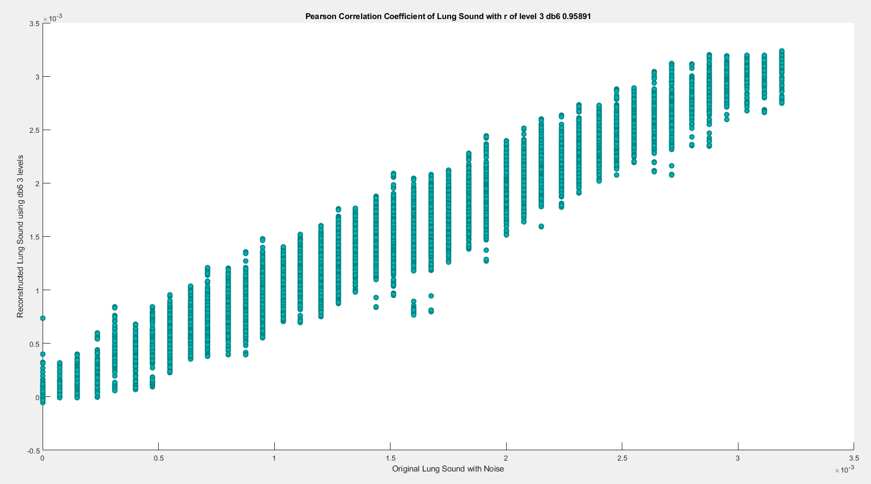

**(3) db6 LEVEL 4**

(a) db6 LEVEL 4 ARCHITECTURE

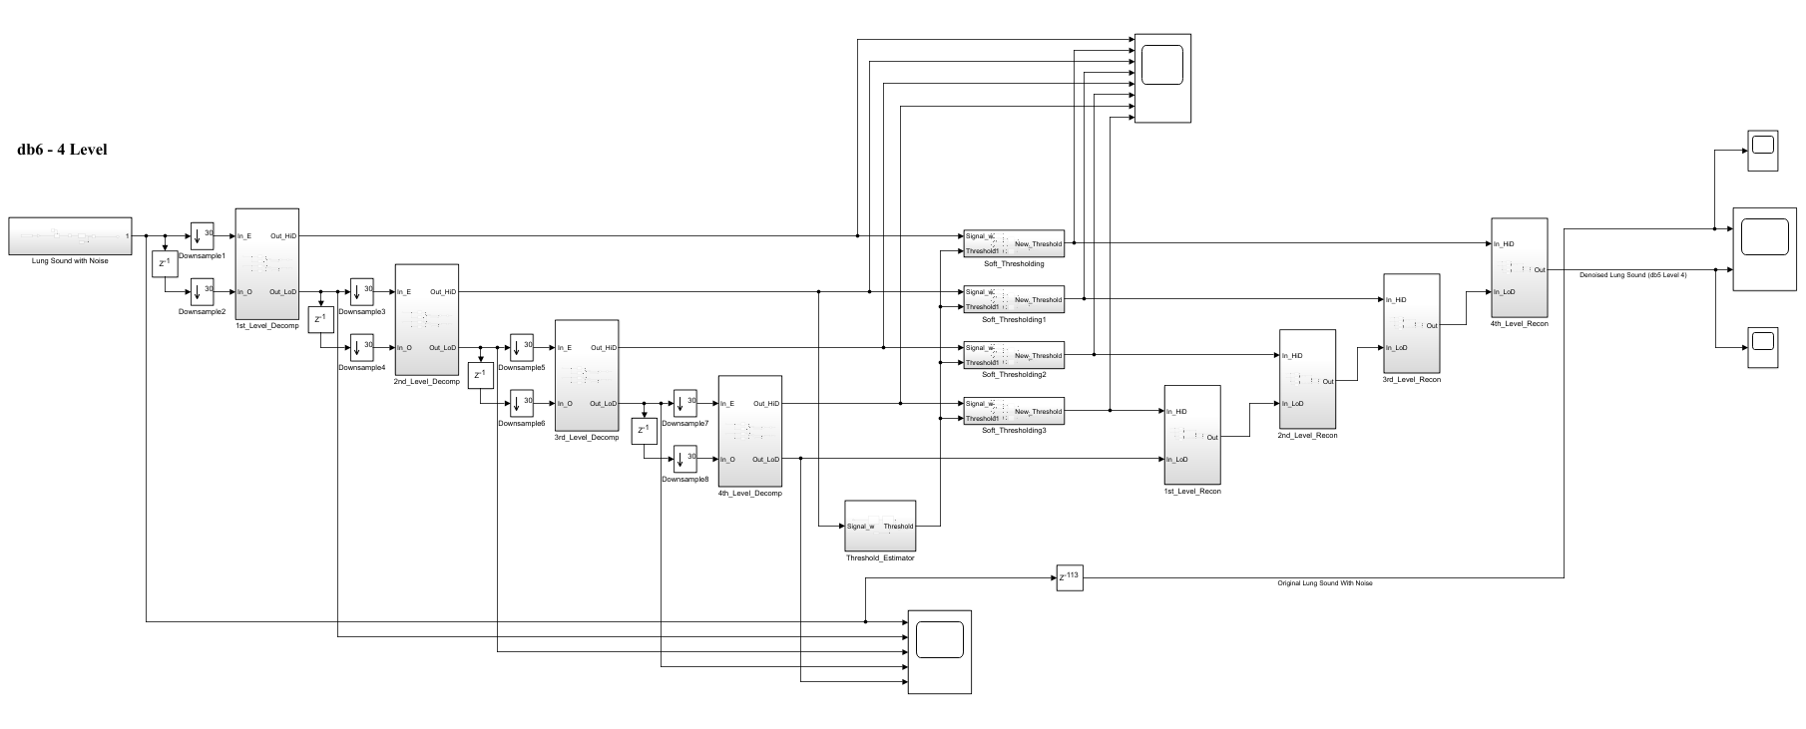

(b) db6 LEVEL 4 SIMULATION RESULT

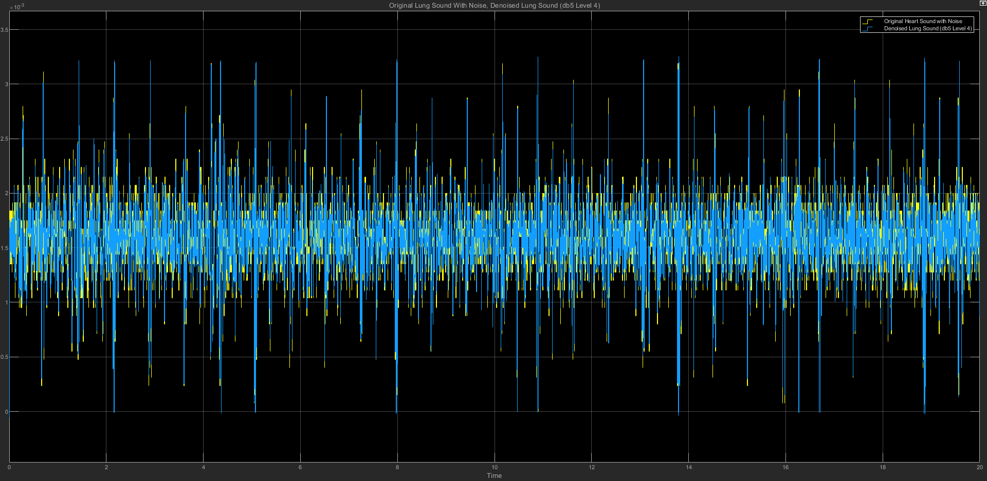

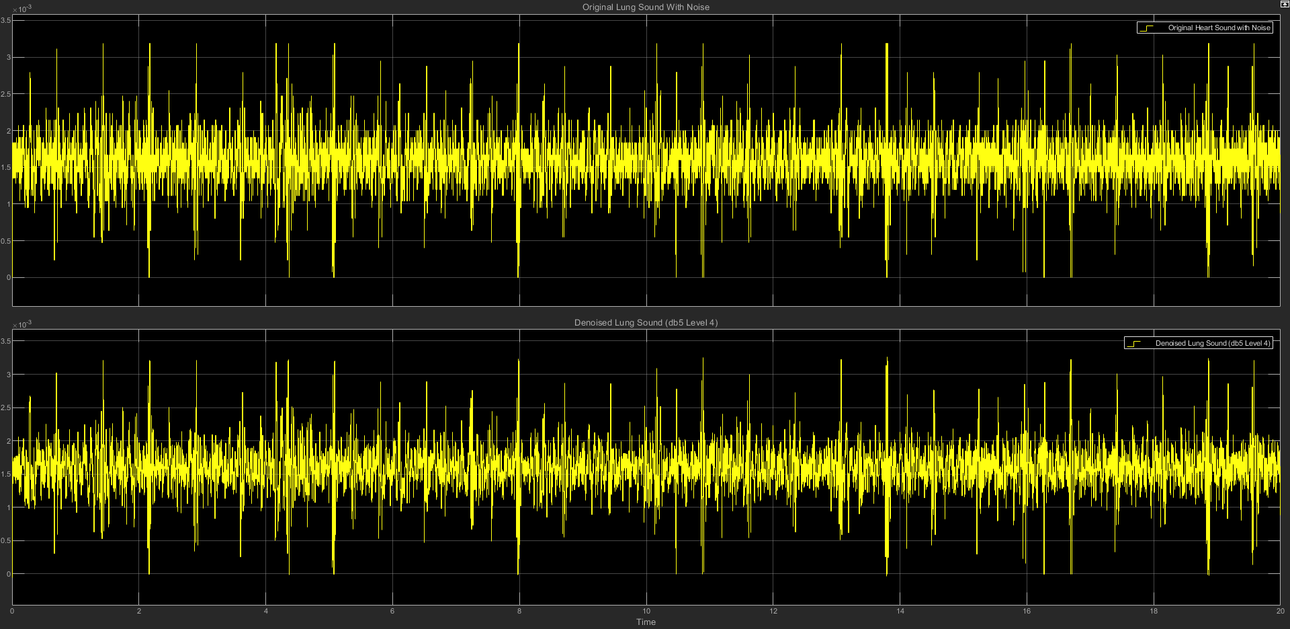

(c) db6 LEVEL 4 STATISTICS RESULT

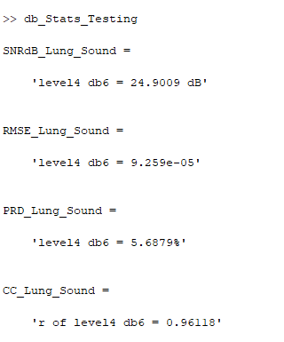

(d) db6 LEVEL 4 SCATTER PLOT RESULT

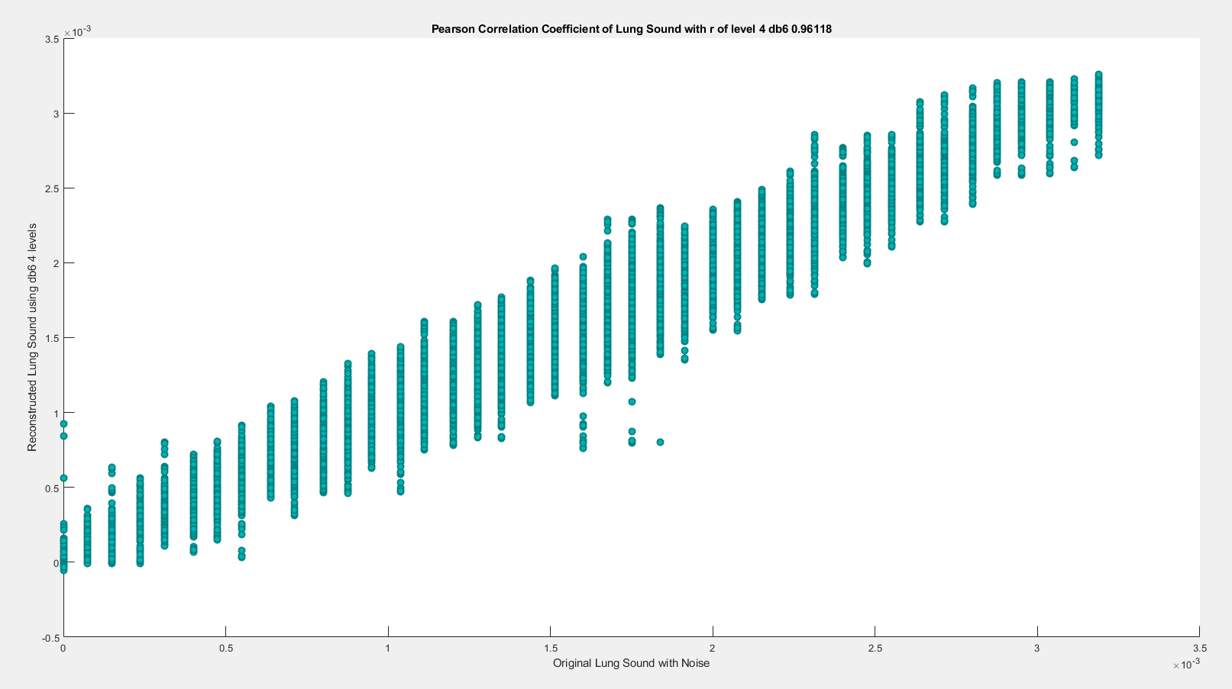

**(4) db6 LEVEL 5**

(a) db6 LEVEL 5 ARCHITECTURE

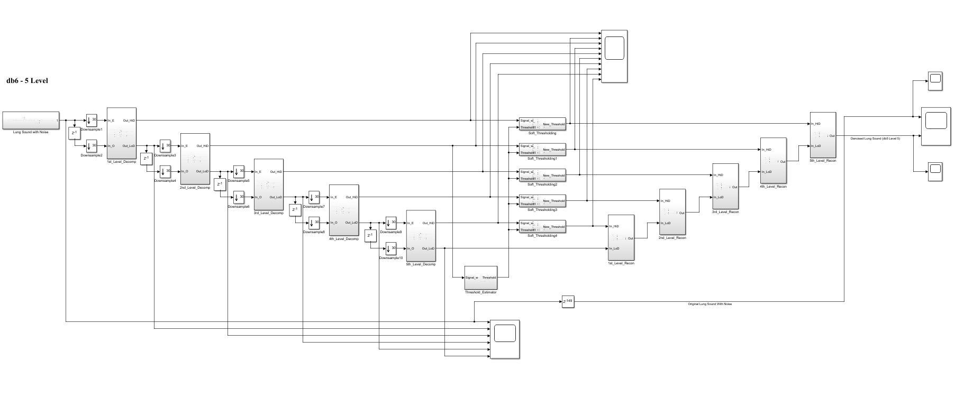

(b) db6 LEVEL 5 SIMULATION RESULT

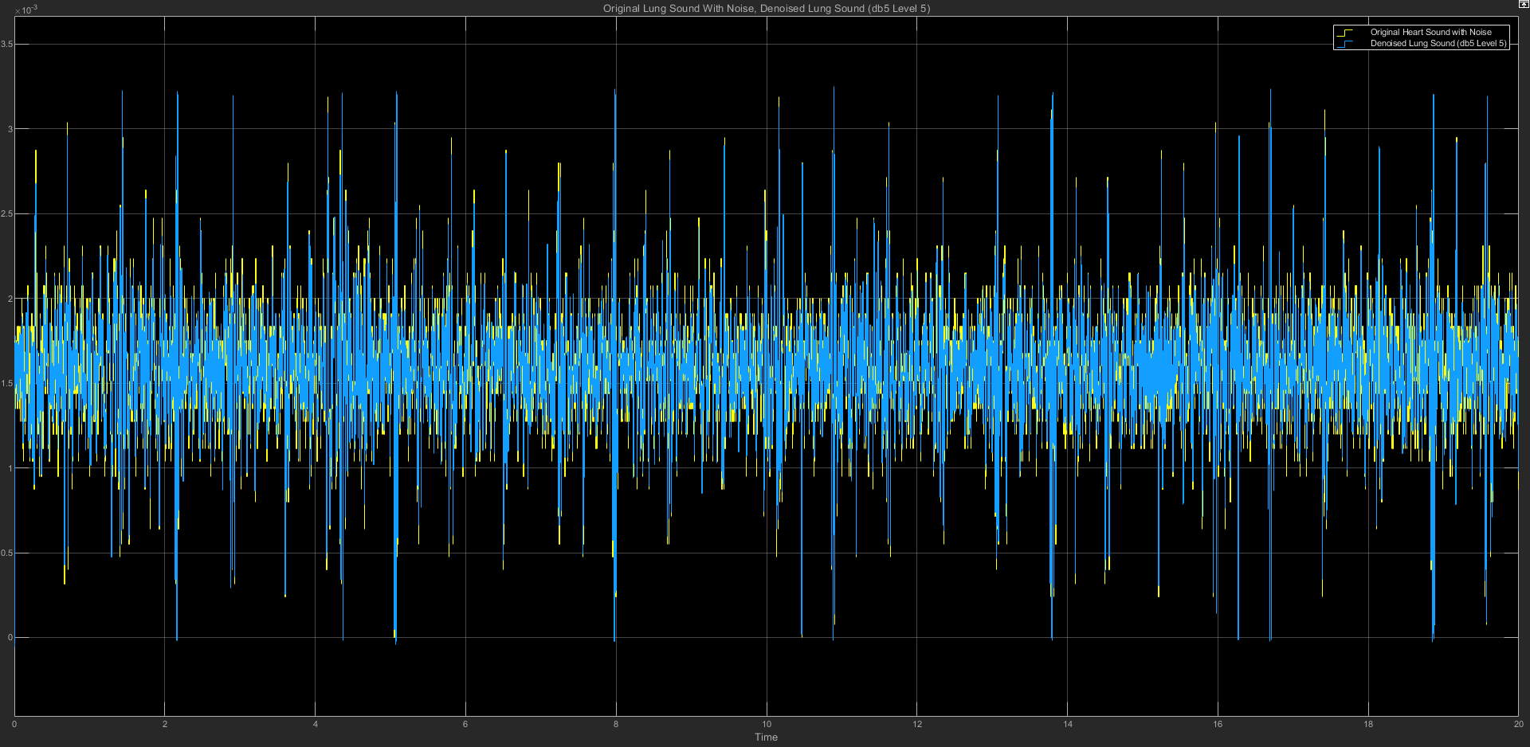

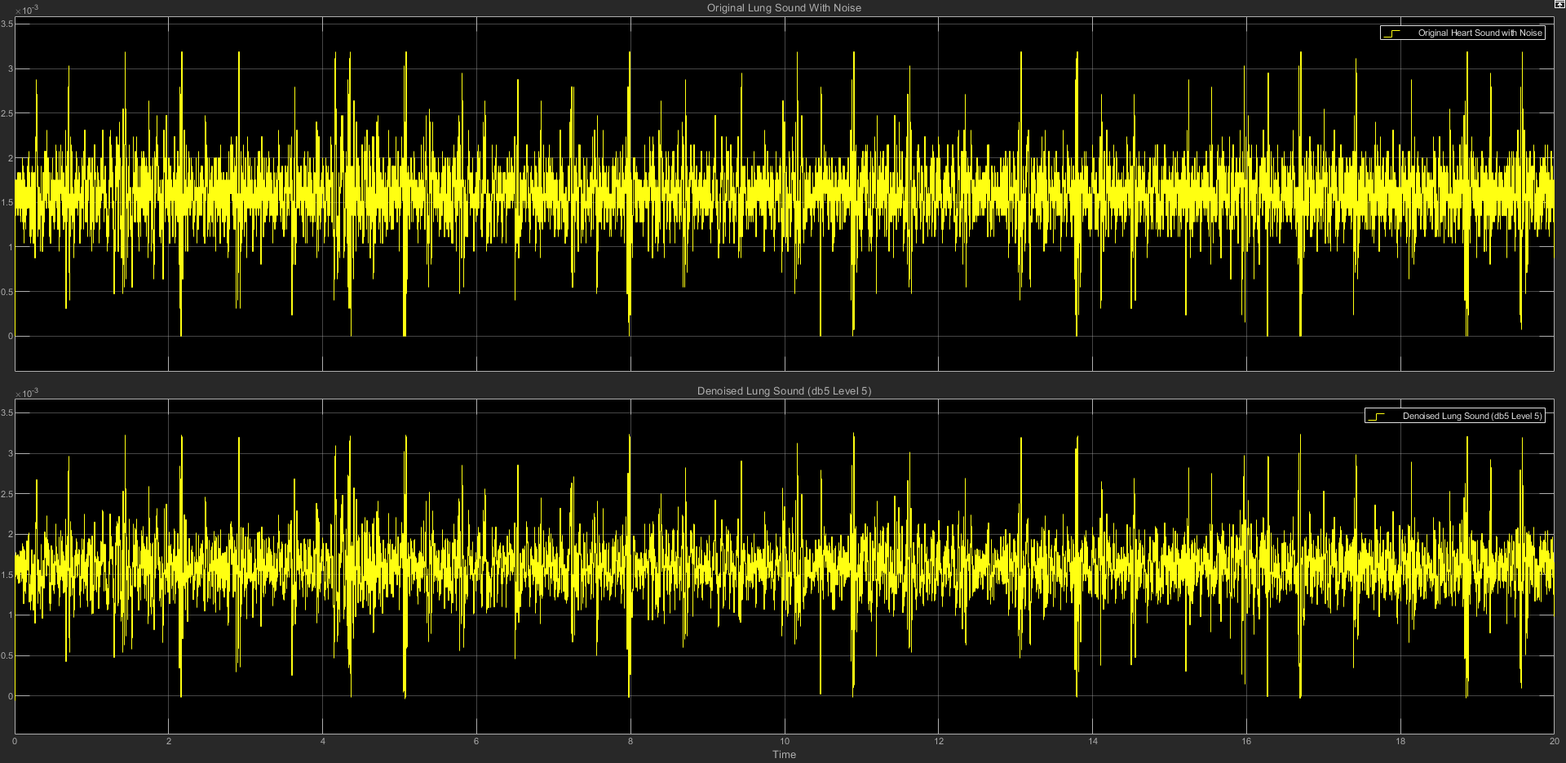

(c) db6 LEVEL 5 STATISTICS RESULT

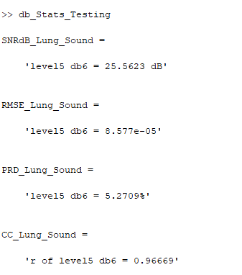

(d) db6 LEVEL 5 SCATTER PLOT RESULT

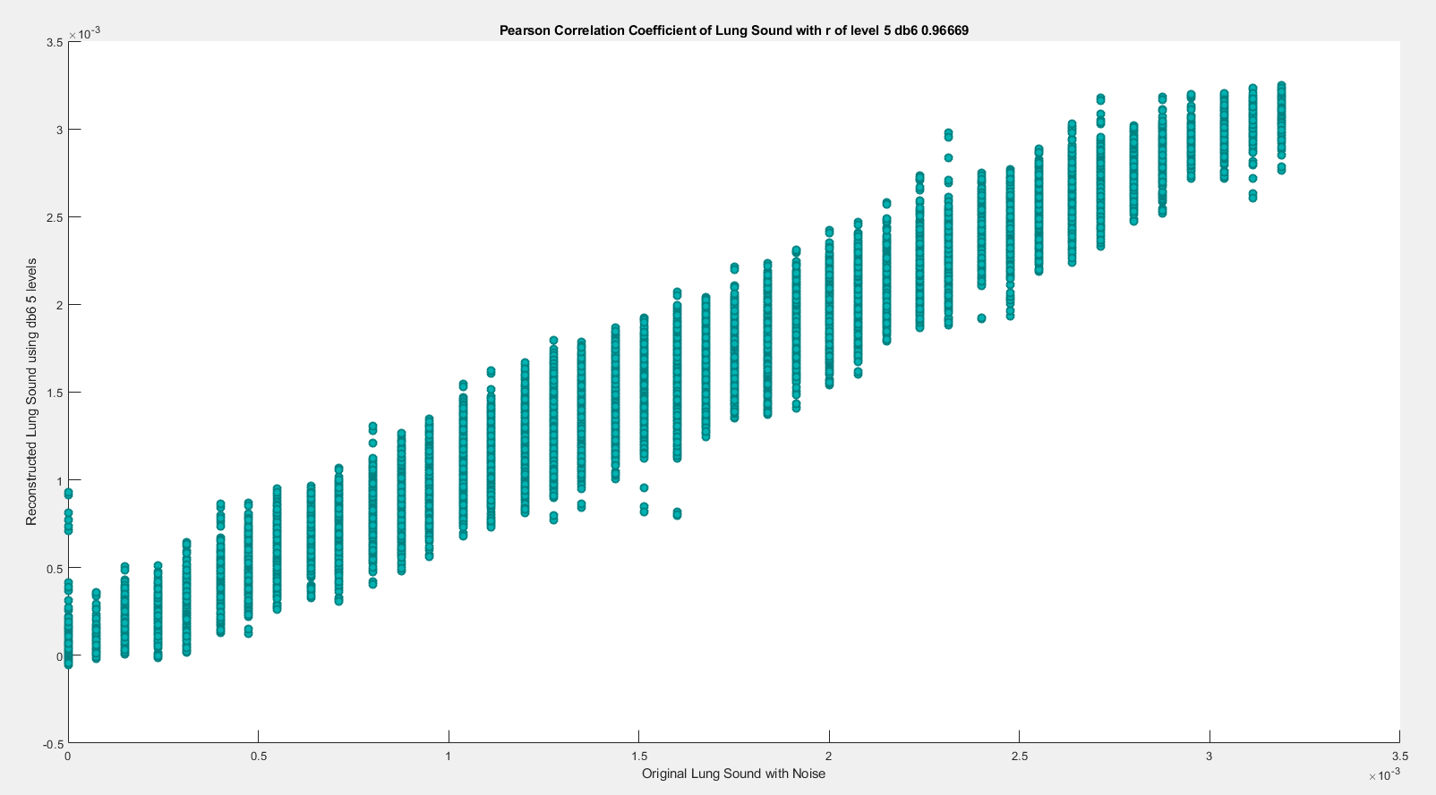

**(5) db6 LEVEL 6**

(a) db6 LEVEL 6 ARCHITECTURE

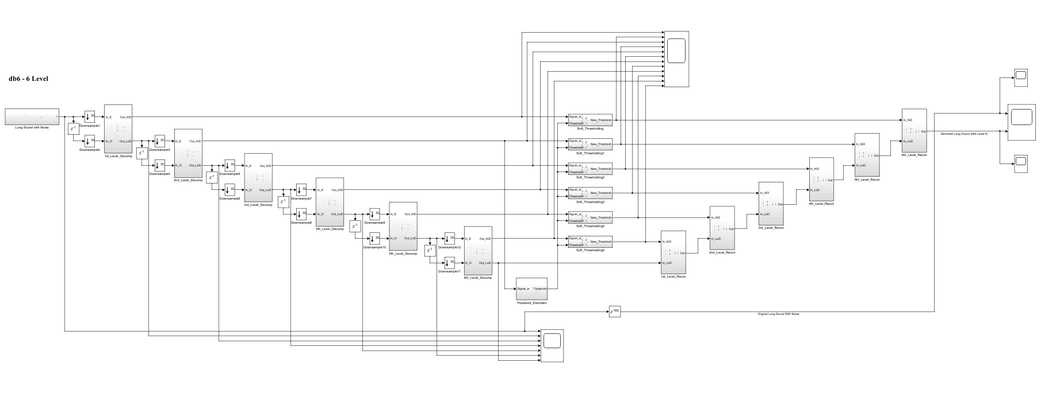

(b) db6 LEVEL 6 SIMULATION RESULT

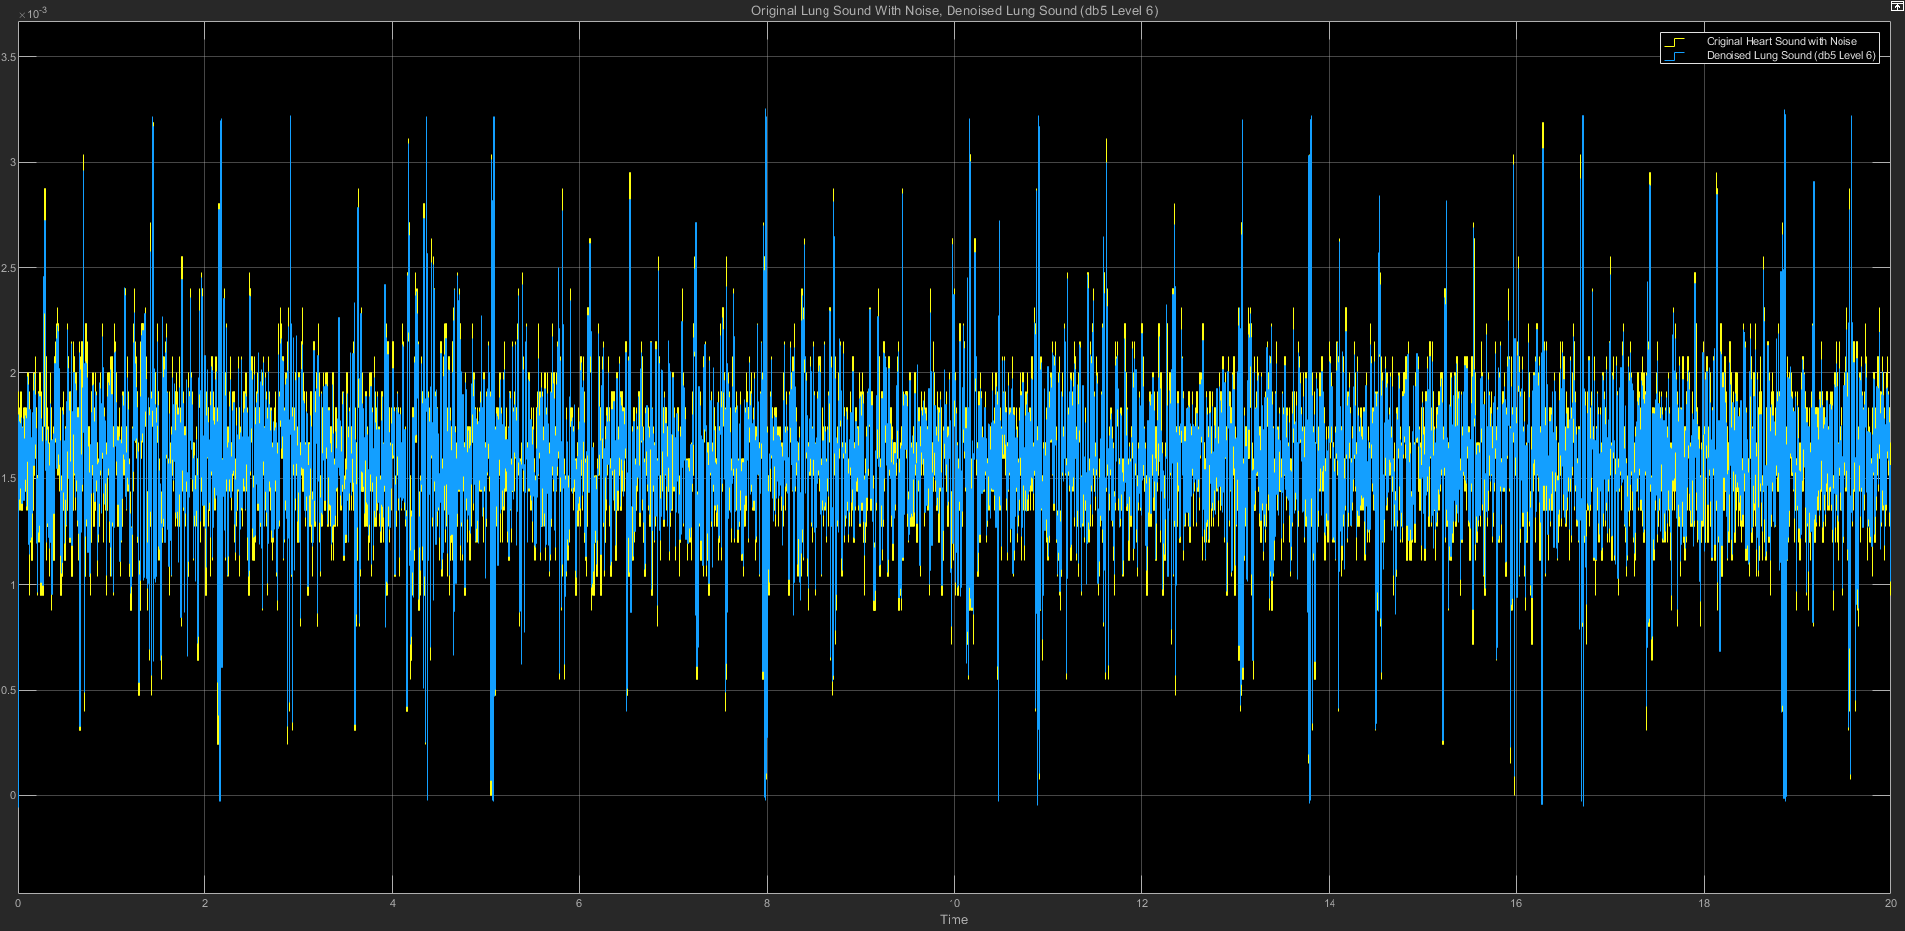

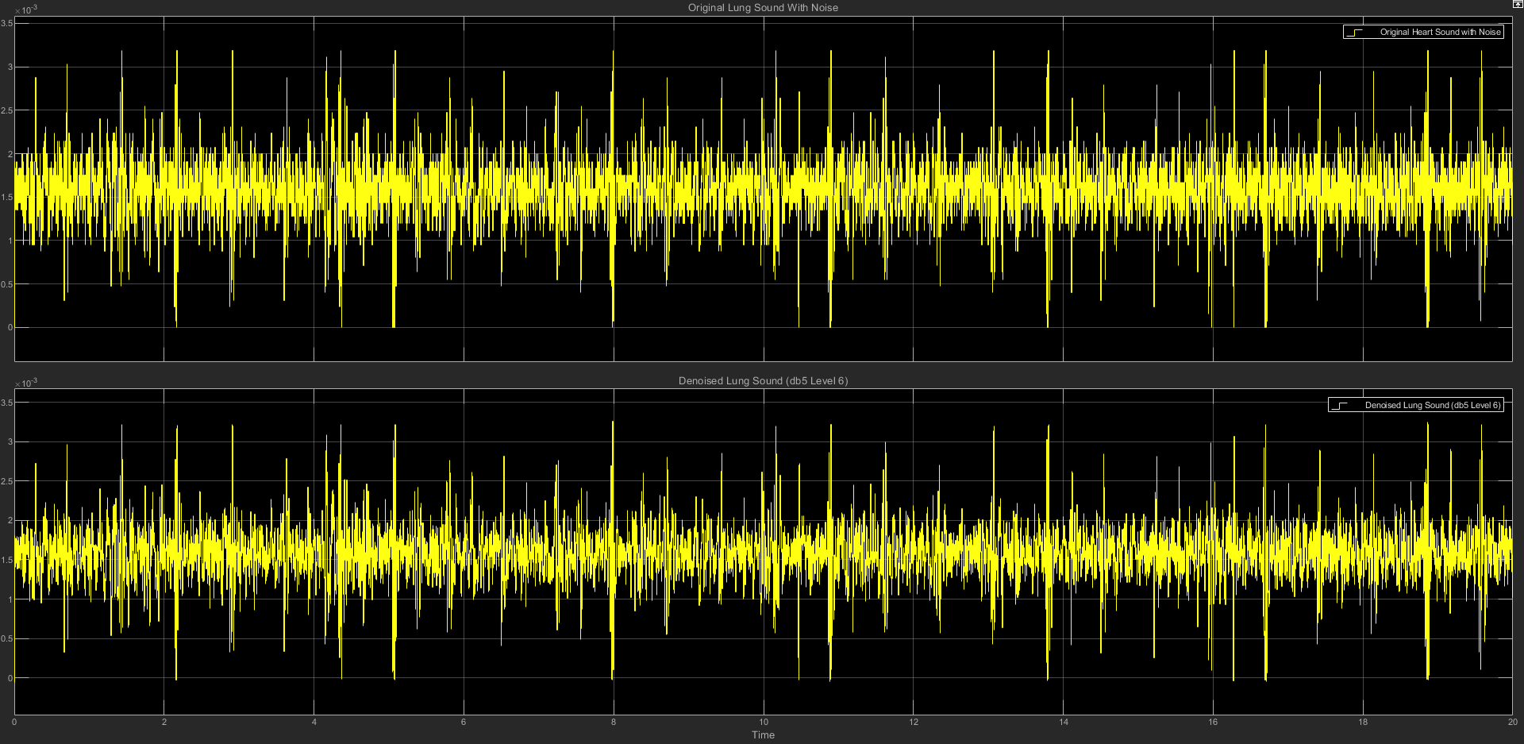

(c) db6 LEVEL 6 STATISTICS RESULT

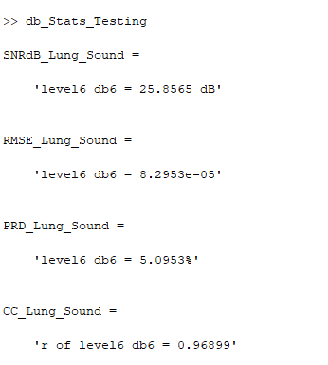

(d) db6 LEVEL 6 SCATTER PLOT RESULT

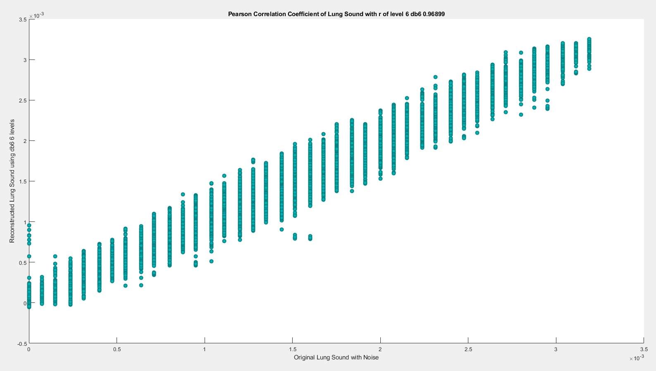

**(6) db6 LEVEL 7**

(a) db6 LEVEL 7 ARCHITECTURE

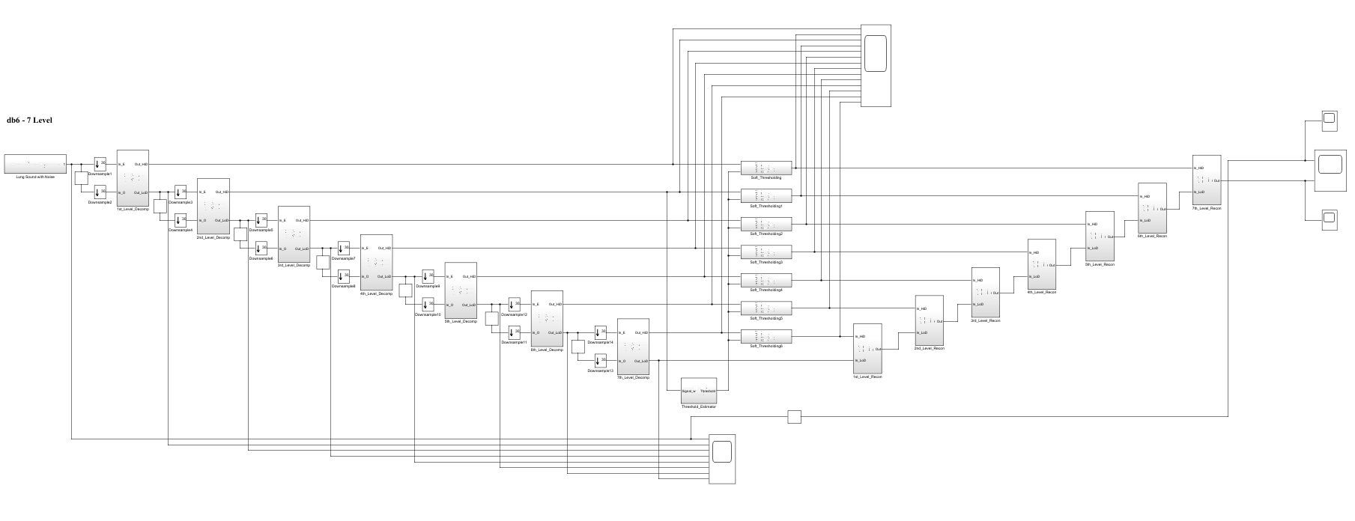

(b) db6 LEVEL 7 SIMULATION RESULT

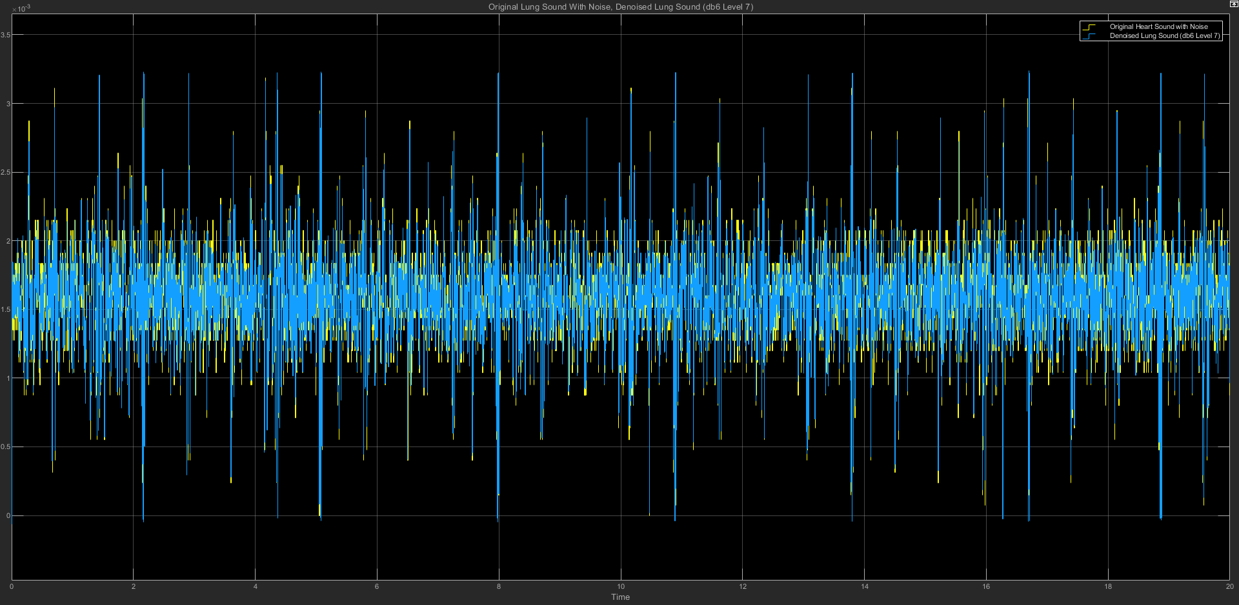

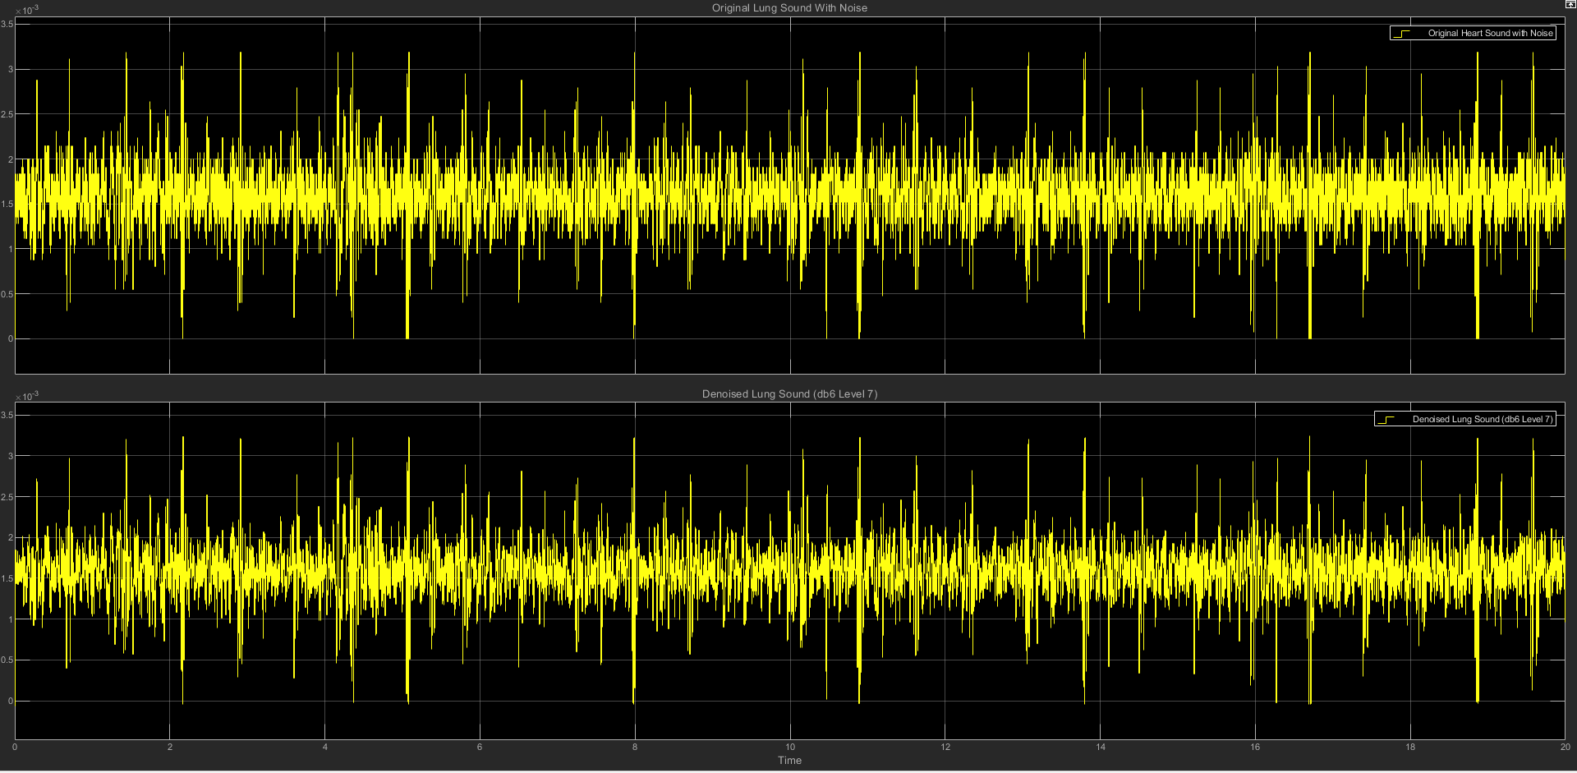

(c) db6 LEVEL 7 STATISTICS RESULT

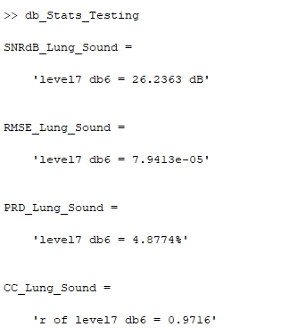

(d) db6 LEVEL 7 SCATTER PLOT RESULT

